|  |
| --- |
| **MINISTRY OF EDUCATION AND TRAINING** |
| **FPT UniverSITY** |

Capstone Project Document

|  |
| --- |
| [Ordering Application by Location] |
|  |
| |  |  | | --- | --- | | **<>** | | | **Group Members** | |  |  |  | | --- | --- | --- | | Student Name | Role No | Student Code | | Nguyễn Quốc Đạt | SE04036 | datnqse04036 | | Nguyễn Đại Thắng | SE04441 | thangndse04441 | | Ngô Ngọc Tuyên | SE04335 | tuyennnse04335 | | Mai Gia Tú | SE04012 | tumgse04012 | | Vũ Sỹ Tùng | SE04113 | tungvsse04113 | | | **Supervisor** | Lương Trung Kiên | | **Ext Supervisor** |  | | **Capstone Project code** | OAL | |

**Ha Noi, 05/2018**

# Introduction

## Purpose

Introduction chapter introduces the background and initial idea of the Capstone Project. In this chapter, we – the developing team – will provide information about what we do, the reason why we do.

By comparing to the similar existing solutions, we also show advantages, benefits, limitation and risks that our system has to face up to in the future.

## Project Information

|  |  |
| --- | --- |
| Project Name | Ordering Application by Location |
| Project Code | OAL |
| Project Category | Development |
| Application Type | Application and Website |
| Timeline | From May 2018 to Sep 2018 |

## Team information

### Supervisor

|  |  |  |  |
| --- | --- | --- | --- |
| **Full Name** | **Phone** | **E-mail** | **Title** |
| Lương Trung Kiên | 0983357211 | [kienlt@fpt.edu.vn](mailto:kienlt@fpt.edu.vn) | Lecturer |

**Table 1-1**: Supervisor information

### Team members

|  |  |  |  |  |  |
| --- | --- | --- | --- | --- | --- |
| **No.** | **Full Name** | **Roll Number** | **Phone** | **E-mail** | **Role in Group** |
| 1 | Nguyễn Quốc Đạt | SE04036 | 0942281296 | [datnqse04036@fpt.edu.vn](mailto:datnqse04036@fpt.edu.vn) | Team Leader |
| 2 | Ngô Ngọc Tuyên | SE04335 | 0964346976 | tuyennnse04335[@fpt.edu.vn](mailto:KhoaNDSE60811@fpt.edu.vn) | Member |
| 3 | Nguyễn Đại Thắng | SE04441 | 01686396395 | thangndse04441[@fpt.edu.vn](mailto:OwokonuSE04494@fpt.edu.vn) | Member |
| 4 | Mai Gia Tú | SE04012 | 0972678655 | tumgse04012[@fpt.edu.vn](mailto:ManhPHSE06191@fpt.edu.vn) | Member |
| 5 | Vũ Sỹ Tùng | SE04113 | 0916606094 | tungvsse04113[@fpt.edu.vn](mailto:ManhPHSE06191@fpt.edu.vn) | Member |

**Table 1-2:**Team’s members information

## Background

Nowadays, Viet Nam becomes one of the fastest growing Internet applications countries in the world. Number of Viet Nam Internet user is 58 million, ranked No.1 in ASEAN on number of national domain name, ranked No.30 worldwide on number of IPV4 address. But, Internet in Viet Nam is grown unevenly, fast develop in big city, exactly, Ha Noi and Ho Chi Minh, and slowly develop in other cities.

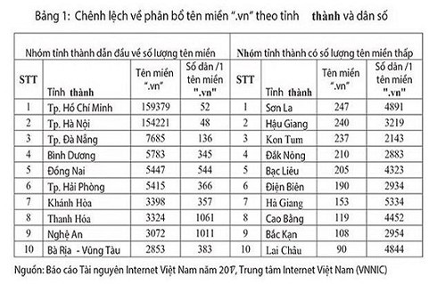

*Nowadays,* as analysis, as Vietnam E-commerce Association, Vietnam's e-commerce growth rate in 2017 is 25 percent and this rate can increase in period 2018-2020. As “We are social” website, mobile connection rate in Viet Nam is 153% as total population in 2017. 73% of Vietnamese have unique mobile, as well as, 50% Vietnamese use mobile social. In Viet Nam, number of grocery is continuous increase, almost of it is owner grocery. So online shopping has not completely replaced private grocery yet. In the other hand, 47% digital user buy products via her/his smartphone in Dec,2017. For which, 16% Vietnamese phone user search for contents based on location on his/her smartphone. So, there is no e-commerce shopping application/website allow user can search products/store based on user’s current location.

TOTAL
POPULATION
INTERNET
USERS
ACTIVE SOCIAL
MEDIA USERS
UNIQUE
MOBILE USERS
ACTIVE MOBILE
SOCIAL USERS
JAN
2018 A SNAPSH...

**Statistics data on digital trends in Vietnam in 2017 (Source :** **wearesocial.com)**

37
NUMBER OF UNIQUE
MOBILE USERS (ANY
TYPE OF HANDSET)
MOBILE PENETRATION
(UNIQUE USERS vs.
TOTAL POPULATION)
TOTAL NUMBER...

**Statistics data on phone and telephone connection in Vietnam in 2017**

**(Source :** **wearesocial.com)**

44
SEARCHED ONLINE
FOR A PRODUCT
OR SERVICE TOBUY
VISITED
ANONLINE
RETAIL STORE
PURCHASED A
PRODUCT OR
SERVICE ONLINE
MADE...

**Statistics on online shopping trends in Vietnam in December 2017 (Source :** **wearesocial.com)**

As Director of Consumer Behaviour Research of Nielsen INC, e-commerce in Vietnam has not reached the expected due to user concerned about the quality of goods, long shipment time,..

E-commerce shopping has some advantages are convenient, every-when-buying, easy payment. But, it also has many disadvantages hard to check product’s quality, hard to check store’s service, long shipment time, so on.

## The capstone aim

The aim of this capstone project is to design and develop an E- Shopping Application, on which End-user can search for products such as housewares, customer goods, electronics, ... and order it through nearby store related to their current location. The store can not only add new products, remove and change price and promotion of products, but also to accept or to decline the ordering.

## Literature review of existing system

### Name of current system

* Shopee: a shopping application which belongs to Garena – a consumer Internet platform provider based in Asia. This application allows user register virtual store in system. The end-user not only can search so many kinds of product through Search box or category, but also to order these products through registered virtual store.
* Lazada: a shopping application which belongs to Alibaba – one of top 10 most valuable and biggest companies in the world. This application allows end-user search products, view products as category, order products through before-registered virtual stores.
* Groupon: an electronic commerce shopping application which belongs to Groupon Inc. This application has same basic function as other e- commerce shopping applications such as: search products, order products, register store, …. Groupon app, in other hand, have a unique function which is locate nearby store to user’s current location.

### Strength of existing system

1. *Shopee*
   * Large community.
   * Colourful, nice user-interface, great user-experience.
   * Promotion programs are usually, attractive.
   * Support website platform.
   * User can comment, rate and report to virtual stores.
2. *Lazada*
   * Large community.
   * Nice user-interface, great user-experience.
   * Promotion programs are usually, attractive.
   * Support website platform.
   * User can comment, rate and report to virtual stores.
   * Have some kinds of genuine.
3. *Groupon*
   * Colourful, nice user-interface, great user-experience.
   * Promotion programs are usually, attractive.
   * Support website platform.
   * Unique function: locate nearby store to user’s current location.

### Weakness of existing system

1. *Shopee*
   * Management virtual store is hard.
   * Sources of product are uncensored.
   * Shipment time is usually long.
   * Hard to find nearby stores to user’s current location.
2. *Lazada*
   * Management virtual store is hard.
   * Sources of product are uncensored.
   * Shipment time is usually long.
   * Hard to find nearby stores to user’s current location.
3. *Groupon*
   * User cannot report to virtual stores.
   * Application do not work in Viet Nam

### 1.6.4 To acquire knowledge

1. *Shopee + Lazada*

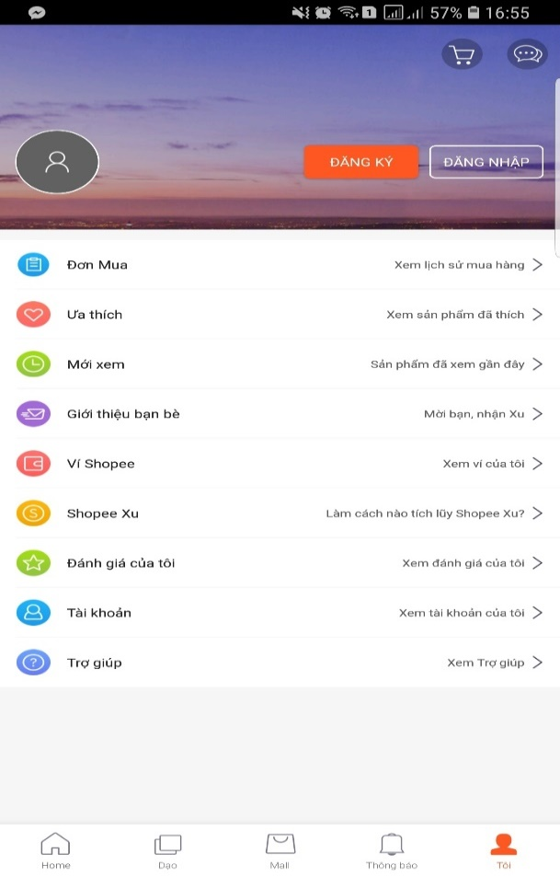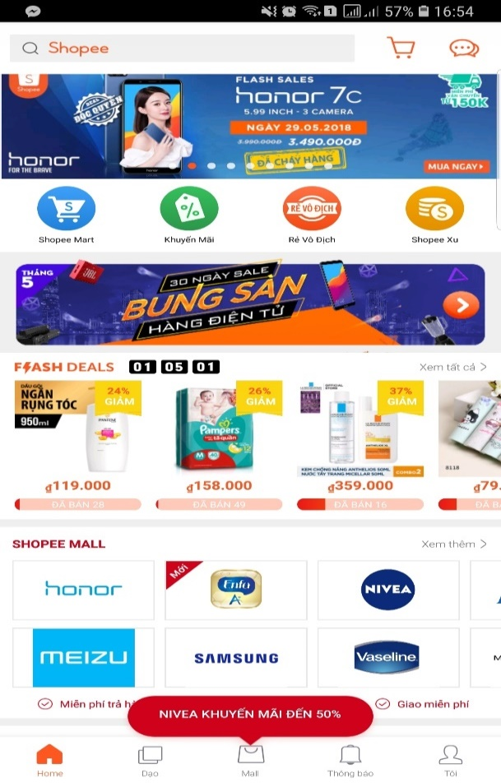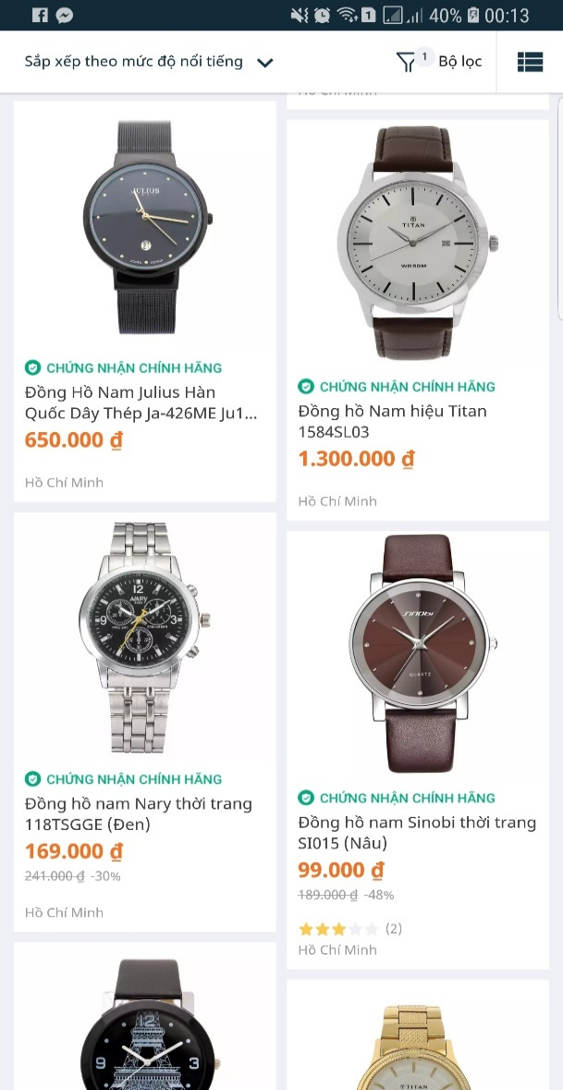

* We can learn more from user-interface; how to arrange components in application screen; how ordering business works; how to display products, categories, product details in colorful, clearly layout.

1. *Grab*

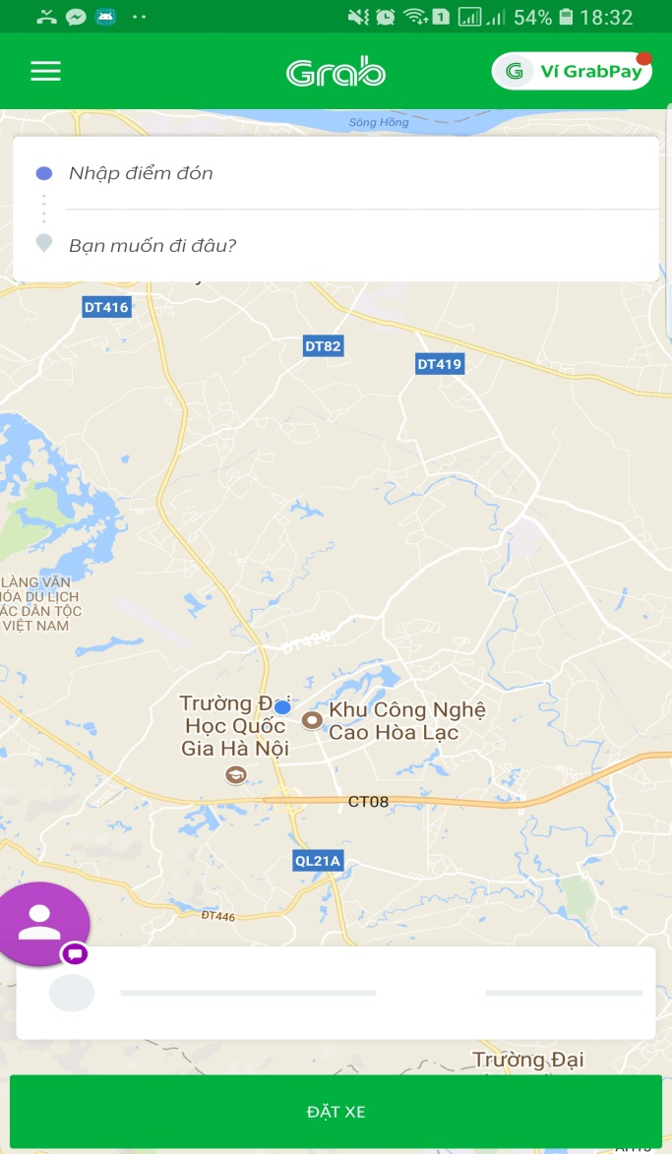

* We have learned how the application locate user’s current location, how application identify nearby target to user’s current location in local map, how application direct the way to target.

1. *Groupon (Website version)*

* 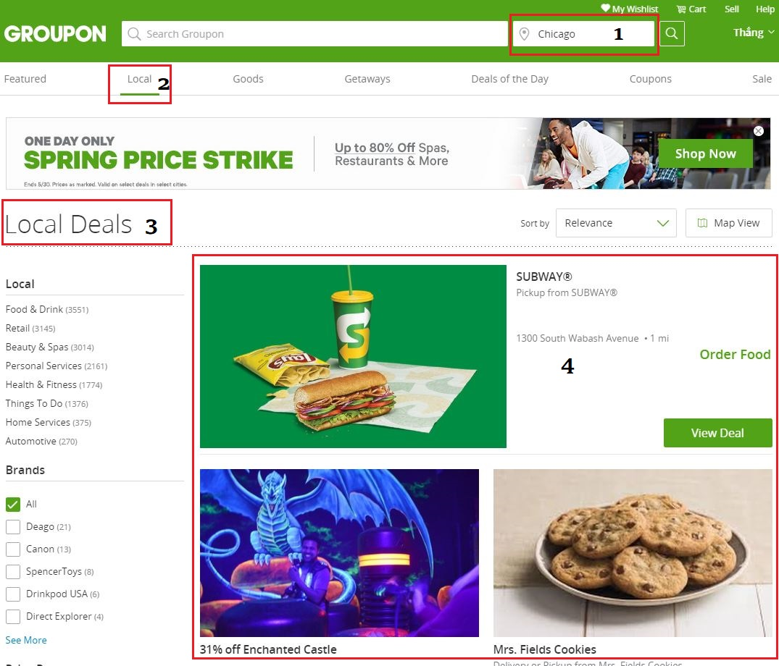We have learned how the application identify nearby target deals to current chosen place (location), how the application identifies chosen place (location).

## Our Proposal

### Situation

* Nam is a high-school student in Hung Yen. This May, he would take part in FPT University entrance exam in Ha Noi. So, he decided to arrive to Ha Noi 1 day early to visit Ho Chi Minh museum, Lotte building,..
* After visiting Ho Chi Minh museum, Nam had arrived to Lotte building and he felt thirsty. He decided to find a grocery or mini mart to buy a beverage bottle and an ice-cream but he couldn’t. He had walked all the Chua Mot Cot Street; he saw fashion shops, souvenir shops, restaurants but no grocery. Then, he tried to walk all the Dien Bien Street and he got same result.
* This is a typical situation which indicates difficulty in finding grocery or mini mart on strange place where users haven’t even arrived.
* 3S will help finding grocery becomes easy.

### Ideas

* To support end-user can find nearest store to order products.
* To minimize product delivery time to end-user.
* Remove direct payment because the development time is limit. In the other hand, the application finds nearby store which have user-needed-products to recommend so the distance between end-user and store is usually short. Recommend to use COD payment.
* To support end-user can find nearby store to user’s current location, in case, user have arrived to strange place (location).

### Advantages

* Easy to search (find) products which they need.
* Easy to order products through nearby store to their current location.
* Easy to register store, but this registration will be close censored.
* Convenient to find nearby store address to user’s current location when user have arrived strange place.

### Disadvantages

* To not have directly online payment yet.
* Hard to control spam ordering (in case, after sending ordering product, end-user cancel these ordering).

### Expectation

* To have a platform to connect stores with users
* To make user convenient, happy in buying products.
* To make store easy to advertise, approach to user.

# Software Project Management Plan(SPMP)

## Problem Definition

### Name of this capstone project

* + This capstone project is a system which includes a mobile application and a website. This system has been named “5SAO” which means “5 Super Application of Ordering”
    1. Super-Fast
    2. Super-Convenient
    3. Super-Saving
    4. Super Professional
    5. Super Friendly

### Project Abstract

* + Nowadays, e-commerce, specifically, e-shopping application becomes more popular. Everyone can approach, search and ordering products via

e-shopping application. But, we realize that we have a trouble which end-users are hard to approach to nearby stores. They usually search products and order these via system-suggested stories which maybe is so far away from them. This can make deliverable time so long.

* + We create a system via locating user’s current location or chosen location to help users decrease deliverable time. This system is useful for people who had arrived to strange place/location.

### Project Overview

1. *The Current System*
2. *The Proposed System*

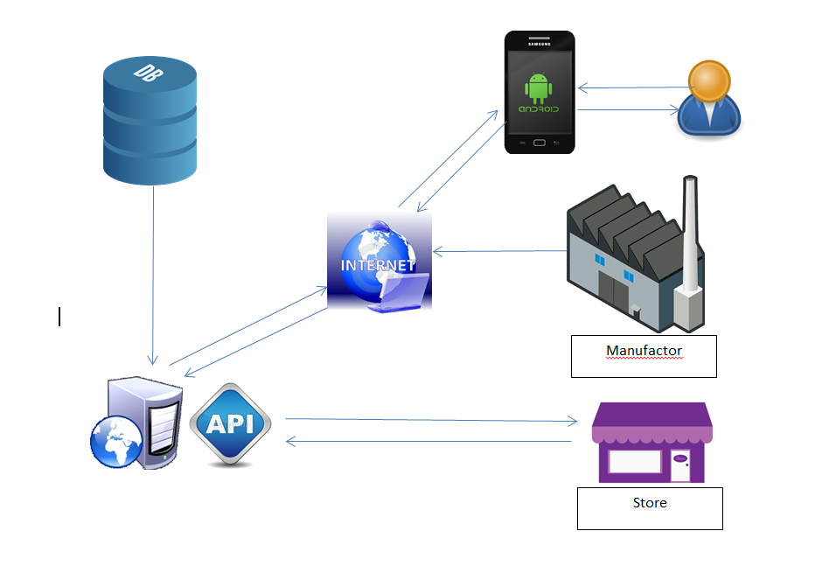

1. *Boundaries of the System*
2. *Development Environment*
   * **JDK 1.8**: The Java Development Kit (JDK) is a software development environment used for developing Java applications and applets. It includes the Java Runtime Environment (JRE), an interpreter/loader (java), a compiler (javac), an archiver (jar), a documentation generator (javadoc) and other tools needed in Java development.
   * **NetBeans IDE 8.2**: An integrated development environment (IDE) for Java
   * **Android SDK (software development kit):** A set of development tools used to develop applications for Android platform. The Android SDK includes the following:
     1. Required libraries
     2. Debugger
     3. An emulator
     4. Relevant documentation for the Android application program interfaces (APIs)
     5. Sample source code
     6. Tutorials for the Android OS
   * **Android Studio 3.1.2**: The official Integrated Development Environment (IDE) for Android app development
   * **Server CentOS 7:** An operating system for server
   * **Tomcat 7.0.76**: An open source implementation of the Java Servlet, Java Server Pages, Java Expression Language and Java Web Socket technologies.
   * **MySQL**: An open-source relational database management system (RDBMS)

## Project Organization

### Project Process Model

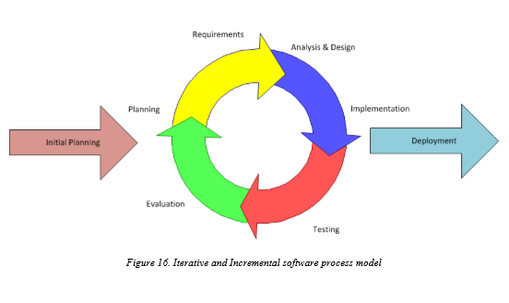

5SAO uses Iterative and Incremental software process model – a method by which system is developed in small phases in a time and through repeated cycles. Developers can take advantage of this model through reviewing parts of system to change or improve them. It also allows developers to receive feedback to modify the target of the next releases.

During the time of doing Capstone project, we divide the process into 2 iterations. Detail information about the iterations is explained in the part of Project management plan.

### Organization Structure

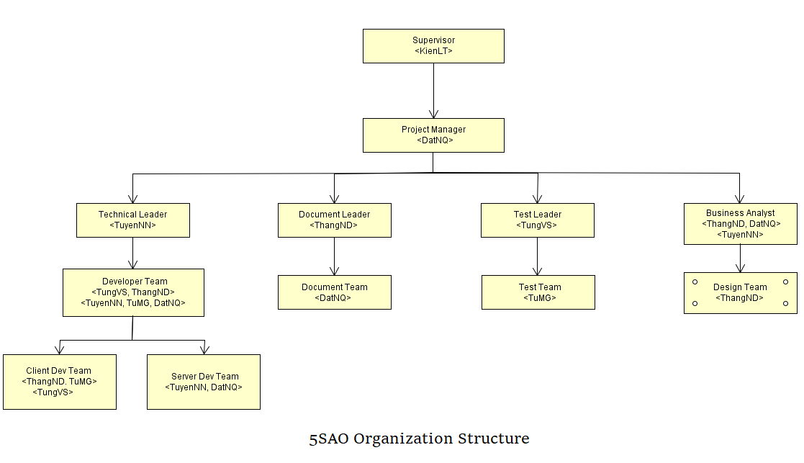

### Organization Structure

|  |  |
| --- | --- |
| **Role** | **Responsibility** |
| Project manager | Project manager has responsibilities to plan, schedule and control the project. He has to communicate with all teams to keep them focusing on the final goal also. |
| Technical leader | Technical leader has responsibilities to decide what technologies the project uses. He works with business analysts to design system architecture and database. Additionally, he supervises other developers working |
| Document leader | Document leader has responsibility to prepare all the documents relating to the project. |
| Test leader | Test leader has responsibilities to plan, monitor and control the testing activities and tasks, including setting up test, evaluating test run and recording test results. |
| Developer | Developers have responsibilities to code product, review other developers’ code. They set up, run unit test, receive bugs from testers and fix these bugs. |
| Tester | Testers have responsibilities to test product, write test cases for integration, regression and acceptance test phases. They execute these written test cases, log bugs and inform developers |
| Designer | Designer has responsibilities to design user interface of product, draw mock-up screens for all user cases before implementing |
| Business analyst | Business analysts have responsibilities to work with project manager to analyse business domain, define functions and scope of system. They work as a bridge between business problems and technology solutions. |

### Project Team Member

|  |  |
| --- | --- |
| **Team member** | **Role** |
| DatNQ | Project manager, Developer, Business Analyst |
| TuyenNN | Technical leader, Developer, Business Analyst |
| ThangND | Document Leader, Developer, Business Analyst, Designer |
| TungVS | Test Leader, Developer, Tester |
| TuMG | Developer, Tester |

### Tools

|  |  |
| --- | --- |
| **UML tool** | Astah |
| **Project management tools** | Trello, Microsoft Project Management |
| **Process model** | Iterative and Incremental software process model. |
| **Drawing mock-up tool** | Fluid UI |
| **API Development Environment** | Postman |

## Project Management Plan

### Tasks schedule

* + Iteration 1: Focusing on developing document,design and basic functions
    1. Duration: May, 15th 2018 – June, 24th 2018.
    2. Content:
       - Identifying group, members and analyzing requirements.
       - Designing, executing and testing basic functions such as: login, register, search products, order products, add products to store,...
       - Do reports.
       - Defining figures of specification about performance (memory, delay time, load time…).
       - Deployment and closing.
  + Iteration 2: Focusing on developing advance functions
    1. Duration: June, 25st 2018 – August, 5th 2018.
    2. Content:
       - Completing basic functions.
       - Designing, executing and testing advance functions.
       - Continue doing reports.
       - Defining figures of specification about performance (memory, delay time, load time…).
       - Deployment.
  + Iteration 3: Focusing on fix bug and optimize application
    1. Duration: August, 6th 2018 – August, 31st 2018.
    2. Content:
       - Completing advance functions.
       - Fix bug
       - Optimize code and application performent.
       - Finish reports.
       - Deployment.
       - Relax

### Project milestones

|  |  |  |  |
| --- | --- | --- | --- |
| **No** | **Milestone** | **Completion Date** | **Verification** |
| 1 | Project start | 14/05/2018 | Supervisor |
| 2 | Submit report 1 | 04/06/2018 | Supervisor |
| 3 | Submit report 2 | 11/06/2018 | Supervisor |
| 4 | Submit report 3 | 18/06/2018 | Supervisor |
| 5 | Submit report 4 | 25/06/2018 | Supervisor |
| 6 | Submit report 5 | 09/07/2018 | Supervisor |
| 7 | Submit report 6 | 23/07/2018 | Supervisor |
| 8 | Final report | 20/08/2018 | FPT University, Supervisor |
| 9 | Defend project | ……. | FPT University, Supervisor |

### Meeting Minutes

A secretary whom the project manager assigns to will note all the meetings of team. He or she should write down ideas, contents discussion and notation by following the meeting minutes form below:

|  |  |  |  |
| --- | --- | --- | --- |
| ***Meeting/Project Name:*** |  | | |
| ***Date of Meeting:*** |  | ***Time: (Type)*** |  |
| ***Meeting Called by:*** |  | ***Location:*** |  |
| ***Note Taker:*** |  | ***Time Keeper:*** |  |
| 1. **Meeting Objective**   *<General description about meeting>*  Example:  -Introducing team members  - Setting up working rules  - Choosing name, raising ideas for project  - Other information | | | |
| 1. **Attendance**  |  |  |  |  | | --- | --- | --- | --- | | ***Member*** | ***Roles*** | ***E-mail*** | ***Attendance*** | | Nguyễn Quốc Đạt | PM, Technical Leader, BA | [datnqse04036@fpt.edu.vn](mailto:datnqse04036@fpt.edu.vn) |  | | Nguyễn Đại Thắng | Developer, Designer | [thangnd04441@fpt.edu.vn](mailto:thangnd04441@fpt.edu.vn) |  | | Ngô Ngọc Tuyên | Developer, Tester, BA | [tuyennnse04335@fpt.edu.vn](mailto:tuyennnse04335@fpt.edu.vn) |  | | Mai Gia Tú | Developer, Tester, BA | [tumgse04012@fpt.edu.vn](mailto:tumgse04012@fpt.edu.vn) |  | | Vũ Sỹ Tùng | Developer, Tester | [tungvsse04113@fpt.edu.vn](mailto:tungvsse04113@fpt.edu.vn) |  | | | | |
| 1. **Content**   **……………………………………………………….……………………………………………………….**  **……………………………………………………….……………………………………………………….**  **……………………………………………………….……………………………………………………….**  **……………………………………………………….……………………………………………………….** | | | |
| 1. **Note**   **……………………………………………………….……………………………………………………….**  **……………………………………………………….……………………………………………………….**  **……………………………………………………….……………………………………………………….**  **……………………………………………………….……………………………………………………….** | | | |

### Coding Convention

* + Purpose of coding conventions:
    1. Coding conventions create a consistent look to the code. They help readers to focus on content, not layout.
    2. Coding conventions enable readers to quickly understand by making assumptions based on previous experiences.
    3. Coding conventions facilitate copying, changing and maintaining the code.
  + Because of these reasons, we strictly follow the Convention Styles Guide below:
    1. Android SDK :
       - Coding Style : <https://source.android.com/setup/contribute/code-style>
       - Project guidelines:

<https://github.com/ribot/android-guidelines/blob/master/project_and_code_guidelines.md>

XML Naming Convention: <https://jeroenmols.com/blog/2016/03/07/resourcenaming/>

* + 1. Java Spring:

<https://docs.spring.io/spring/docs/current/javadoc-api/org/springframework/core/Conventions.html>

### Risk management

|  |  |  |  |  |
| --- | --- | --- | --- | --- |
| **No** | **Description** | **Avoidance plan** | **Contingency plan** | **Impact** |
| R1 | Absence/illness of team members | Members have inform the project manager the reason why they are absent and build their own plan to keep up with the work process. | The project manager always has back up plan to avoid effect from the absence and ensure that problem will be solved | High |
| R2 | Conflicts among members | At the beginning, members should clear their roles and responsibilities. | The project manager has to find out the root that caused problem and solve it. Face-to-face meeting is a good method | Medium |
| R3 | Project team member misunderstands requirements | Members have to read requirement specification and related documents carefully. | Making sure that any miscommunication would be resolved. | Medium |
| R4 | Equipment of members is broken. | Members must be careful with their equipment. | Members should use another equipment until the broken one is fixed or buy the new one. | Low |
| R5 | Business problem | Any ideas are welcome but members have to discuss with others and always focus on the reality and possibility. | Making sure that the business logic of any ideas is carefully analyzed. | High |
| R6 | New technologies | Choosing technology based on members’ qualification. All team members must nurture by self-study. | When the technical leader chooses a new technology, he has to explain to all team members about the decision. | High |
| R7 | Lack of knowledge and experiences about source code management |  |  |  |

# Software Requirements Specifications (SRS)

## Purpose

* + Software Requirements Specifications chapter provides general, as well as specific information of the system. It also shows the describing of functional requirements and non-functional requirements. Following these requirements, our product will perform its intended functionality used in designing developing and testing. All members work based on the information that provided in this document.

## User Requirement Specification

* + A application system which is intermedium between buyers and sellers
  + A application system which provide necessary information about products, stores to be most convenient for User in shopping

## System Requirement Specification (Specific Requirements)

### External Interface Requirements

#### User Interfaces

#### Hardware Interfaces

#### Software Interfaces

#### Communications Protocol

### System Features

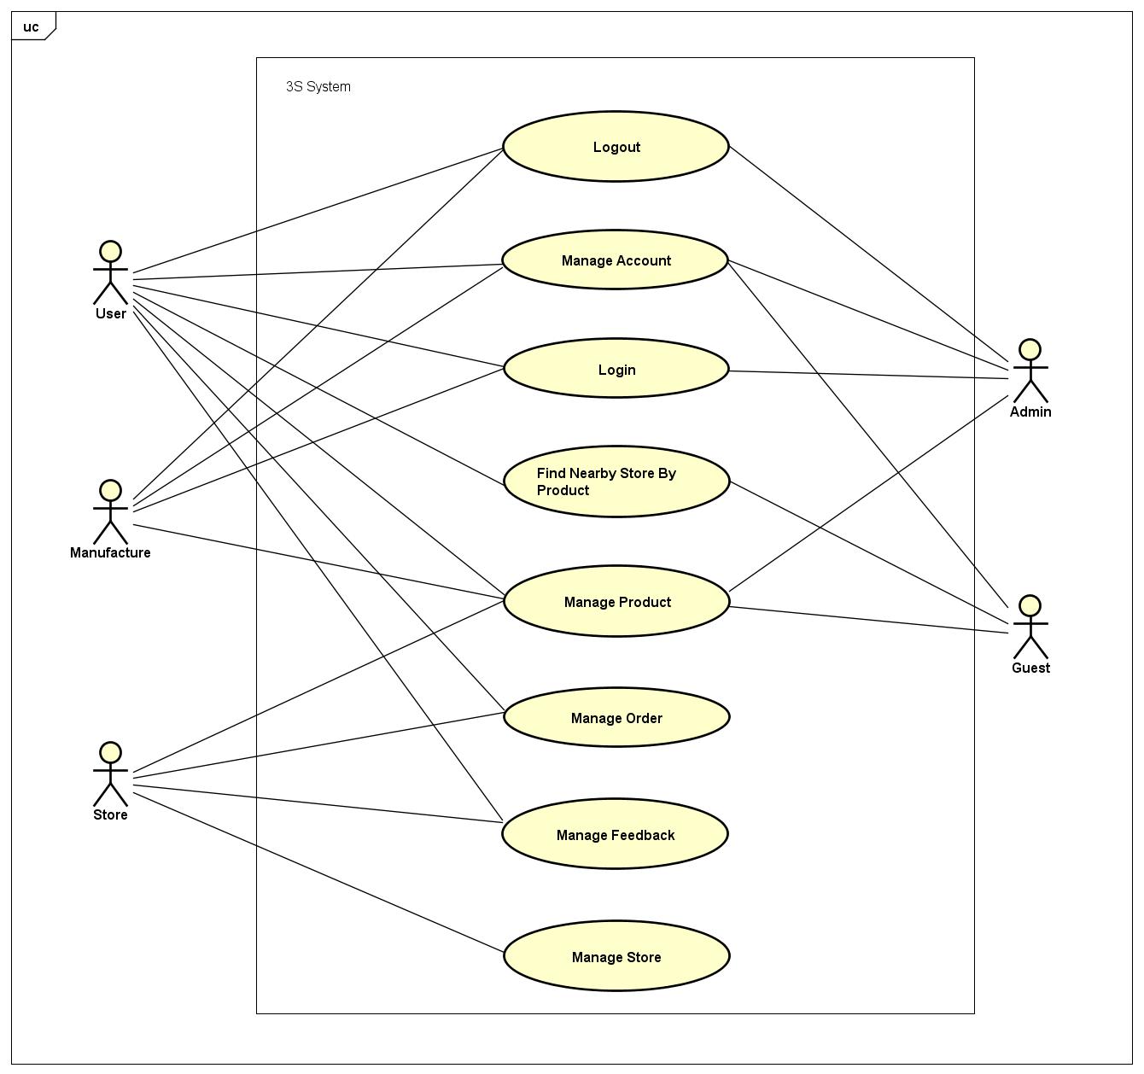

#### Logout

|  |  |  |  |
| --- | --- | --- | --- |
| UC ID and Name: | **UC-1: Logout** | | |
| Created by: | **ThangND** | Created date: | **May 19th, 2018** |
| Primary Actor: | **User** | Secondary Actor: | **Admin - Manufacture** |
| Trigger: | N/A | | |
| Description: | User or Admin who want to log out of application system. | | |
| Preconditions: | **PRE-1.1:** The user has logged in to application system. | | |
| Post conditions: | **POST-1.1:** The user will have logged out of application system.  **POST-1.2:** The user will have accessed to application as Guest. | | |
| Normal Flow: | 1. User opens the application. 2. Home screen is displayed. 3. User clicks on “Người dùng” tab with  icon on the right of bottom navigation bar in home screen. 4. 4.”Người dùng” screen is displayed with user information function form and “Đăng xuất” button. 5. User clicks on “Đăng xuất” button 6. Redirect to home screen , user accesses to system as Guest | | |
| Alternative Flows: | N/A | | |
| Exceptions: | N/A | | |
| Priority: | High | | |
| Frequency of Use: | Medium | | |
| Other Information: | N/A | | |
| Assumptions: | Server is stable running.  Internet service is turning on. | | |

#### Login

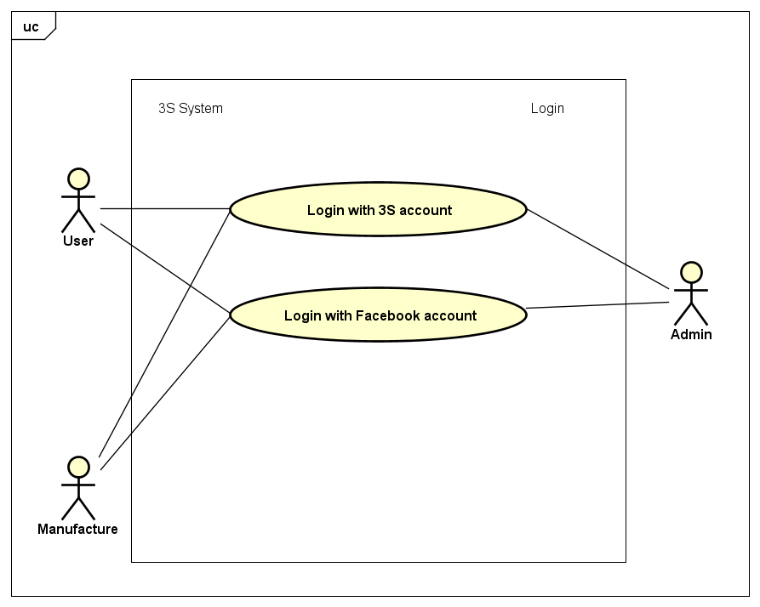

##### Login with 3S account

|  |  |  |  |
| --- | --- | --- | --- |
| UC ID and Name: | **UC-2: Login with 3S account** | | |
| Created by: | **ThangND** | Created date: | **May 23th, 2018** |
| Primary Actor: | **User** | Secondary Actor: | **Admin-Manufacture** |
| Trigger: | N/A | | |
| Description: | User who wants to login with Customer’s account. | | |
| Preconditions: | **PRE-2.1:** The user has a 3S account.  **PRE-2.2:** The user had not logged in to application system. | | |
| Post conditions: | **POST-2.1:** The user will have logged in to application system. | | |
| Normal Flow: | 1. User opens the application. 2. Home screen is displayed. 3. User clicks on “Người dùng” tab with  icon on the right of bottom navigation bar in home screen. 4. ”Người dùng” screen is displayed with “Bạn chưa đăng nhập” notification message and “Đăng nhập” button. 5. User clicks on “Đăng nhập” button. 6. “Đăng nhập” screen is displayed. 7. User enters correct username and password into login form, and then clicks on “Đăng nhập” button. 8. Redirect to home screen. | | |
| Alternative Flows: | 1. User opens the application. 2. Displays home screen. 3. User clicks on “Cửa hàng” tab with  icon on the center of bottom navigation bar in home screen. 4. ” Cửa hàng” screen is displayed with “Vui lòng đăng nhập để xem thông tin cửa hàng” notification message and “Đăng nhập” button. 5. User clicks on “Đăng nhập” button. 6. “Đăng nhập” screen is displayed. 7. User enters correct username and password into login form, and then clicks on “Đăng nhập” button. 8. Redirect to home screen. | | |
| Exceptions: | Incorrect 3S account credentials | | |
| Priority: | High | | |
| Frequency of Use: | High | | |
| Other Information: | N/A | | |
| Assumptions: | Server is stable running.  Internet service is turning on. | | |

##### Login with Facebook account

|  |  |  |  |
| --- | --- | --- | --- |
| UC ID and Name: | **UC-3: Login with Facebook account** | | |
| Created by: | **ThangND** | Created date: | **May 23th, 2018** |
| Primary Actor: | **User** | Secondary Actor: | **Admin-Manufacture** |
| Trigger: | N/A | | |
| Description: | User who wants to login with Facebook account. | | |
| Preconditions: | **PRE-3.1:** The user has a Facebook account.  **PRE-3.2:** The user had not logged in to application system. | | |
| Post conditions: | **POST-3.1:** The user will have logged in to application system. | | |
| Normal Flow: | 1. User opens the application. 2. Home screen is displayed. 3. User clicks on “Người dùng” tab with  icon on the right of bottom navigation bar in home screen. 4. ”Người dùng” screen is displayed with “Bạn chưa đăng nhập” notification message and “Đăng nhập” button. 5. User clicks on “Đăng nhập” button. 6. “Đăng nhập” screen is displayed. 7. User clicks on “Đăng nhập với tài khoản Facebook” button. 8. User enter correct Facebook account to Facebook login form. 9. Redirect to home screen. | | |
| Alternative Flows: | 1. User opens the application. 2. Home screen iss displayed. 3. User clicks on “Cửa hàng” tab with  icon on the center of bottom navigation bar in home screen. 4. ”Cửa hàng” screens is displayed with “Vui lòng đăng nhập để xem thông tin cửa hàng” notification message and “Đăng nhập” button. 5. User clicks on “Đăng nhập” button. 6. “Đăng nhập” screen is displayed. 7. User clicks on “Đăng nhập với tài khoản Facebook” button. 8. User enter correct Facebook account to Facebook login form. 9. Redirect to home screen. | | |
| Exceptions: | 1. Incorrect Facebook credentials. 2. Facebook account have been logged in on current device. 3. Mobile device have not had access permission to Facebook account. | | |
| Priority: | High | | |
| Frequency of Use: | High | | |
| Other Information: | N/A | | |
| Assumptions: | Server is stable running.  Internet service is turning on. | | |

#### Management Order

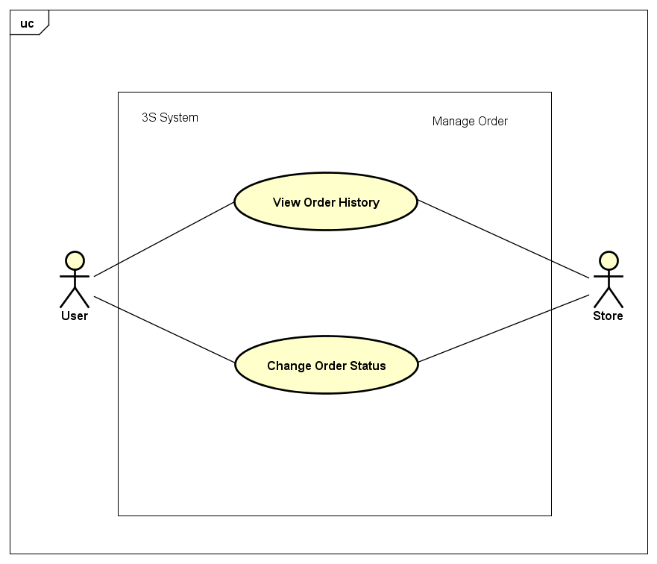

##### View Order History

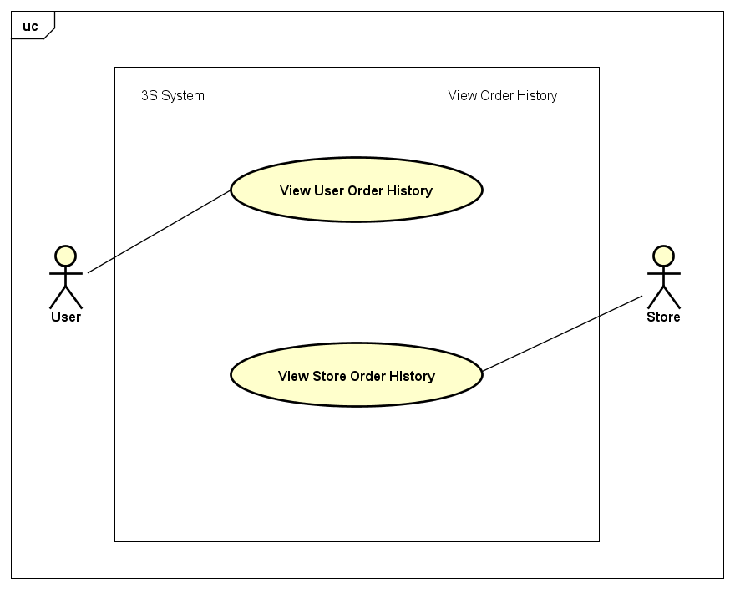

|  |  |  |  |
| --- | --- | --- | --- |
| UC ID and Name: | **UC-4: View User Order History** | | |
| Created by: | **ThangND** | Created date: | **Jun 1st, 2018** |
| Primary Actor: | **User** | Secondary Actor: |  |
| Trigger: | N/A | | |
| Description: | User wants to view order history himseft / herseft. | | |
| Preconditions: | **PRE-4.1:** The user had logged in to application system yet. | | |
| Post conditions: | N/A | | |
| Normal Flow: | 1. User opens the application. 2. Home screen is displayed. 3. User clicks on “Người dùng” tab with  icon on the right of bottom navigation bar in home screen. 4. User clicks on “Đơn hàng của tôi” layout button. 5. “Quản lý đơn hàng” screen in User role is displayed with a order list with order information and function buttons. | | |
| Alternative Flows: | N/A | | |
| Exceptions: | User order history is blank. | | |
| Priority: | High | | |
| Frequency of Use: | Medium | | |
| Other Information: | N/A | | |
| Assumptions: | Server is stable running.  Internet service is turning on. | | |

|  |  |  |  |
| --- | --- | --- | --- |
| UC ID and Name: | **UC-5: View Store Order History** | | |
| Created by: | **ThangND** | Created date: | **Jun 1st, 2018** |
| Primary Actor: | **Store** | Secondary Actor: |  |
| Trigger: | N/A | | |
| Description: | Store wants to view order history. | | |
| Preconditions: | **PRE-5.1:** The user had logged in to application system.  **PRE-5.2:** The user had had a store. | | |
| Post conditions: | **N/A** | | |
| Normal Flow: | 1. User opens the application. 2. Home screen is displayed. 3. User clicks on “Cửa hàng” tab with  icon on the center of bottom navigation bar in home screen . 4. Store clicks on “Quản lý đơn hàng” button. 5. “Quản lý đơn hàng” screen in Store role is displayed with 3 tabs equivalently 3 order statuses which are “Đợi xử lý”, “Đang xử lý” and “Đã xử lý”. | | |
| Alternative Flows: | N/A | | |
| Exceptions: | Store order history is blank. | | |
| Priority: | High | | |
| Frequency of Use: | High | | |
| Other Information: | N/A | | |
| Assumptions: | Server is stable running.  Internet service is turning on. | | |

##### Change Order Status

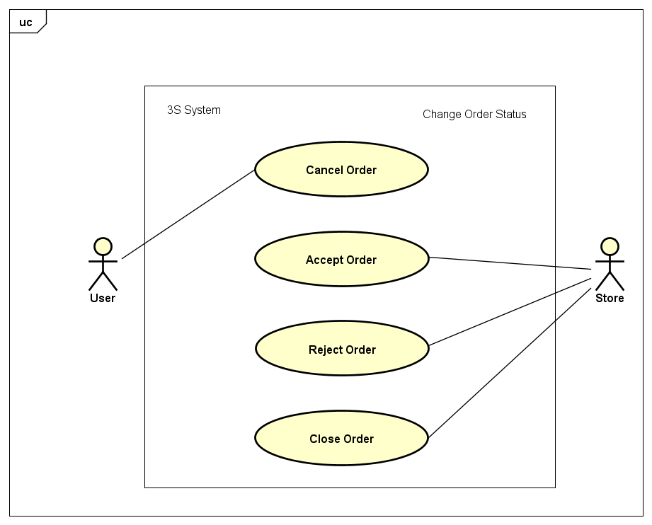

|  |  |  |  |
| --- | --- | --- | --- |
| UC ID and Name: | **UC-6: Cancel Order** | | |
| Created by: | **ThangND** | Created date: | **Jun 1st, 2018** |
| Primary Actor: | **User** | Secondary Actor: |  |
| Trigger: | User had ordered product yet. | | |
| Description: | User wants to cancel order. | | |
| Preconditions: | **PRE-6.1:** The user had logged in to application system.  **PRE-6.2:** The store had not accepted / rejected this order yet . | | |
| Post conditions: | **POST-6.1 :** The waiting order will have been destroyed. | | |
| Normal Flow: | 1. User access “Quản lý đơn hàng” screen in User role. 2. In order with waiting status, user clicks on “Hủy đơn hàng” button. 3. User clicks on “Đồng ý” button in “Hủy đơn hàng” dialog. | | |
| Alternative Flows: | N/A | | |
| Exceptions: | User order history is blank. | | |
| Priority: | High | | |
| Frequency of Use: | Medium | | |
| Other Information: | N/A | | |
| Assumptions: | Server is stable running.  Internet service is turning on. | | |

|  |  |  |  |
| --- | --- | --- | --- |
| UC ID and Name: | **UC-7: Accept Order** | | |
| Created by: | **ThangND** | Created date: | **Jun 1st, 2018** |
| Primary Actor: | **Store** | Secondary Actor: |  |
| Trigger: | N/A | | |
| Description: | Store wants to accept waitting order. | | |
| Preconditions: | **PRE-7.1:** The user had logged in to application system.  **PRE-7.2:** The user had had a store.  **PRE-7.3:** The user had not canceled this order yet. | | |
| Post conditions: | **POST-7.1 :** The order will have been accepted by store.  **POST-7.2 :** That order’s status will have been changed to processing. | | |
| Normal Flow: | 1. Store access “Quản lý đơn hàng” screen in Store role. 2. In “Đợi xử lý” tabs, store clicks on “Chấp nhận” button which in order detail. 3. Store clicks on “Đồng ý” button in “Chấp nhận đơn hàng” dialog. | | |
| Alternative Flows: | N/A | | |
| Exceptions: | N/A | | |
| Priority: | Medium | | |
| Frequency of Use: | High | | |
| Other Information: | N/A | | |
| Assumptions: | Server is stable running.  Internet service is turning on. | | |

|  |  |  |  |
| --- | --- | --- | --- |
| UC ID and Name: | **UC-8: Reject Order** | | |
| Created by: | **ThangND** | Created date: | **Jun 1st, 2018** |
| Primary Actor: | **Store** | Secondary Actor: |  |
| Trigger: | N/Á | | |
| Description: | Store wants to reject waitting order. | | |
| Preconditions: | **PRE-8.1:** The user had logged in to application system.  **PRE-8.2:** The user had had a store.  **PRE-8.3:** The user had not canceled this order yet. | | |
| Post conditions: | **POST-8.1 :** The order will have been rejected by store.  **POST-8.2 :** That order’s status will have been changed to done. | | |
| Normal Flow: | 1. Store access “Quản lý đơn hàng” screen in Store role. 2. In “Đợi xử lý” tabs, store clicks on “Từ chối” button which in order detail 3. Store clicks on “Đồng ý” button in “Từ chối đơn hàng” dialog. | | |
| Alternative Flows: | N/A | | |
| Exceptions: | N/A | | |
| Priority: | Medium | | |
| Frequency of Use: | High | | |
| Other Information: | N/A | | |
| Assumptions: | Server is stable running.  Internet service is turning on. | | |

|  |  |  |  |
| --- | --- | --- | --- |
| UC ID and Name: | **UC-9: Close Order** | | |
| Created by: | **ThangND** | Created date: | **Jun 1st, 2018** |
| Primary Actor: | **Store** | Secondary Actor: |  |
| Trigger: | N/Á | | |
| Description: | Store wants to reject order. | | |
| Preconditions: | **PRE-9.1:** The user had logged in to application system.  **PRE-9.2:** The user had had a store.  **PRE-9.2:** This order’s status must be processing. | | |
| Post conditions: | **POST-9.1 :** The order will have been closed by store.  **POST-9.2 :** That order’s status will have been changed to done. | | |
| Normal Flow: | 1. Store access “Quản lý đơn hàng” screen in Store role. 2. In “Đang xử lý” tabs, store clicks on “Đã giao hàng” button which in order detail. 3. Store clicks on “Đồng ý” button in “Đóng đơn hàng” dialog. | | |
| Alternative Flows: | N/A | | |
| Exceptions: | N/A | | |
| Priority: | Medium | | |
| Frequency of Use: | High | | |
| Other Information: | N/A | | |
| Assumptions: | Server is stable running.  Internet service is turning on. | | |

#### Manage Store

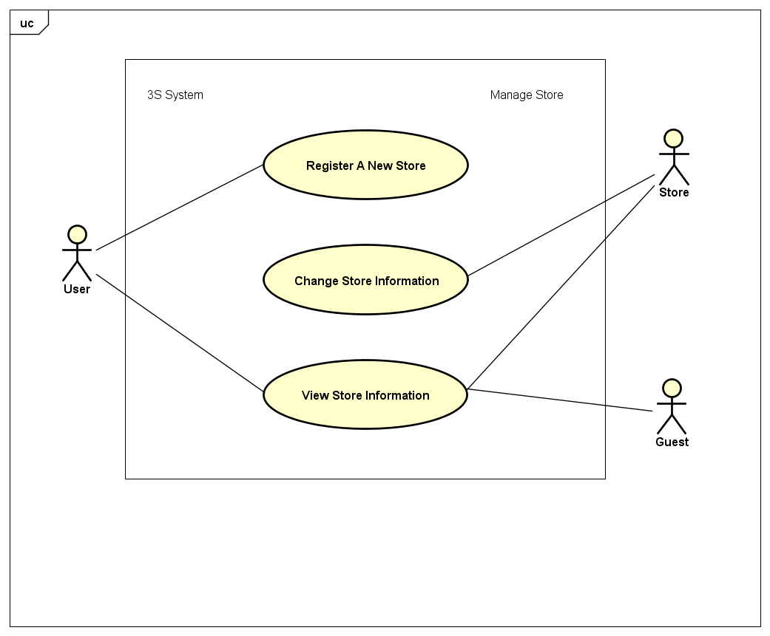

##### Register A New Store

|  |  |  |  |
| --- | --- | --- | --- |
| UC ID and Name: | **UC-10: Register A New Store** | | |
| Created by: | **ThangND** | Created date: | **Jun 2nd, 2018** |
| Primary Actor: | **User** | Secondary Actor: |  |
| Trigger: | N/A | | |
| Description: | User wants register a new store to buy products. | | |
| Preconditions: | **PRE-10.1:** The user had logged in to application system.  **PRE-10.2:** The user had not had a registered store.  **PRE-10.3:** The user has turned on his/her GPS location service in mobile device.  **PRE-10.4:** The current device has allowed application access GPS service. | | |
| Post conditions: | **POST-10.1 :** Store will have been registered under user account. | | |
| Normal Flow: | 1. User opens the application with logged in account. 2. Home screen is displayed. 3. User clicks on “Cửa hàng” tab with  icon on the center of bottom navigation bar in home screen . 4. ”Cửa hàng” screens is displayed with “Bạn chưa có cửa hàng” notification message and “Đăng kí cửa hàng” button. 5. User clicks on “Đăng kí cửa hàng” button. 6. “Đăng kí cửa hàng” screen is displayed. 7. Fill out store information form with valid information. 8. User clicks on “Đăng kí” button. 9. Redirect to home screen. | | |
| Alternative Flows: | N/A | | |
| Exceptions: | * 1. Invalid Store name.   2. Invalid Store phone. | | |
| Priority: | Medium | | |
| Frequency of Use: | Low | | |
| Other Information: | N/A | | |
| Assumptions: | Server is stable running.  Internet service is turning on. | | |

##### View Store Information

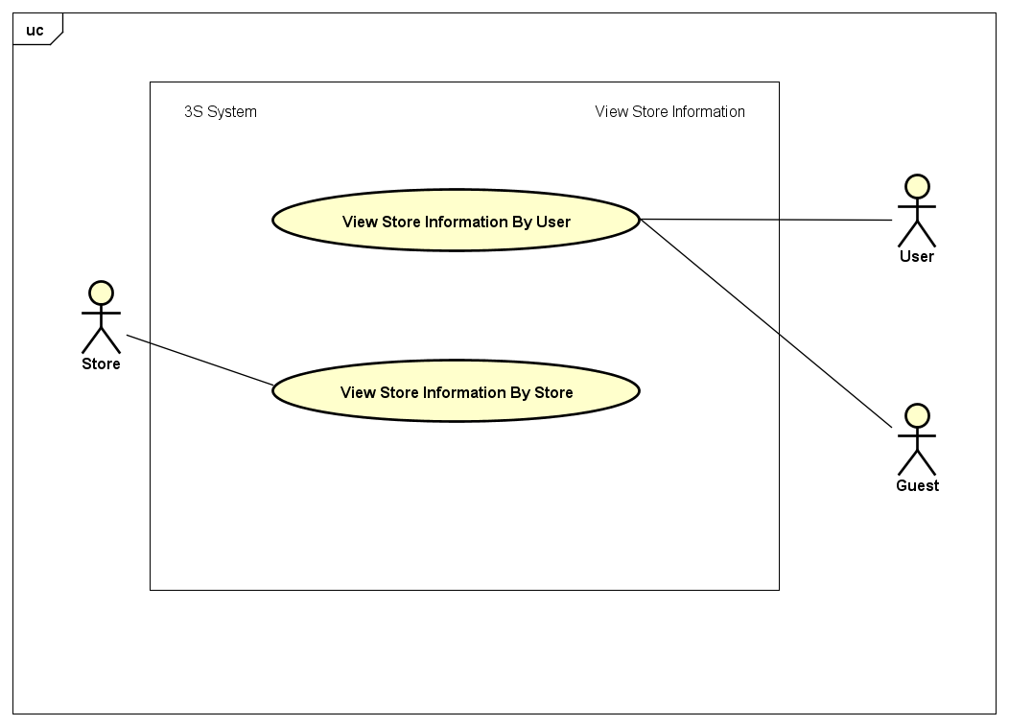

|  |  |  |  |
| --- | --- | --- | --- |
| UC ID and Name: | **UC-11: View Store Information By User** | | |
| Created by: | **ThangND** | Created date: | **Jun 2nd, 2018** |
| Primary Actor: | **User** | Secondary Actor: | **Guest** |
| Trigger: | N/A | | |
| Description: | User wants to view store information. | | |
| Preconditions: | **PRE-11.1:** The user has turned on his/her GPS location service in mobile device.  **PRE-12.2:** The current device has allowed application access GPS service.  **PRE-11.3:** The current device has allowed application access Camera service. | | |
| Post conditions: | N/A | | |
| Normal Flow: | 1. User had found nearby store by product after finishing UC-19 or UC-20. 2. User clicks on store name. 3. “Sản phẩm cửa hàng” is displayed with store name and product list in store. 4. User clicks on store name. 5. “Thông tin cửa hàng” screen is displayed with store information. | | |
| Alternative Flows: | 1. User access “Quản lý đơn hàng” screen in User role. 2. User clicks on store name in order detail layout. 3. “Sản phẩm cửa hàng” is displayed with store name and product list in store. 4. User clicks on store name. 5. “Thông tin cửa hàng” is displayed with store information. | | |
| Exceptions: | User order history is blank. | | |
| Priority: | Low | | |
| Frequency of Use: | Medium | | |
| Other Information: | N/A | | |
| Assumptions: | Server is stable running.  Internet service is turning on. | | |

|  |  |  |  |
| --- | --- | --- | --- |
| UC ID and Name: | **UC-12: View Store Information By Store** | | |
| Created by: | **ThangND** | Created date: | **Jun 2nd, 2018** |
| Primary Actor: | **User** | Secondary Actor: |  |
| Trigger: | N/A | | |
| Description: | Store wants to view store information. | | |
| Preconditions: | **PRE-12.1:** The user had logged in to application system.  **PRE-12.2:** The user had had a registered store. | | |
| Post conditions: | N/A | | |
| Normal Flow: | 1. Store opens the application with logged in account. 2. Home screen is displayed. 3. Store clicks on “Cửa hàng” tab with  icon on the center of bottom navigation bar in home screen. 4. ”Cửa hàng” screen is displayed with store information, “Quản lý đơn hàng” button and “Sản phẩm cửa hàng” button. | | |
| Alternative Flows: | N/A | | |
| Exceptions: | N/A | | |
| Priority: | Medium | | |
| Frequency of Use: | High | | |
| Other Information: | N/A | | |
| Assumptions: | Server is stable running.  Internet service is turning on. | | |

##### Change Store Information

|  |  |  |  |
| --- | --- | --- | --- |
| UC ID and Name: | **UC-13: Change Store Information** | | |
| Created by: | **ThangND** | Created date: | **Jun 2nd, 2018** |
| Primary Actor: | **Store** | Secondary Actor: |  |
| Trigger: | N/A | | |
| Description: | Store wants edit store information | | |
| Preconditions: | **PRE-13.1:** The user had logged in to application system.  **PRE-13.2:** The user had had a store.  **PRE-13.3:** The user has turned on his/her GPS location service in mobile device.  **PRE-13.4:** The user has allowed application access GPS service. | | |
| Post conditions: | **POST-13.1 :** Store information will have been changed. | | |
| Normal Flow: | 1. Store opens the application. 2. Home screen is dispalyed. 3. Store clicks on “Cửa hàng” tab with  icon on the center of bottom navigation bar in home screen. 4. ”Cửa hàng” screen is displayed with store information, “Quản lý đơn hàng” button and “Sản phẩm cửa hàng” button. 5. Store clicks on “Sửa thông tin” button with  icon. 6. “Thay đổi thông tin” screen is displayed. 7. Change needed information with valid information. 8. Store clicks on “Lưu thay đổi” button. 9. Redirect to “Cửa hàng” screen with changed information. | | |
| Alternative Flows: | N/A | | |
| Exceptions: | * 1. Invalid Store name   2. Invalid Store phone | | |
| Priority: | Medium | | |
| Frequency of Use: | Low | | |
| Other Information: | N/A | | |
| Assumptions: | Server is stable running.  Internet service is turning on. | | |

#### Manage Account

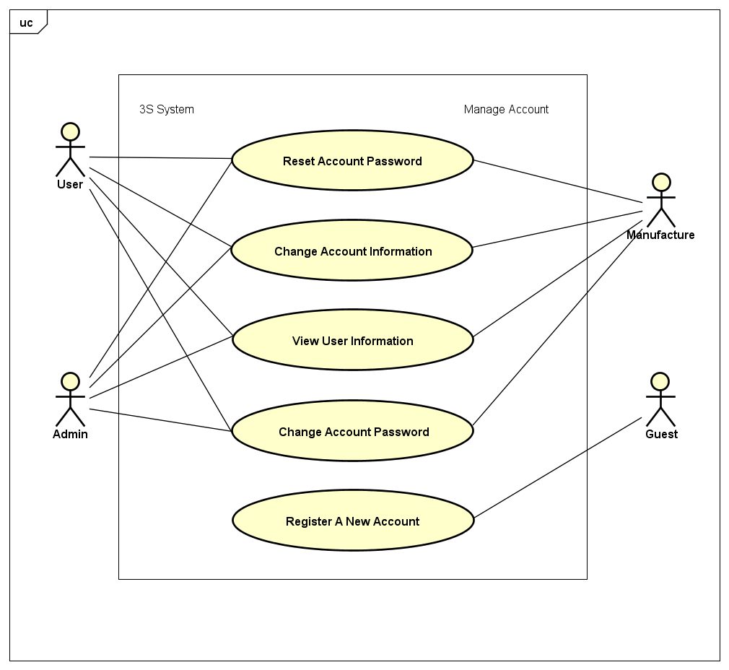

##### View user Information

|  |  |  |  |
| --- | --- | --- | --- |
| UC ID and Name: | **UC-14: View User Information** | | |
| Created by: | **ThangND** | Created date: | **Jun 2nd, 2018** |
| Primary Actor: | **User** | Secondary Actor: | **Admin - Manufacture** |
| Trigger: | N/A | | |
| Description: | User wants to view his / her account information. | | |
| Preconditions: | **PRE-14.1:** The user had logged in to application system. | | |
| Post conditions: | N/A | | |
| Normal Flow: | 1. User opens the application. 2. Home screen is displayed. 3. User clicks on “Người dùng” tab with  icon on the right of bottom navigation bar in home screen. 4. .”Người dùng” screen is displayed user information function form and “Đăng xuất” button. 5. Click on “Thông tin tài khoản” layout button. 6. “Thông tin tài khoản” is displayed with user information and “Thay đổi thông tin” button. | | |
| Alternative Flows: | N/A | | |
| Exceptions: | N/A | | |
| Priority: | Medium | | |
| Frequency of Use: | High | | |
| Other Information: | N/A | | |
| Assumptions: | Server is stable running.  Internet service is turning on. | | |

##### Change Account Information

|  |  |  |  |
| --- | --- | --- | --- |
| UC ID and Name: | **UC-15: Change Account Information** | | |
| Created by: | **ThangND** | Created date: | **Jun 2nd, 2018** |
| Primary Actor: | **User** | Secondary Actor: | **Admin - Manufacture** |
| Trigger: | N/A | | |
| Description: | User wants to edit his / her account information . | | |
| Preconditions: | **PRE-15.1:** The user had logged in to application system. | | |
| Post conditions: | **POST-15.1** **:** The user account information will have been changed. | | |
| Normal Flow: | 1. User accesses to “Thông tin tài khoản” screen. 2. “Thông tin tài khoản” is displayed with user information and “Thay đổi thông tin” button . 3. User clicks on “Thay đổi thông tin” button. 4. Thay đổi thông tin” screen is displayed. 5. User enters needed change information with valid information. 6. User clicks on “Lưu thay đổi” button. 7. Redirect “Thông tin tài khoản” screen. | | |
| Alternative Flows: | N/A | | |
| Exceptions: | 1. Invalid display name. 2. Invalid account phone. 3. Invalid email. 4. Invalid Date of Birth. | | |
| Priority: | Medium | | |
| Frequency of Use: | High | | |
| Other Information: | N/A | | |
| Assumptions: | Server is stable running.  Internet service is turning on. | | |

##### Register A New Account

|  |  |  |  |
| --- | --- | --- | --- |
| UC ID and Name: | **UC-16: Register A New Account** | | |
| Created by: | **ThangND** | Created date: | **Jun 2nd, 2018** |
| Primary Actor: | **Guest** | Secondary Actor: |  |
| Trigger: | N/A | | |
| Description: | Guest wants to create a new account with User role . | | |
| Preconditions: | N/A | | |
| Post conditions: | **POST-16.1** **:** The new account had been registered succcessfully. | | |
| Normal Flow: | 1. Guest accesses to “Đăng nhập” screen. 2. Guest clicks on “Đăng kí” borderless button on the bottom of screen. 3. “Đăng kí” screen is displayed. 4. Guest fill out register account form with valid information. 5. Guest clicks on “Đăng kí” button. | | |
| Alternative Flows: | N/A | | |
| Exceptions: | 1. Invalid Username. 2. Invalid Password. 3. Invalid Display Name. 4. Invalid Account Phone. 5. Invalid Email. 6. Re-input password is different from password. | | |
| Priority: | Medium | | |
| Frequency of Use: | High | | |
| Other Information: | N/A | | |
| Assumptions: | Server is stable running.  Internet service is turning on. | | |

##### Reset Account Password

|  |  |  |  |
| --- | --- | --- | --- |
| UC ID and Name: | **UC-17: Reset Account Password** | | |
| Created by: | **ThangND** | Created date: | **Jun 2nd, 2018** |
| Primary Actor: | **User** | Secondary Actor: | **Admin - Manufacture** |
| Trigger: | N/A | | |
| Description: | User who had forgotten password wants to reset his / her password | | |
| Preconditions: | **PRE-18.1:** The user had not logged in to application system | | |
| Post conditions: | **POST-18.1** **:** The account password have been changed | | |
| Normal Flow: | 1. User accesses to “Đăng nhập” screen 2. User clicks on “Quên mật khẩu?” button below “Mật khẩu” field 3. “Quên mật khẩu” screen is displayed 4. User enter valid account phone number to “Số điện thoại” field 5. Clicks on “Tiếp tục” button 6. User receives OTP code via registered phone number 7. User enter valid OTP code to “Mã xác thực SMS” field 8. Redirect “Đổi mật khẩu” screen. | | |
| Alternative Flows: | N/A | | |
| Exceptions: | Invalid phone number  Invalid OTP code | | |
| Priority: | Medium | | |
| Frequency of Use: | High | | |
| Other Information: | N/A | | |
| Assumptions: | Server is stable running.  Internet service is turning on. | | |

##### Change Account Password

|  |  |  |  |
| --- | --- | --- | --- |
| UC ID and Name: | **UC-18: Change Account Password** | | |
| Created by: | **ThangND** | Created date: | **Jun 2nd, 2018** |
| Primary Actor: | **User** | Secondary Actor: | **Admin - Manufacture** |
| Trigger: | N/A | | |
| Description: | User wants to change his / her account password. | | |
| Preconditions: | **PRE-18.1:** The user had logged in to application system. | | |
| Post conditions: | **POST-18.1** **:** The account password will have been changed. | | |
| Normal Flow: | 1. User opens the application. 2. Home screen is displayed. 3. User clicks on “Người dùng” tab with  icon on the right of bottom navigation bar in home screen. 4. ”Người dùng” screen is displayed user information function form and “Đăng nhập” button. 5. User clicks on “Đổi mật khẩu” layout button. 6. “Đổi mật khẩu” screen is displayed. 7. User entercurrent password to “Mật khẩu hiện tại” field, then enter new password to “Mật khẩu mới” field and “Nhập lại mật khẩu” field. 8. Redirect to “Người dùng” screen with “Thay đổi mật khẩu thành công” notification message. | | |
| Alternative Flows: | N/A | | |
| Exceptions: | 1. Incorrect current password. 2. Invalid new password. 3. Re-input password is different from new password. | | |
| Priority: | High | | |
| Frequency of Use: | Medium | | |
| Other Information: | N/A | | |
| Assumptions: | Server is stable running.  Internet service is turning on. | | |

#### Find Nearby Store By Product

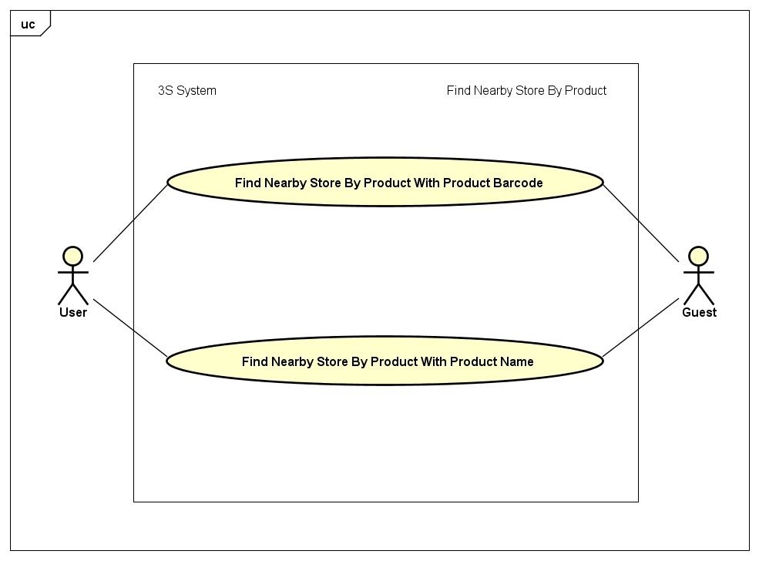

##### Find Nearby Store By Product With Product Barcode

|  |  |  |  |
| --- | --- | --- | --- |
| UC ID and Name: | **UC-19: Find Nearby Store By Product With Product Barcode** | | |
| Created by: | **ThangND** | Created date: | **Jun 2nd, 2018** |
| Primary Actor: | **User** | Secondary Actor: | **Guest** |
| Trigger: | N/A | | |
| Description: | User who wants to find nearby store which have bought needed product via product barcode. | | |
| Preconditions: | **PRE-19.1:** The user has turned on his/her GPS location service in mobile device.  **PRE-19.2:** The current device has allowed application access GPS service.  **PRE-19.3:** The current device has allowed application access Camera service. | | |
| Post conditions: | **POST-19.1:** The user will have found nearby store which have bought their needed products. | | |
| Normal Flow: | 1. User opens the application. 2. Home screen is displayed. 3. User clicks on icon  which is on the right of search bar in home screen. 4. Scan QR code/ barcode screen is displayed. 5. User scans bar code on product surface. 6. “Tìm kiếm sản phẩm” screen is displayed with product equivalently scanned barcode. 7. User clicks “Tìm cửa hàng” button in product description layout. 8. “Cửa hàng gần đây” screen is displayed with nearby store list | | |
| Alternative Flows: | 1. User opens the application. 2. Home screen is displayed. 3. User clicks on search bar in home screen. 4. “Tìm kiếm sản phẩm” screen is displayed. 5. User clicks on icon  which is on the right of search bar in “Tìm kiếm sản phẩm” screen. 6. Scan QR code/ barcode screen is displayed. 7. User scans bar code on product surface. 8. “Tìm kiếm sản phẩm” screen is displayed with product equivalently scanned barcode. 9. User clicks “Tìm cửa hàng” button in product description layout. 10. “Cửa hàng gần đây” screen is displayed with nearby store list | | |
| Exceptions: | 1. Barcode is not exist in appication database. 2. No nearby store have user’s needed product. | | |
| Priority: | High | | |
| Frequency of Use: | High | | |
| Other Information: | N/A | | |
| Assumptions: | Server is stable running.  Internet service is turning on. | | |

##### Find Nearby Store By Product With Product Name

|  |  |  |  |
| --- | --- | --- | --- |
| UC ID and Name: | **UC-20: Find Nearby Store By Product With Product Name** | | |
| Created by: | **ThangND** | Created date: | **Jun 2nd, 2018** |
| Primary Actor: | **User** | Secondary Actor: | **Guest** |
| Trigger: | N/A | | |
| Description: | User who wants to find nearby store which have bought needed product via product name. | | |
| Preconditions: | **PRE-20.1:** The user has turned on his/her GPS location service in mobile device.  **PRE-20.2:** The current device has allowed application access GPS service. | | |
| Post conditions: | **POST-20.1:** The user will have found nearby store which have bought their needed products. | | |
| Normal Flow: | 1. User opens the application. 2. Home screen is displayed. 3. User clicks on search bar in home screen. 4. “Tìm kiếm sản phẩm” screen is displayed . 5. User enters product name to search bar in “Tìm kiếm sản phẩm” screen. 6. Product list equivalently searched product name is displayed in “Tìm kiếm sản phẩm” screen. 7. User clicks “Tìm cửa hàng” button in product description layout. 8. “Cửa hàng gần đây” screen is displayed with nearby store list. | | |
| Alternative Flows: | N/A | | |
| Barcode is not exist in appication database. | 1. Product name is not exist in appication database. 2. No nearby store have user’s needed product. | | |
| Priority: | High | | |
| Frequency of Use: | High | | |
| Other Information: | N/A | | |
| Assumptions: | Server is stable running.  Internet service is turning on. | | |

#### Manage Product

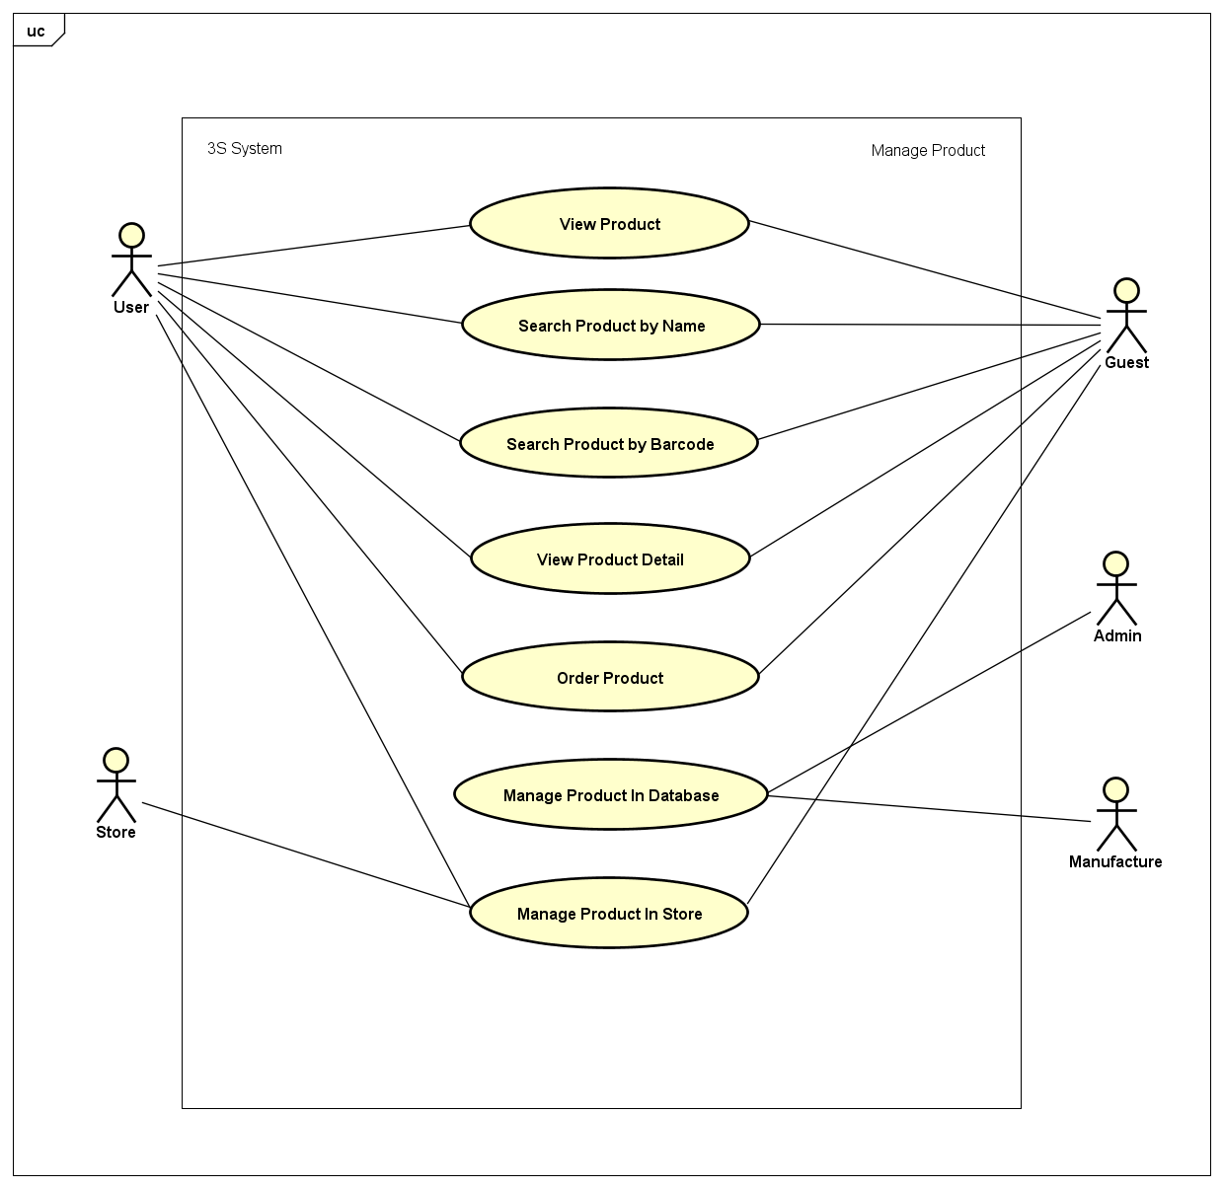

##### Search Product By Name

|  |  |  |  |
| --- | --- | --- | --- |
| UC ID and Name: | **UC-21: Search Product By Name** | | |
| Created by: | **ThangND** | Created date: | **Jun 2nd, 2018** |
| Primary Actor: | **User** | Secondary Actor: | **Guest** |
| Trigger: | N/A | | |
| Description: | User who wants to search product by product name. | | |
| Preconditions: | N/A | | |
| Post conditions: | **POST-21.1:** The user will have found needed product | | |
| Normal Flow: | 1. User opens the application. 2. Home screen is displayed. 3. User clicks on search bar in home screen. 4. “Tìm kiếm sản phẩm” screen is displayed. 5. User enters product name to search bar in “Tìm kiếm sản phẩm” screen. 6. “Tìm kiếm sản phẩm” screen is displayed with product equivalently searched product name. | | |
| Alternative Flows: | N/A | | |
| Exceptions: | Product name is not exist in appication database. | | |
| Priority: | High | | |
| Frequency of Use: | High | | |
| Other Information: | N/A | | |
| Assumptions: | Server is stable running.  Internet service is turning on. | | |

##### Search Product By Barcode

|  |  |  |  |
| --- | --- | --- | --- |
| UC ID and Name: | **UC-22: Search Product By Barcode** | | |
| Created by: | **ThangND** | Created date: | **Jun 2nd, 2018** |
| Primary Actor: | **User** | Secondary Actor: | **Guest** |
| Trigger: | N/A | | |
| Description: | User who wants to search product by product name. | | |
| Preconditions: | **PRE-22.1:** The user has allowed application access Camera service. | | |
| Post conditions: | **POST-22.1:** The user will have found needed product. | | |
| Normal Flow: | 1. User opens the application. 2. Home screen is displayed. 3. User clicks on icon  which is on the right of search bar in home screen. 4. Scan QR code/ barcode screen is displayed. 5. User scans bar code on product surface. 6. “Tìm kiếm sản phẩm” screen is displayed with product equivalently scanned barcode. | | |
| Alternative Flows: | 1. User opens the application. 2. Home screen is displayed. 3. User clicks on icon search bar in home screen. 4. “Tìm kiếm sản phẩm” screen is displayed. 5. User clicks on icon  which is on the right of search bar in “Tìm kiếm sản phẩm” screen. 6. Scan QR code/ barcode screen is displayed. 7. User scans bar code on product surface. 8. “Tìm kiếm sản phẩm” screen is displayed with product equivalently scanned barcode. | | |
| Exceptions: | Barcode is not exist in appication database. | | |
| Priority: | High | | |
| Frequency of Use: | High | | |
| Other Information: | N/A | | |
| Assumptions: | Server is stable running.  Internet service is turning on. | | |

##### View Product Detail

|  |  |  |  |
| --- | --- | --- | --- |
| UC ID and Name: | **UC-23: View Product Detail** | | |
| Created by: | **ThangND** | Created date: | **Jun 2nd, 2018** |
| Primary Actor: | **User - Guest** | Secondary Actor: | **Store** |
| Trigger: | N/A | | |
| Description: | User or Guest or Store who wants to view product detail | | |
| Preconditions: |  | | |
| Post conditions: | **POST-23.1:** The user will have found needed product | | |
| Normal Flow: | 1. User accesses to “Sản phẩm giảm giá” screen or “Sản phẩm danh mục” screen or “Sản phẩm thương hiệu” screen or “Sản phẩm” screen 2. Product list is displayed in each screen. 3. User clicks on product name 4. “Thông tin sản phẩm” screen is displayed with product detail information | | |
| Alternative Flows: | 1. User accesses to “Sản phẩm giảm giá” screen or “Sản phẩm danh mục” screen or “Sản phẩm thương hiệu” screen or “Sản phẩm” screen 2. Product list is displayed in each screen. 3. User clicks on product name   “Thông tin sản phẩm” screen is displayed with product detail information | | |
| Exceptions: | N/A | | |
| Priority: | High | | |
| Frequency of Use: | High | | |
| Other Information: | N/A | | |
| Assumptions: | Server is stable running.  Internet service is turning on. | | |

##### View Product

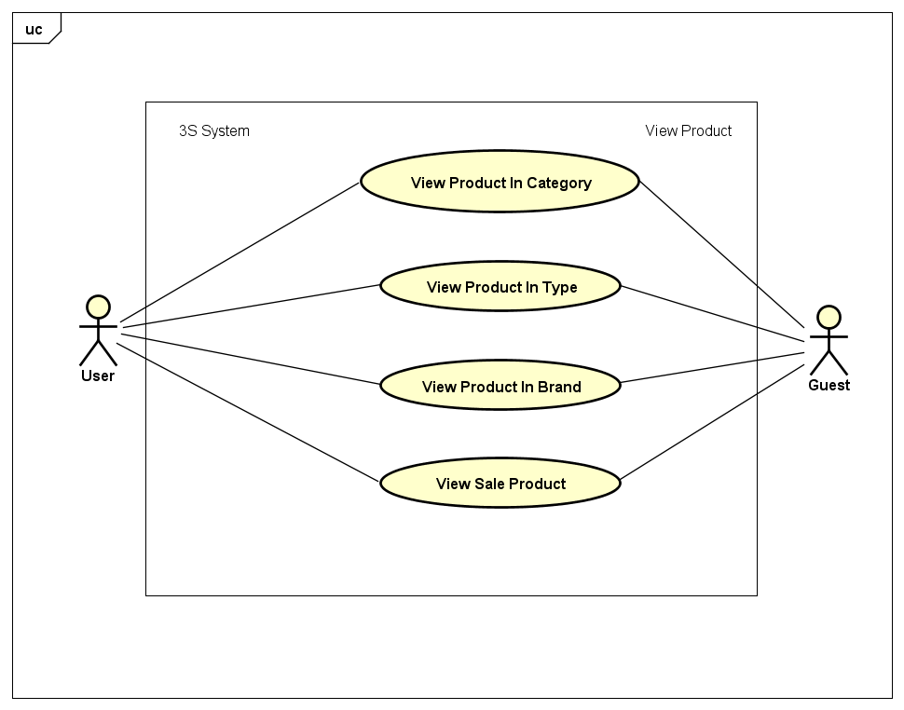

###### View Product In Category

|  |  |  |  |
| --- | --- | --- | --- |
| UC ID and Name: | **UC-24: View Product In Category** | | |
| Created by: | **ThangND** | Created date: | **Jun 2nd, 2018** |
| Primary Actor: | **User** | Secondary Actor: | **Guest** |
| Trigger: | N/A | | |
| Description: | User who wants to view products in any category. | | |
| Preconditions: | N/A | | |
| Post conditions: | **POST-24.1:** The user will have seen product list of category. | | |
| Normal Flow: | 1. User opens to application. 2. Home screen is displayed. 3. User clicks on “Xem thêm” borderless button in “Danh mục sản phẩm” layout. 4. “Danh mục sản phẩm” screen is displayed. 5. User clicks on any category in category list. 6. “Chủng loại danh mục” screen is displayed with type category list. 7. User clicks on “Tất cả sản phẩm” button which below type category list. 8. “Sản phẩm danh mục” screen is displayed with product listview. | | |
| Alternative Flows: | 1. User opens to application. 2. Home screen is displayed. 3. User clicks on any category in “Danh mục sản phẩm” layout. 4. “Chủng loại danh mục” screen is displayed with type category list. 5. User clicks on “Tất cả sản phẩm” button which below type category list. 6. “Sản phẩm danh mục” screen is displayed with product listview. | | |
| Exceptions: | N/A | | |
| Priority: | High | | |
| Frequency of Use: | High | | |
| Other Information: | N/A | | |
| Assumptions: | Server is stable running.  Internet service is turning on. | | |

###### View Product In Type

|  |  |  |  |
| --- | --- | --- | --- |
| UC ID and Name: | **UC-25: View Product In Type** | | |
| Created by: | **ThangND** | Created date: | **Jun 2nd, 2018** |
| Primary Actor: | **User** | Secondary Actor: | **Guest** |
| Trigger: | N/A | | |
| Description: | User who wants to view products in any type category. | | |
| Preconditions: | N/A | | |
| Post conditions: | **POST-25.1:** The user will have seen product list of type category. | | |
| Normal Flow: | 1. User opens to application. 2. Home screen is displayed. 3. User clicks on “Xem thêm” borderless button in “Danh mục sản phẩm” layout. 4. “Danh mục sản phẩm” screen is displayed. 5. User clicks on any category in category list. 6. “Chủng loại danh mục” screen is displayed with type category list. 7. User clicks on any type category in type category list. 8. “Sản phẩm chủng loại” screen is displayed with product listview in that type category. | | |
| Alternative Flows: | 1. User accesses to application 2. Home screen is displayed 3. User clicks on any category in “Danh mục sản phẩm” layout. 4. “Chủng loại danh mục” screen is displayed with type category list. 5. User clicks on one type category in type category list. 6. “Sản phẩm chủng loại” screen is displayed with product listview in that type category. | | |
| Exceptions: | N/A | | |
| Priority: | High | | |
| Frequency of Use: | High | | |
| Other Information: | N/A | | |
| Assumptions: | Server is stable running.  Internet service is turning on. | | |

###### View Product In Brand

|  |  |  |  |
| --- | --- | --- | --- |
| UC ID and Name: | **UC-26: View Product In Brand** | | |
| Created by: | **ThangND** | Created date: | **Jun 2nd, 2018** |
| Primary Actor: | **User** | Secondary Actor: | **Guest** |
| Trigger: | N/A | | |
| Description: | User who wants to view products in any brand. | | |
| Preconditions: | N/A | | |
| Post conditions: | **POST-26.1:** The user will have seen product list of brand. | | |
| Normal Flow: | 1. User opens to application. 2. Home screen is displayed. 3. User clicks on any brand in “Thương hiệu” layout. 4. “Sản phẩm thương hiệu” screen is displayed with product list in that brand. | | |
| Alternative Flows: | 1. User opens to application. 2. Home screen is displayed. 3. User clicks on “Xem thêm” borderless button in “Thương hiệu” layout. 4. “Thương hiệu” screen is displayed with brand list. 5. User clicks on any brand in brnad list. 6. “Sản phẩm thương hiệu” screen is displayed with product list in that brand. | | |
| Exceptions: | N/A | | |
| Priority: | High | | |
| Frequency of Use: | High | | |
| Other Information: | N/A | | |
| Assumptions: | Server is stable running.  Internet service is turning on. | | |

###### View Product In Sale

|  |  |  |  |
| --- | --- | --- | --- |
| UC ID and Name: | **UC-27: View Product On Sale** | | |
| Created by: | **ThangND** | Created date: | **Jun 2nd, 2018** |
| Primary Actor: | **User** | Secondary Actor: | **Guest** |
| Trigger: | N/A | | |
| Description: | User who wants to view sale product list. | | |
| Preconditions: | N/A | | |
| Post conditions: | **POST-27.1:** The user will have seen sale product list. | | |
| Normal Flow: | 1. User opens to application. 2. Home screen is displayed. 3. User clicks on “Xem thêm” borderless button in “Sản phẩm giảm giá” layout. 4. “Sản phẩm giảm giá” screen is displayed with sale product list. | | |
| Alternative Flows: | N/A | | |
| Exceptions: | N/A | | |
| Priority: | High | | |
| Frequency of Use: | High | | |
| Other Information: | N/A | | |
| Assumptions: | Server is stable running.  Internet service is turning on. | | |

##### Manage Product In Store

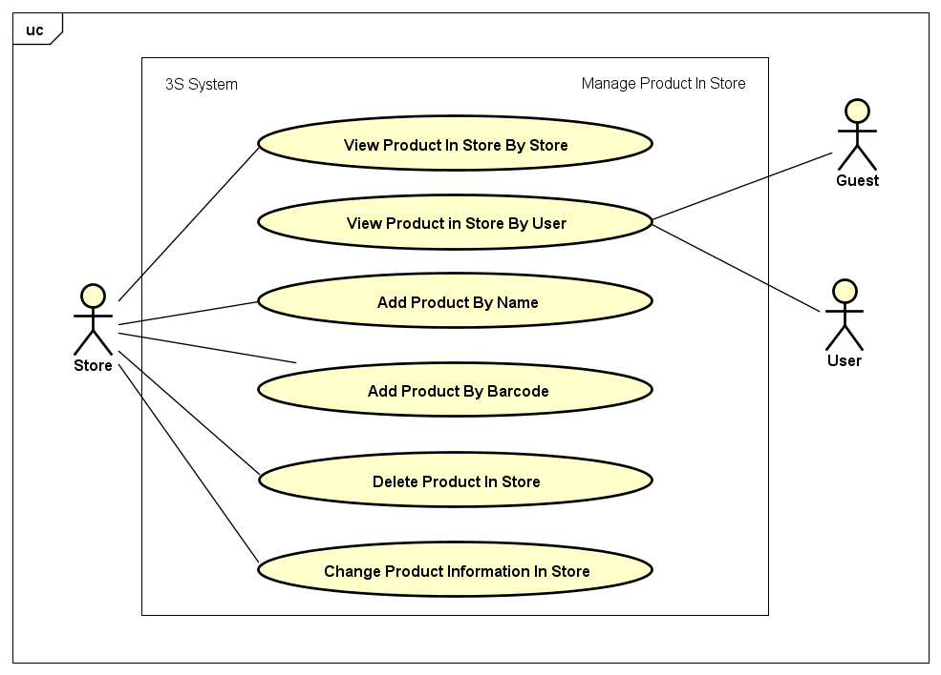

###### View Product In Store By Store

|  |  |  |  |
| --- | --- | --- | --- |
| UC ID and Name: | **UC-28: View Product In Store By Store** | | |
| Created by: | **ThangND** | Created date: | **Jun 2nd, 2018** |
| Primary Actor: | **Store** | Secondary Actor: |  |
| Trigger: | N/A | | |
| Description: | Store wants to view products in store. | | |
| Preconditions: | **PRE-28.1:** The user had logged in to application system  **PRE-28.2:** The user had had a store. | | |
| Post conditions: | **POST-28.1:** The store will have seen products in store. | | |
| Normal Flow: | 1. Store opens to application 2. Home screen is displayed. 3. Store clicks on “Cửa hàng” tab with  icon on the center of bottom navigation bar in home screen. 4. ”Cửa hàng” screen is displayed. 5. Store clicks on “Quản lý sản phẩm” button. 6. “Sản phẩm cửa hàng” screen is displayed with added-to-store product list and “Thêm sản phẩm” button. | | |
| Alternative Flows: | N/A | | |
| Exceptions: | N/A | | |
| Priority: | High | | |
| Frequency of Use: | High | | |
| Other Information: | N/A | | |
| Assumptions: | Server is stable running.  Internet service is turning on. | | |

###### View Product In Store By User

|  |  |  |  |
| --- | --- | --- | --- |
| UC ID and Name: | **UC-29: View Product In Store By User** | | |
| Created by: | **ThangND** | Created date: | **Jun 2nd, 2018** |
| Primary Actor: | **User** | Secondary Actor: | **Guest** |
| Trigger: | N/A | | |
| Description: | User wants to view products in store. | | |
| Preconditions: | **PRE-29.1:** The user had logged in to application system.  **PRE-29.2:** The user had had a store.  **PRE-29.1:** The user has turned on his/her GPS location service in mobile device.  **PRE-29.2:** The current device has allowed application access GPS service.  **PRE-29.3:** The current device has allowed application access Camera service. | | |
| Post conditions: | **POST-29.1:** The user will have seen products in store. | | |
| Normal Flow: | 1. User opens the application. 2. Home screen is displayed. 3. User clicks on any sale product in “Sản phẩm giảm giá” layout. 4. “Thông tin sản phẩm” screen is displayed. 5. User clicks on store name. 6. “Sản phẩm cửa hàng” screen in User role is displayed. | | |
| Alternative Flows: | 1. User had found nearby store by product after finishing UC-19 or UC-20. 2. User clicks on store name. 3. “Sản phẩm cửa hàng” screen in User role is displayed. | | |
| Exceptions: | N/A | | |
| Priority: | High | | |
| Frequency of Use: | High | | |
| Other Information: | N/A | | |
| Assumptions: | Server is stable running.  Internet service is turning on. | | |

###### Add product By Name

|  |  |  |  |
| --- | --- | --- | --- |
| UC ID and Name: | **UC-30: Add Product By Name** | | |
| Created by: | **ThangND** | Created date: | **Jun 2nd, 2018** |
| Primary Actor: | **Store** | Secondary Actor: |  |
| Trigger: | N/A | | |
| Description: | Store wants to add new product to store category via product name. | | |
| Preconditions: | **PRE-30.1:** The user had logged in to application system.  **PRE-30.2:** The user had had a store. | | |
| Post conditions: | **POST-30.1:** Product will have added to product list in store. | | |
| Normal Flow: | 1. Store opens to application 2. Home screen is displayed. 3. Store clicks on “Cửa hàng” tab with  icon on the center of bottom navigation bar in home screen 4. ”Cửa hàng” screen is displayed. 5. Store clicks on “Quản lý sản phẩm” button. 6. “Sản phẩm cửa hàng” in Store role screen is displayed . 7. Store clicks on “Thêm sản phẩm” button. 8. “Tìm kiếm sản phẩm” screen is displayed. 9. Store clicks on Search button with search icon, enters product name to search bar, then submit. 10. Searched product list which Store had not had yet is displayed. 11. Store clicks on “Thêm vào cửa hàng” button in product description layout. 12. “Đặt giá sản phẩm” dialog is displayed in “Tìm kiếm sản phẩm” screen. 13. Store enters product price to “Giá sản phẩm” field and enters product promotion percent to “Chiết khấu” field. 14. Store clicks on “Thêm tùy chọn”. 15. Confirm dialog is displayed. 16. Store clicks on “Thêm” button to finish adding process. 17. “Thêm sản phẩm thành công” snack bar is displayed in “Tìm kiếm sản phẩm” screen. | | |
| Alternative Flows: | N/A | | |
| Exceptions: | * 1. Product name is not exist in appication database.   2. Invalid product price.   3. Invalid product promotion. | | |
| Priority: | High | | |
| Frequency of Use: | High | | |
| Other Information: | N/A | | |
| Assumptions: | Server is stable running.  Internet service is turning on. | | |

###### Add Product By Barcode

|  |  |  |  |
| --- | --- | --- | --- |
| UC ID and Name: | **UC-31: Add Product By Barcode** | | |
| Created by: | **ThangND** | Created date: | **Jun 2nd, 2018** |
| Primary Actor: | **Store** | Secondary Actor: |  |
| Trigger: | N/A | | |
| Description: | Store wants to add new product to store category via product barcode. | | |
| Preconditions: | **PRE-31.1:** The user had logged in to application system.  **PRE-31.2:** The user had had a store.  **PRE-31.3:** The current device has allowed application access Camera service. | | |
| Post conditions: | **POST-31.1:** Product will have added to product list in store. | | |
| Normal Flow: | 1. Store opens to application. 2. Home screen is displayed. 3. Store clicks on “Cửa hàng” tab with  icon on the center of bottom navigation bar in home screen. 4. ”Cửa hàng” screen is displayed. 5. Store clicks on “Quản lý sản phẩm” button. 6. “Sản phẩm cửa hàng” screen is displayed . 7. Store clicks on “Thêm sản phẩm” button. 8. “Tìm kiếm sản phẩm” screen is displayed. 9. Store clicks on Scan QRCode/ Barcode button with barcode_icon icon. 10. Scan QR code/ barcode screen is displayed. 11. Store scans bar code on product surface. 12. “Tìm kiếm sản phẩm” screen is displayed with search product list which Store had not had yet. 13. Store clicks on “Thêm vào cửa hàng” button in product description layout. 14. “Đặt giá sản phẩm” dialog is displayed in “Tìm kiếm sản phẩm” screen. 15. Store enters product price to “Giá sản phẩm” field and enters product promotion percent to “Chiết khấu” field 16. Store clicks on “Thêm tùy chọn”. 17. Confirm dialog is displayed. 18. Store clicks on “Thêm” button to finish adding process. 19. “Thêm sản phẩm thành công” snack bar is displayed in “Tìm kiếm sản phẩm” screen. | | |
| Alternative Flows: | N/A | | |
| Exceptions: | * 1. Barcode is not exist in appication database.   2. Invalid product price.   3. Invalid product promotion. | | |
| Priority: | High | | |
| Frequency of Use: | Medium | | |
| Other Information: | N/A | | |
| Assumptions: | Server is stable running.  Internet service is turning on. | | |

###### Delete Product In Store

|  |  |  |  |
| --- | --- | --- | --- |
| UC ID and Name: | **UC-32: Delete Product In Store** | | |
| Created by: | **ThangND** | Created date: | **Jun 2nd, 2018** |
| Primary Actor: | **Store** | Secondary Actor: |  |
| Trigger: | N/A | | |
| Description: | Store wants to delete exist products from product list in store. | | |
| Preconditions: | **PRE-32.1:** The user had logged in to application system  **PRE-32.2:** The user had had a store. | | |
| Post conditions: | **POST-32.1:** Product will have deleted from product list in store. | | |
| Normal Flow: | 1. Store opens to application. 2. Home screen is displayed. 3. Store clicks on “Cửa hàng” tab with  icon on the center of bottom navigation bar in home screen. 4. ”Cửa hàng” screen is displayed. 5. Store clicks on “Quản lý sản phẩm” button. 6. “Sản phẩm cửa hàng” screen is displayed . 7. Store clicks on “Delete” button with deleteicon. 8. Confirm dialog is displayed in “Sản phẩm cửa hàng” screen. 9. Store clicks on “Đồng ý” button. 10. “Xóa sản phẩm thành công” toast message is displayed in “Sản phẩm cửa hàng” screen. | | |
| Alternative Flows: | N/A | | |
| Exceptions: | N/A | | |
| Priority: | Medium | | |
| Frequency of Use: | Low | | |
| Other Information: | N/A | | |
| Assumptions: | Server is stable running.  Internet service is turning on. | | |

###### Change product Information In Store

|  |  |  |  |
| --- | --- | --- | --- |
| UC ID and Name: | **UC-33: Change Product Information In Store** | | |
| Created by: | **ThangND** | Created date: | **Jun 2nd, 2018** |
| Primary Actor: | **Store** | Secondary Actor: |  |
| Trigger: | N/A | | |
| Description: | Store wants to edit product information . | | |
| Preconditions: | **PRE-33.1:** The user had logged in to application system.  **PRE-33.2:** The user had had a store. | | |
| Post conditions: | **POST-33.1:** That product information will have been changed. | | |
| Normal Flow: | 1. Store opens to application. 2. Home screen is displayed. 3. Store clicks on “Cửa hàng” tab with  icon on the center of bottom navigation bar in home screen. 4. ”Cửa hàng” screen is displayed. 5. Store clicks on “Quản lý sản phẩm” button. 6. “Sản phẩm cửa hàng” screen is displayed . 7. Store clicks on “Edit” button with editicon. 8. “Thay đổi thông tin sản phẩm” screen is displayed. 9. Store enters new product price to “Giá sản phẩm (đ)” field and new product promotion to “chiết khấu (%)” field. 10. Store clicks on “Lưu thay đổi” button. 11. “Thay đổi thông tin sản phẩm thành công” toast message is displayed in “thay đổi thông tin sản phẩm” screen. 12. Redirect to “Sản phẩm cửa hàng” screen . | | |
| Alternative Flows: | N/A | | |
| Exceptions: | 1. Invalid new product price.  2. Invalid new product promation.  3. Product information is not changed. | | |
| Priority: | Medium | | |
| Frequency of Use: | Medium | | |
| Other Information: | N/A | | |
| Assumptions: | Server is stable running.  Internet service is turning on. | | |

##### Order Product

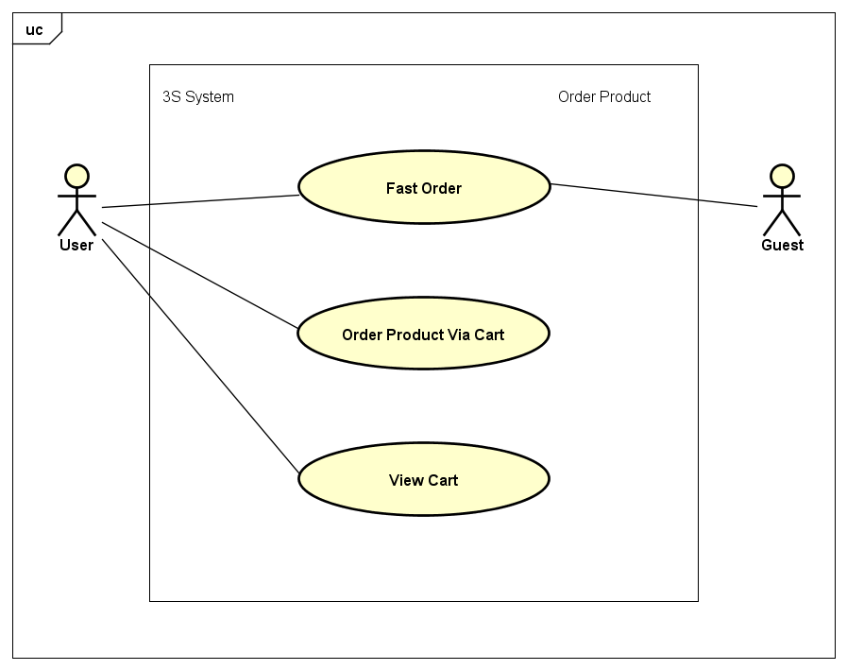

###### Fast Order

|  |  |  |  |
| --- | --- | --- | --- |
| UC ID and Name: | **UC-34: Fast Order** | | |
| Created by: | **ThangND** | Created date: | **Jun 2nd, 2018** |
| Primary Actor: | **User** | Secondary Actor: | **Guest** |
| Trigger: | N/A | | |
| Description: | User wants to order a product via neaby store function. | | |
| Preconditions: | **PRE-34.1:** The user has turned on his/her GPS location service in mobile device.  **PRE-34.2:** The current device has allowed application access GPS service.  **PRE-34.3:** The current device has allowed application access Camera service. | | |
| Post conditions: | **POST-34.1:** That order will have requested to Store. | | |
| Normal Flow: | 1. User had found nearby store by product in UC-19 or UC-20. 2. User clicks on “Đặt hàng” button in store detail layout. 3. “Đặt hàng nhanh” screen is displayed. 4. User chooses number of products. 5. Guest enters name and phone number, but User does not. 6. User chooses delivery time and delivary address. 7. User clicks on “Đặt hàng” button. | | |
| Alternative Flows: | N/A | | |
| Exceptions: | * + - 1. Invalid delivery time.  1. Invalid phone number | | |
| Priority: | Medium | | |
| Frequency of Use: | Medium | | |
| Other Information: | N/A | | |
| Assumptions: | Server is stable running.  Internet service is turning on. | | |

###### Order Product Via Cart

|  |  |  |  |
| --- | --- | --- | --- |
| UC ID and Name: | **UC-35: Order Product Via Cart** | | |
| Created by: | **ThangND** | Created date: | **Jun 2nd, 2018** |
| Primary Actor: | **User** | Secondary Actor: |  |
| Trigger: | N/A | | |
| Description: | User wants to order a product via shopping cart. | | |
| Preconditions: | **PRE-35.1:** The user had logged in to application system.  **PRE-35.2:** The user has turned on his/her GPS location service in mobile device.  **PRE-35.3:** The current device has allowed application access GPS service.  **PRE-35.4:** The current device has allowed application access Camera service.  **PRE-35.5:** The cart must have at least 1 product. | | |
| Post conditions: | **POST-35.1:** That order will have requested to Store. | | |
| Normal Flow: | 1. User had accessed “Giỏ hàng” screen after finishing UC-36. 2. User clicks on “Mua hàng” button. 3. “Đặt hàng” screen is displayed. 4. User chooses delivery time and delivary address for all order from cart. 5. User clicks on “Đặt hàng” button. | | |
| Alternative Flows: | 1. User had accessed “Giỏ hàng” screen after finishing UC-36. 2. User chooses store to checkout order in that store. 3. “Đặt hàng” screen is displayed. 4. User chooses delivery time and delivary address for chosen order. 5. User clicks on “Đặt hàng” button. | | |
| Exceptions: | Invalid delivery time. | | |
| Priority: | Medium | | |
| Frequency of Use: | Medium | | |
| Other Information: | N/A | | |
| Assumptions: | Server is stable running.  Internet service is turning on. | | |

###### View Cart

|  |  |  |  |
| --- | --- | --- | --- |
| UC ID and Name: | **UC-36: View Cart** | | |
| Created by: | **ThangND** | Created date: | **Jun 2nd, 2018** |
| Primary Actor: | **User** | Secondary Actor: |  |
| Trigger: | N/A | | |
| Description: | User wants to view his / her shopping cart. | | |
| Preconditions: | **PRE-36.1:** The user had logged in to application system.  **PRE-36.2:** The cart must have at least 1 product. | | |
| Post conditions: | N/A | | |
| Normal Flow: | 1. User opens the application. 2. Home screen is displayed. 3. User clicks on “Người dùng” tab with  icon on the right of bottom navigation bar in home screen. 4. ”Người dùng” screen is displayed user information function form and “Đăng nhập” button. 5. User clicks on “Giỏ hàng” layout button. 6. “Giỏ hàng” screen is displayed. | | |
| Alternative Flows: | 1. User had accessed “Giỏ hàng” screen after finishing UC-36. 2. User chooses store to checkout order in that store. 3. “Đặt hàng” screen is displayed. 4. User chooses delivery time and delivary address for chosen order. 5. User clicks on “Đặt hàng” button. | | |
| Exceptions: | Invalid delivery time. | | |
| Priority: | Medium | | |
| Frequency of Use: | Medium | | |
| Other Information: | N/A | | |
| Assumptions: | Server is stable running.  Internet service is turning on. | | |

### Software System Attributes

#### Reliability

* Some operate under predefined conditions:
  + No Internet: Some information is still show, display screen no internet.
  + The network is disconnected while in use: Notify the user of the disconnection issue.
  + The permission to user GPS service rejected by the user: Some functions can’t be used.

#### Availability

* The application should be available anytime users want to use it.
* Usage frequency: Daily.
* User try logging in 1 account to 2 devides simultaneously, application system will notify and eject the account of device
* Time needed to update the software: Depends on the update and will be notified in detail.

#### Security

* Server has ability to detect DDoS attacks.
* User account password is encrypted by MD5 library when interacting between client and server.
* User access is controlled by account and password system.

#### Maintainability

* It is easy to maintain or change the system due to the fact that it is divided into small parts with the person responsible for each part.
* Server should be developed based on Object Oriented Programming paradigm in order to increase maintainability and extensibility.
* Android application uses MVC model, modular software and component-based development.

#### Portability

* The Android platform offers high portability and flexibility for the application.
* Use Firebase storage provides the convenience of storing photos or files.

#### Performance

* Application front-end uses clever techniques of Glider which is a Google library for Android to minimize the number of costly DOM operations required to update user interface
* Load time of single screen is not more than 3 seconds in standard network environment.

#### Privacy

* Application request access permission before using service in user’s current device
* Users can disallow the access permission in current device

### Software Entity Relationship Diagram or Data Structures

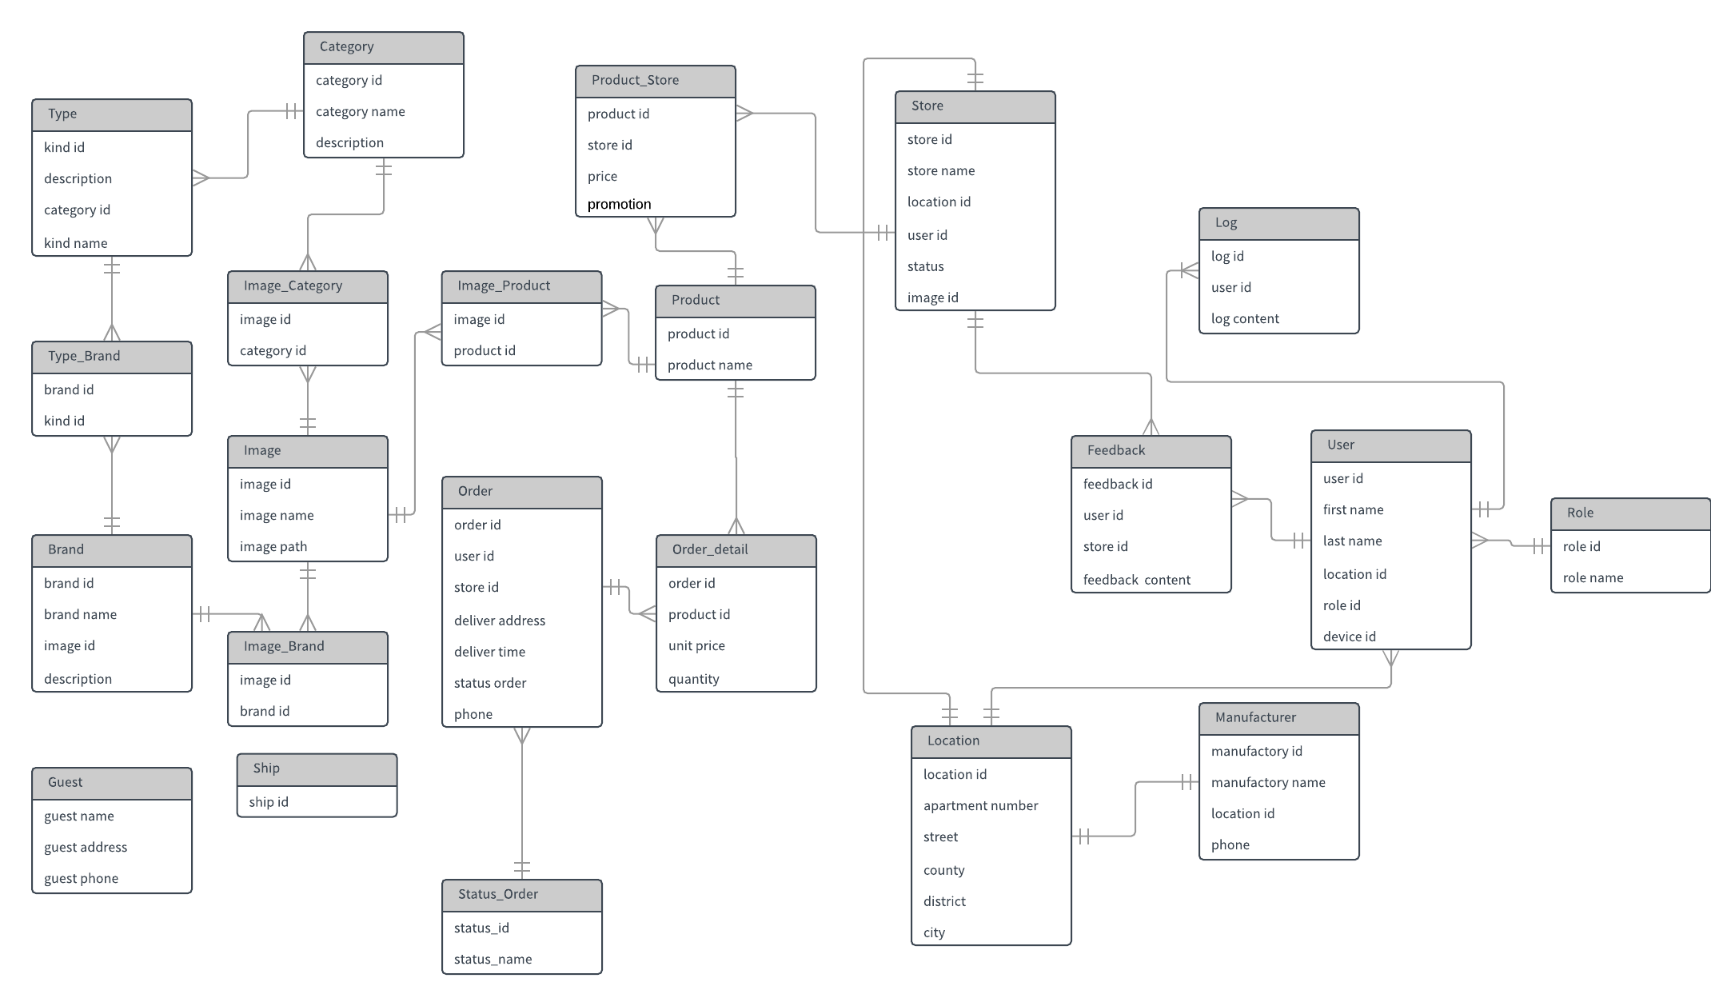

# Software Design Description (SDD)

## Purpose

* This chapter is to give the develop team of what the system’s architecture is, and how it should be implemented. Software Design Specification consists of:
  + Design overview
  + System Architecture Design
  + Component diagram
  + Sequence Diagram
  + Class Diagram
  + User Interface Design
  + Database Design

## Design Overview

## System Architecture Design

### Choice of System Architecture

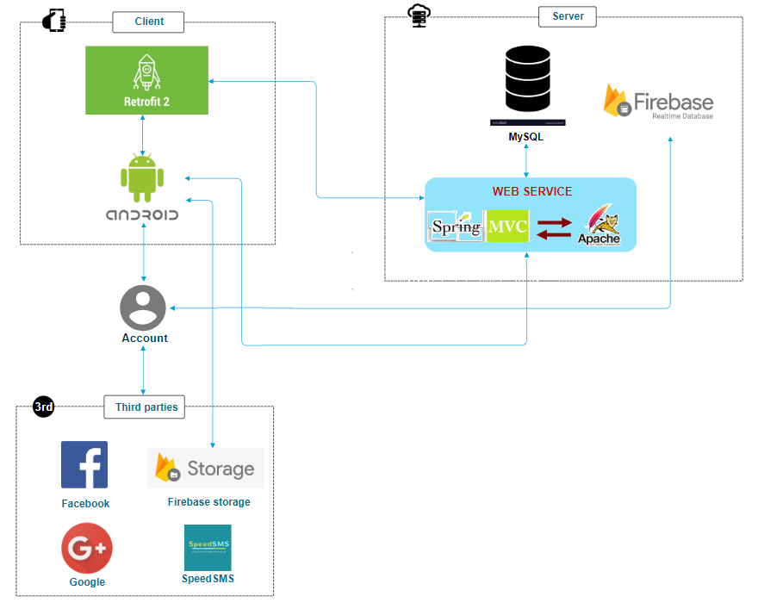

* + Retrofit 2 : Automatically convert JSON to Java objects.
  + MySQL: easy to use.
  + Spring MVC: Spring MVC provides a very clean division between controllers, JavaBean models, and views.
  + Firebase: Firebase NoSQL cloud provides a database for real-time applications as a service. This service provides an API for developers, lets you synchronize data and store it in the Firebase cloud.
  + Android platform:
    1. Open Source: The Android platform for app development is open source which means it is royalty-free and isn’t restricted to just the Android Market. This gives a lot of liberty and freedom to innovate and be creative. The SDK architecture is a major advantage that permits you to communicate with the community on future expansions of mobile app development. You can install Android apps from any source that increases the possibilities of the platform.
    2. Pro-active Testing: The integration of the platform is easy and the SDK lets you install & run your app on the device each time you compile.
    3. Popular Platform: 84.7% of mobile devices are based on the Android platform creating a lot of scope for app development’s bright future.
  + Speed SMS: interacts with Retrofit Client.

## Component diagram

### Component diagram of front-end

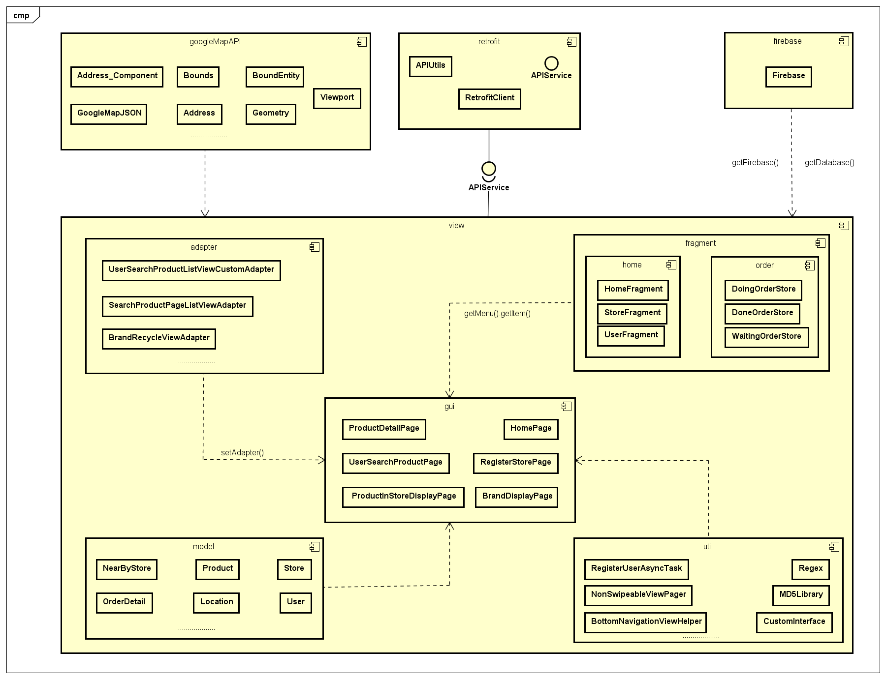

### Component diagram of back-end

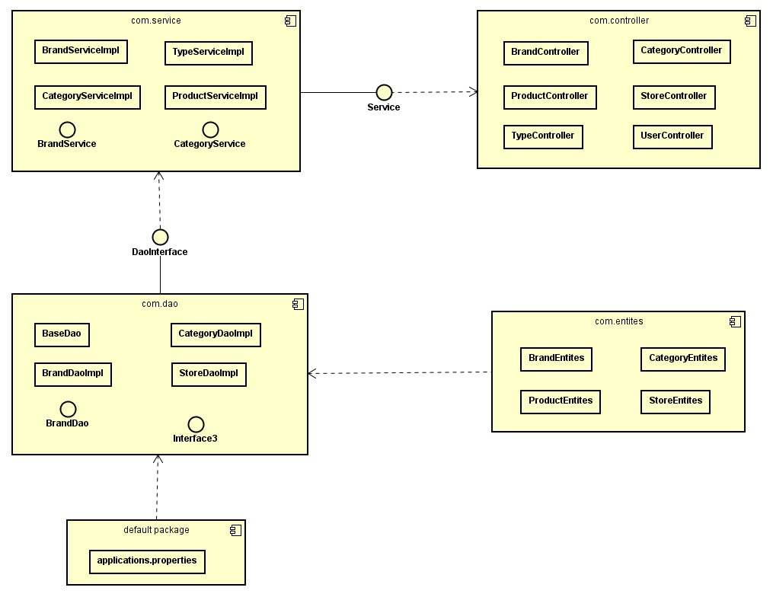

## Detailed Description of Components

### CRC Cards (Class-Responsibility Collaborators)

### Class Diagram

#### Class Diagram

##### Login

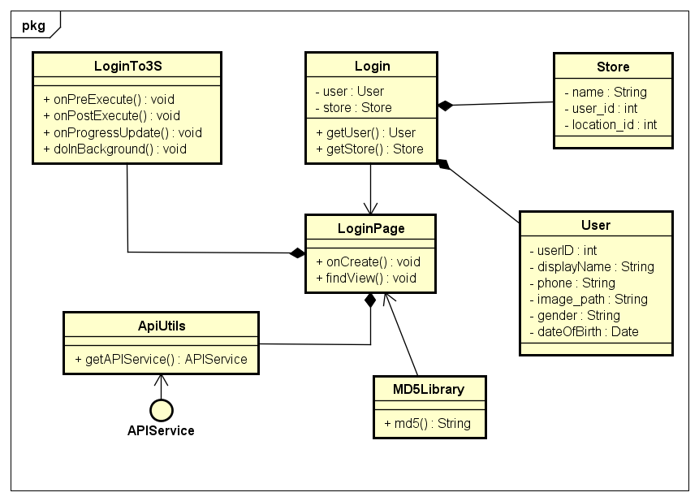

* + User : object contains user information when user logged in.
  + Store: object contains store information when user logged in.
  + Login: object contains user information and store information when user logged in.
  + MD5Library: class includes function which support password encryption.
  + LoginTo3S: asynctask supports call ApiUtils to execute logging in.
  + ApiUtils: creates Retrofit Client.
  + APIService: interacts with Retrofit Client.

##### Manage Account

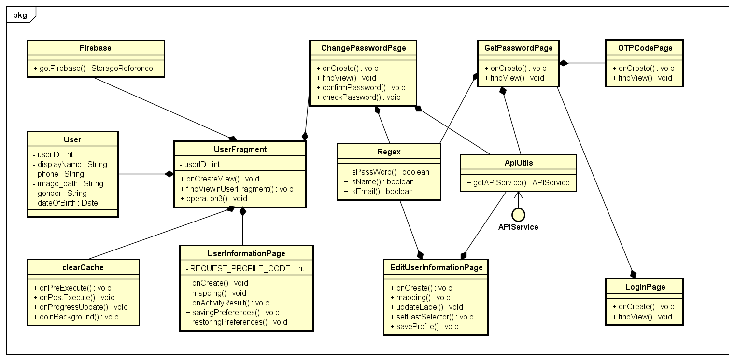

##### Manage Store

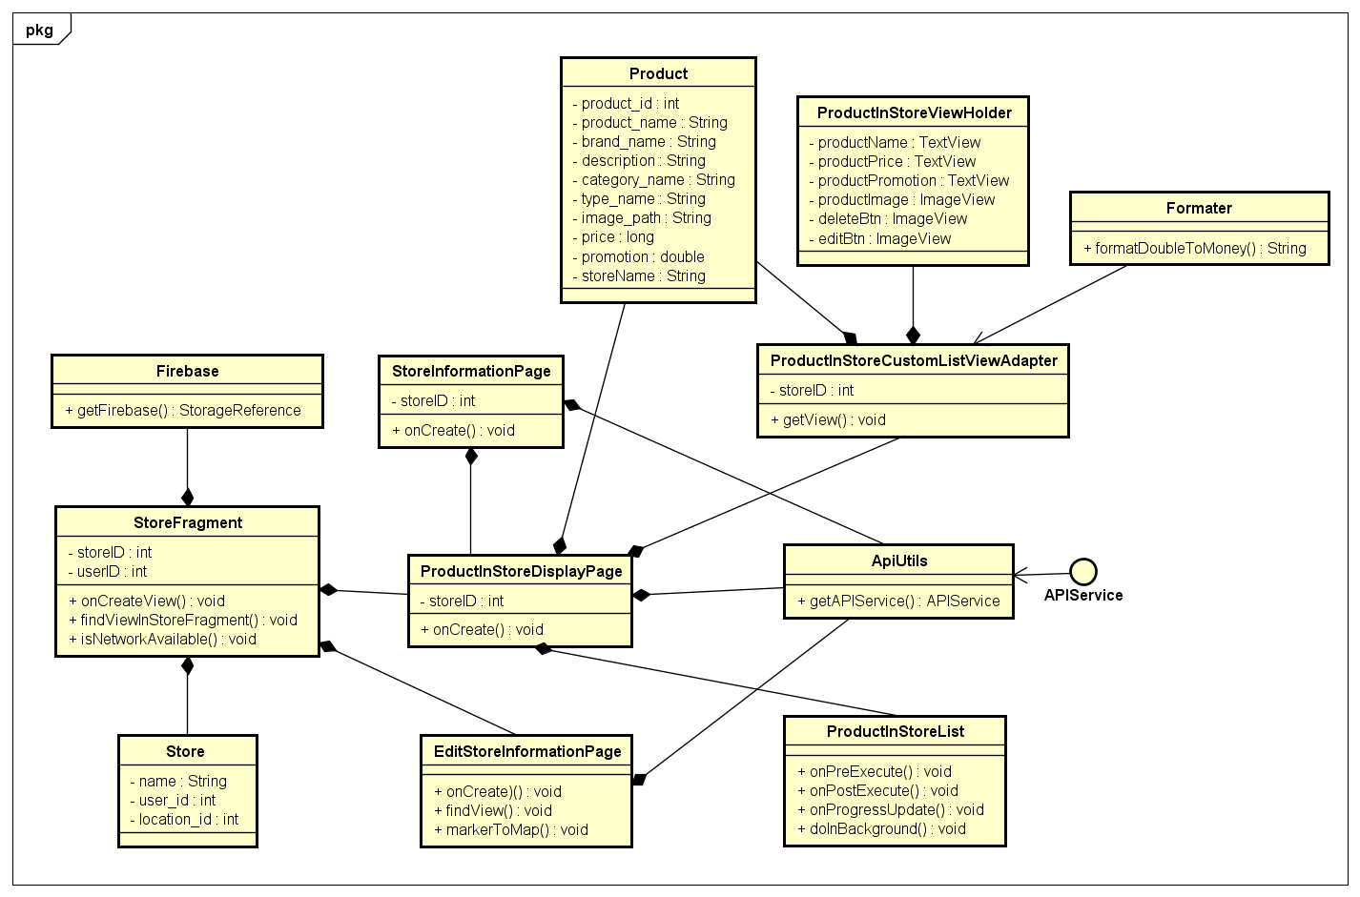

* + Product: object contains product information.
  + ProductInStoreViewHolder: initializes Android component to ProductInStoreCustomListViewAdapter.
  + ProductInStoreCustomListViewAdapter: layout item listview in ProductInStoreDisplayPage.
  + Formatter: class includes functions which support format information.
  + Firebase: class includes functions which support get data from Firebase server.
  + Store: <description above>.
  + StoreInformationPage: screen displays store information.
  + StoreFragment: screen displays store information.
  + ProductInStoreDisplayPage: screen displays products in store.
  + EditStoreInformationPage: screen allows Store edit store information.
  + ProductInStoreList: asynctask supports call ApiUtils to execute getting products in store.
  + ApiUtils: <description above>.
  + APIService: <description above>.

##### Manage Order

##### Order Product

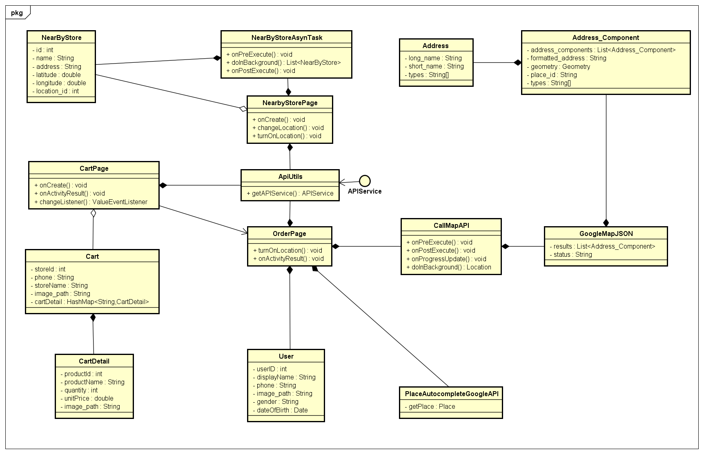

* + NearbyStore: object contains nearby store information.
  + NearByStoreAsynTask: asynctask supports call ApiUtils to execute getting nearby stores.
  + Address: object contains address information from GooogleMap API.
  + Address\_Component: object contains address information from GooogleMap API.
  + GoogleMapJSON: json contains Component list from GooogleMap API.
  + CallMapAPI: asynctask supports interact with GooogleMap API.
  + NearbyStorePage: screen displays nearby store list.
  + CartDetail: object contains product information in cart.
  + Cart: object contains cart information.
  + CartPage: screen displays cart list.
  + User: < description above >
  + OrderPage: screen allows User provide information for order.
  + ApiUtils: <description above>.
  + APIService: <description above>.

##### Register Account

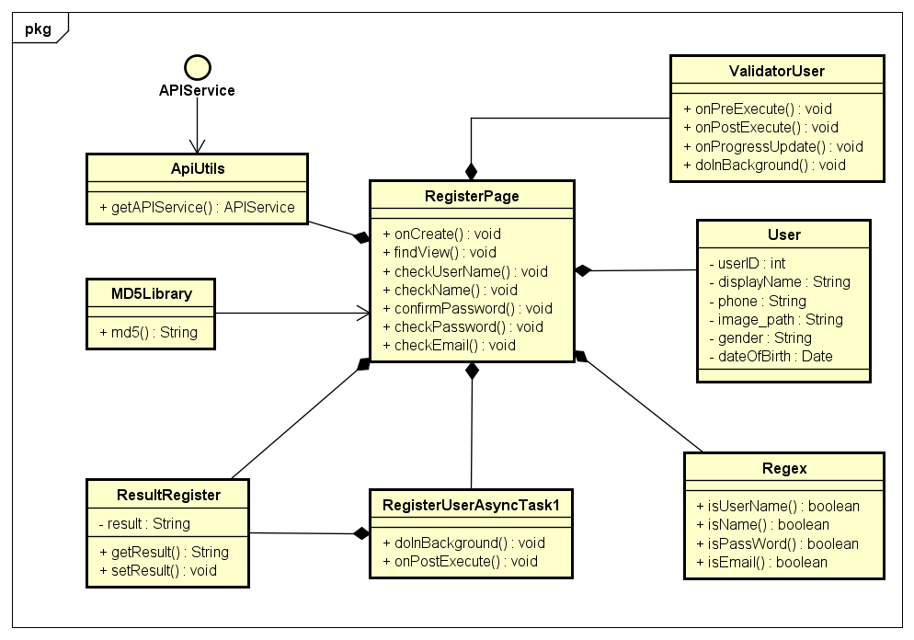

* + ValidatorUser: asynctask supports validate user information.
  + User : <description above>.
  + Regex: class includes functions which support check Regular Expressions to validate input data.
  + MD5Library: <description above>.
  + ResultRegister: object contains register account result status.
  + RegisterUserAsyncTask1: asynctask supports call ApiUtils to execute registering usser account.
  + ApiUtils: <description above>.
  + APIService: <description above>.

##### Register Store

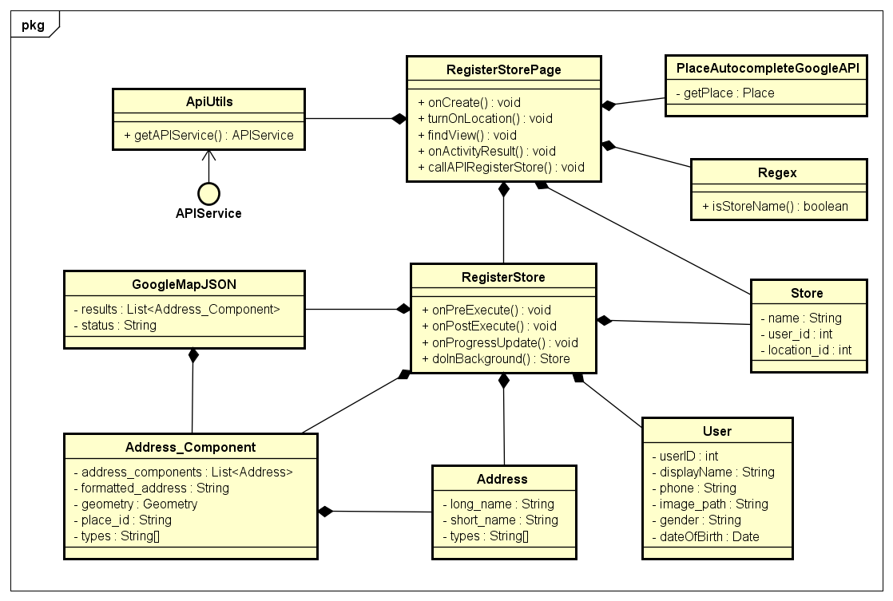

* + RegisterStorePage: screen allows User register a new store.
  + GoogleMapJSON: <description above>.
  + Address\_Component: <description above>.
  + Address: <description above>.
  + User: <description above>.
  + Store: <description above>.
  + Regex: <description above>.
  + PlaceAutocompleteGoogleAPI: class supports get place address from GoogleMap API.
  + RegisterStore: asynctask supports call ApiUtils to execute registering store.
  + ApiUtils: <description above>.
  + APIService: <description above>.

##### Search Product By User

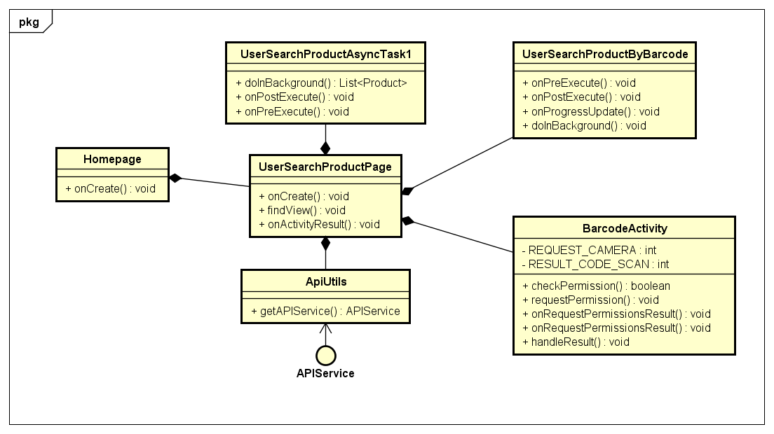

* + Homepage: application’s home screen.
  + UserSearchProductPage: screen allows User search products.
  + UserSearchProductAsyncTask1: asynctask supports call ApiUtils to execute searching products by product name.
  + UserSearchProductByBarcode: asynctask supports call ApiUtils to execute searching products by product barcode.
  + BarcodeActivity: screen allows User scan product barcode.
  + ApiUtils: <description above>.
  + APIService: <description above>.

##### View Product

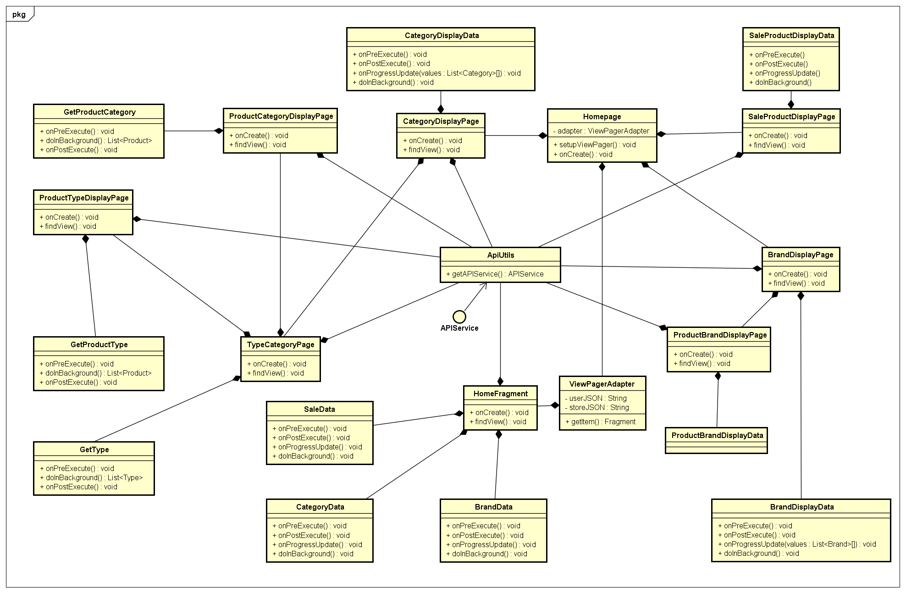

* + TypeCategoryPage: screen displays all type category.
  + GetType: asynctask supports call ApiUtils to getting all types category.
  + ProductTypeDisplayPage: screen displays all products in types category.
  + GetProductType: asynctask supports call ApiUtils to getting all products in types category.
  + ProductCategoryDisplayPage: screen displays all products in categories.
  + GetProductCategory: asynctask supports call ApiUtils to getting all products in categories.
  + CategoryDisplayPage: screen displays all categories.
  + CategoryDisplayData: asynctask supports call ApiUtils to getting all categories.
  + HomeFragment: screen displays some products,..
  + SaleData: asynctask supports call ApiUtils to getting top 20 sale products.
  + CategoryData: asynctask supports call ApiUtils to getting top 10 categories.
  + BrandData: asynctask supports call ApiUtils to getting top 10 brands.
  + ViewPagerAdapter: adapter sets layout view pager for HomePage.
  + Homepage: <description above>.
  + BrandDisplayPage: screen displays all brands.
  + BrandDisplayData: asynctask supports call ApiUtils to getting all brands.
  + ProductBrandDisplayPage: screen displays all products in brands.
  + ProductBrandDisplayData: asynctask supports call ApiUtils to getting all products in brands.
  + SaleProductDisplayPage: screen displays all products on sales.
  + SaleProductDisplayData: asynctask supports call ApiUtils to getting all products on sale.
  + ApiUtils: <description above>.
  + APIService: <description above>.

##### Find Nearby Store By Product

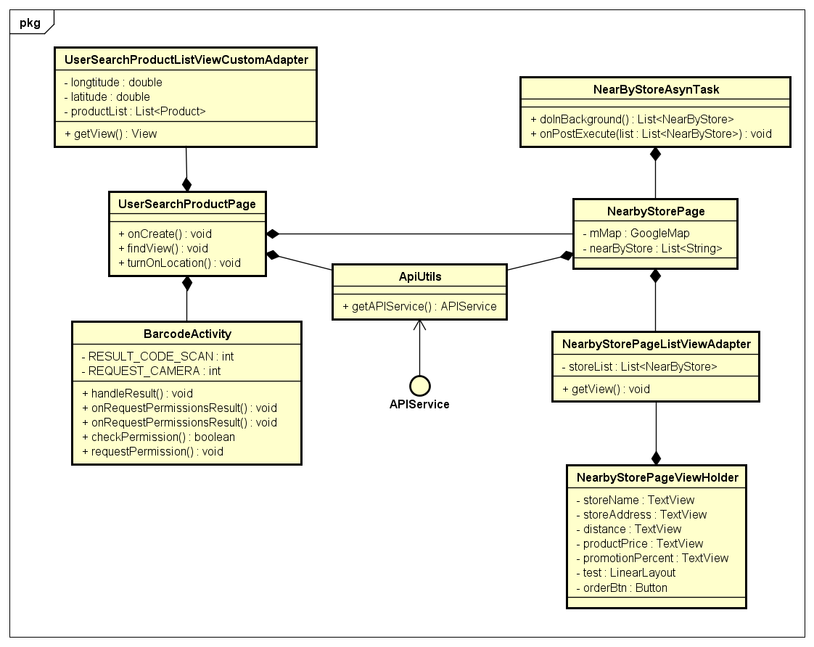

* + UserSearchProductListViewCustomAdapter: adapter sets layout for product list in UserSearchProductPage.
  + UserSearchProductPage: screen displays product list.
  + BarcodeActivity: < description above >
  + NearByStoreAsynTask: < description above >
  + NearbyStorePage: < description above >
  + NearbyStorePageListViewAdapter: adapter sets layout for store list in NearbyStorePage.
  + NearbyStorePageViewHolder: initializes Android component to NearbyStorePageListViewAdapter.
  + ApiUtils: <description above>.
  + APIService: <description above>.

##### Manage Feedback

## Sequence Diagram

### Logout

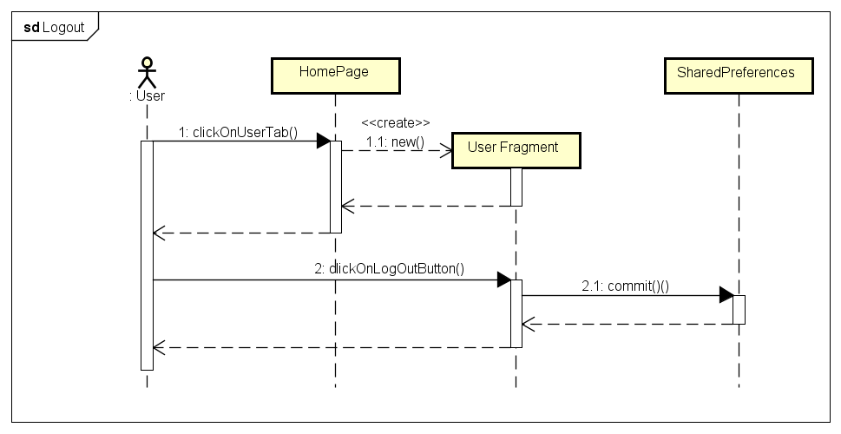

### Login with 3S account

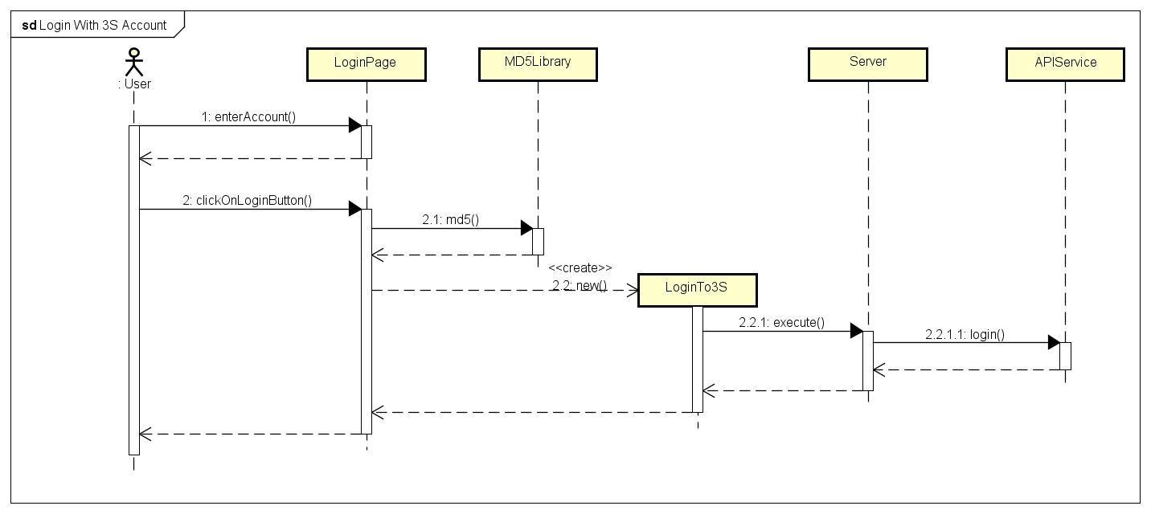

### Login with Facebook account

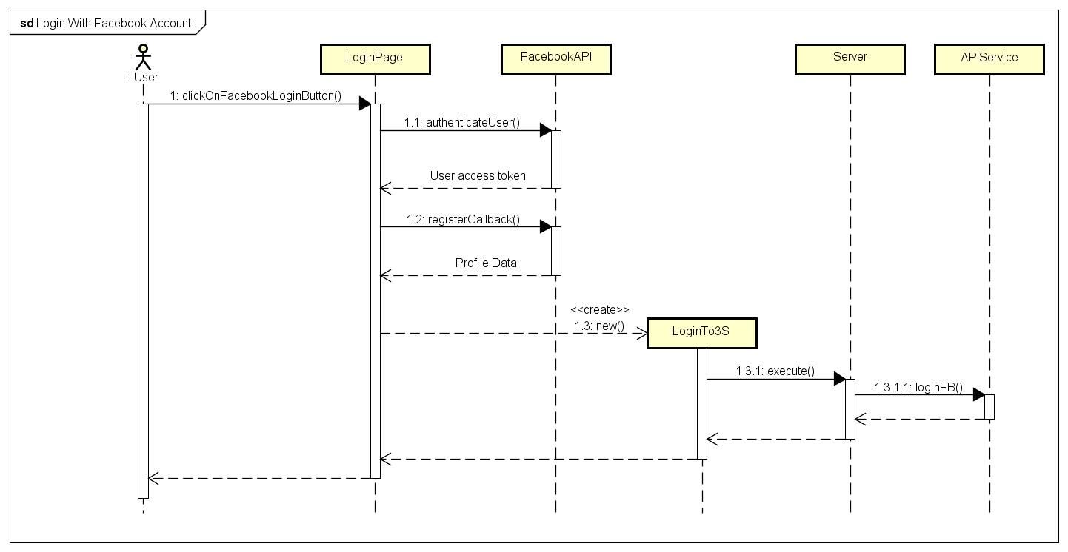

### View User Order History

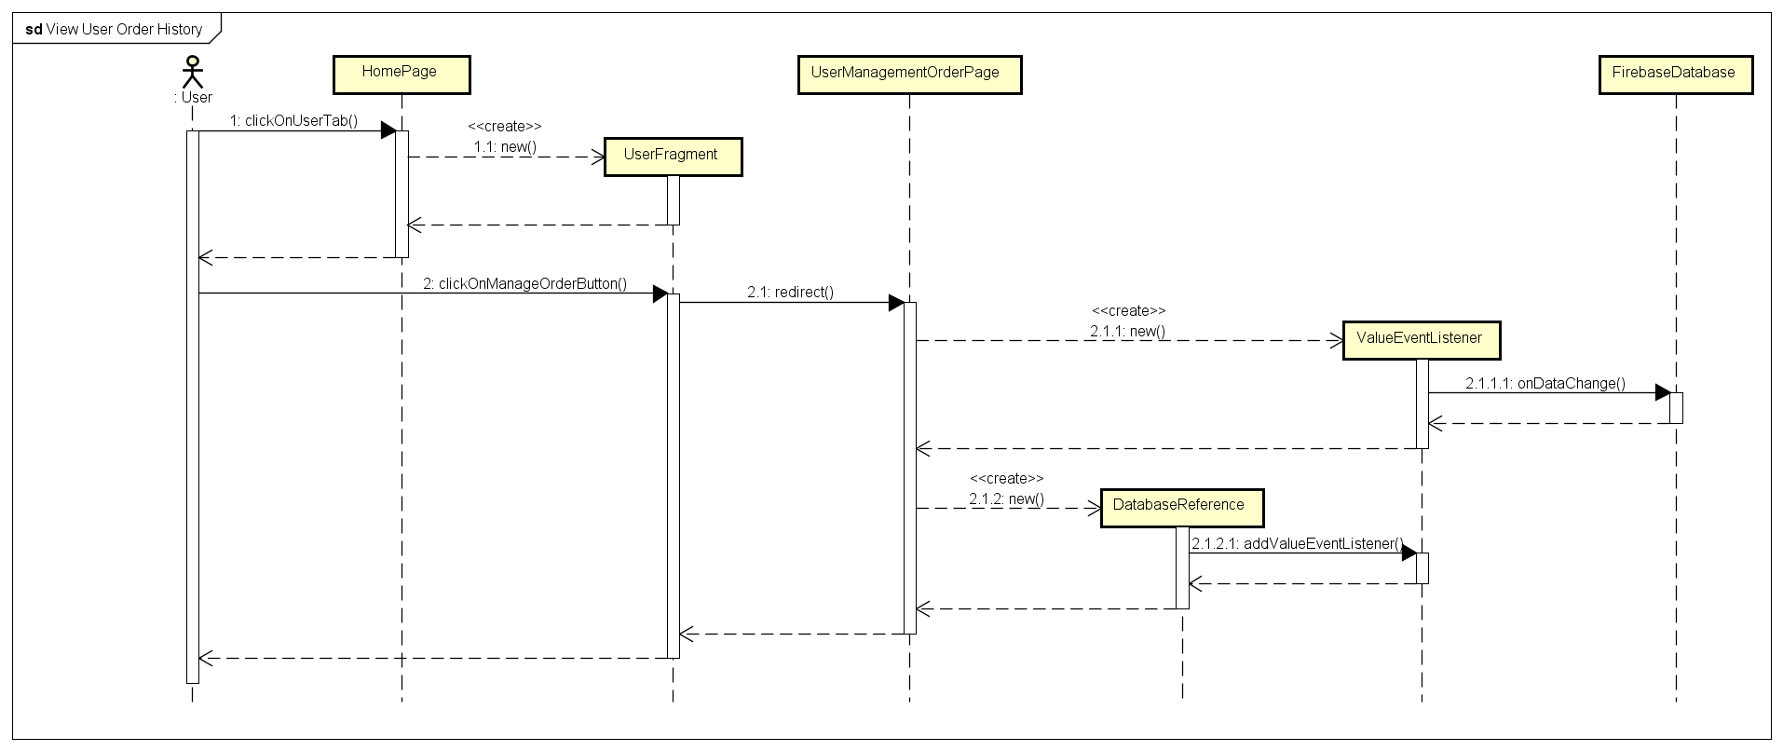

### View Store Order History

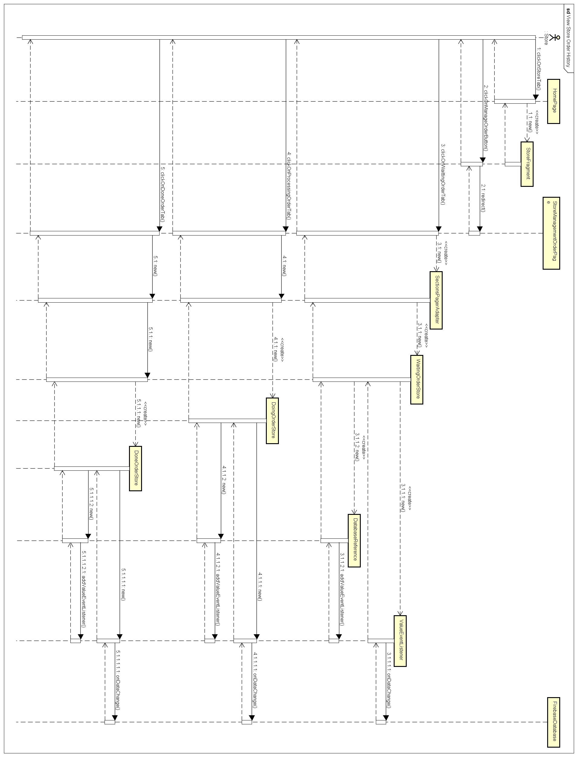

### Cancel Order

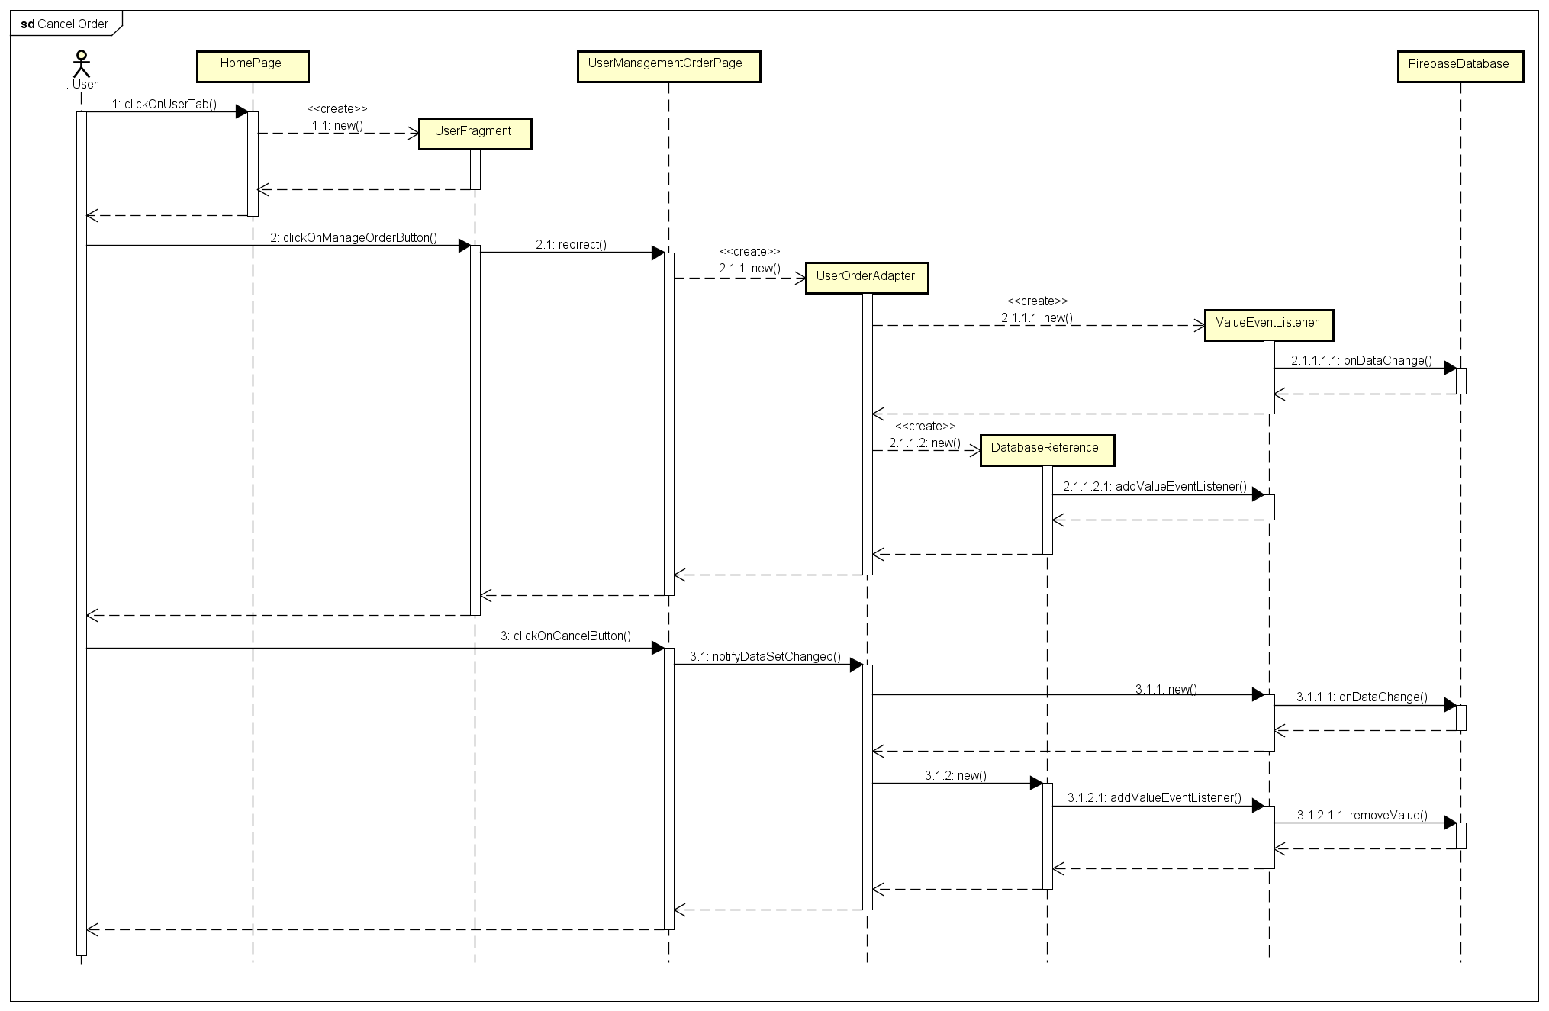

### Accept Order

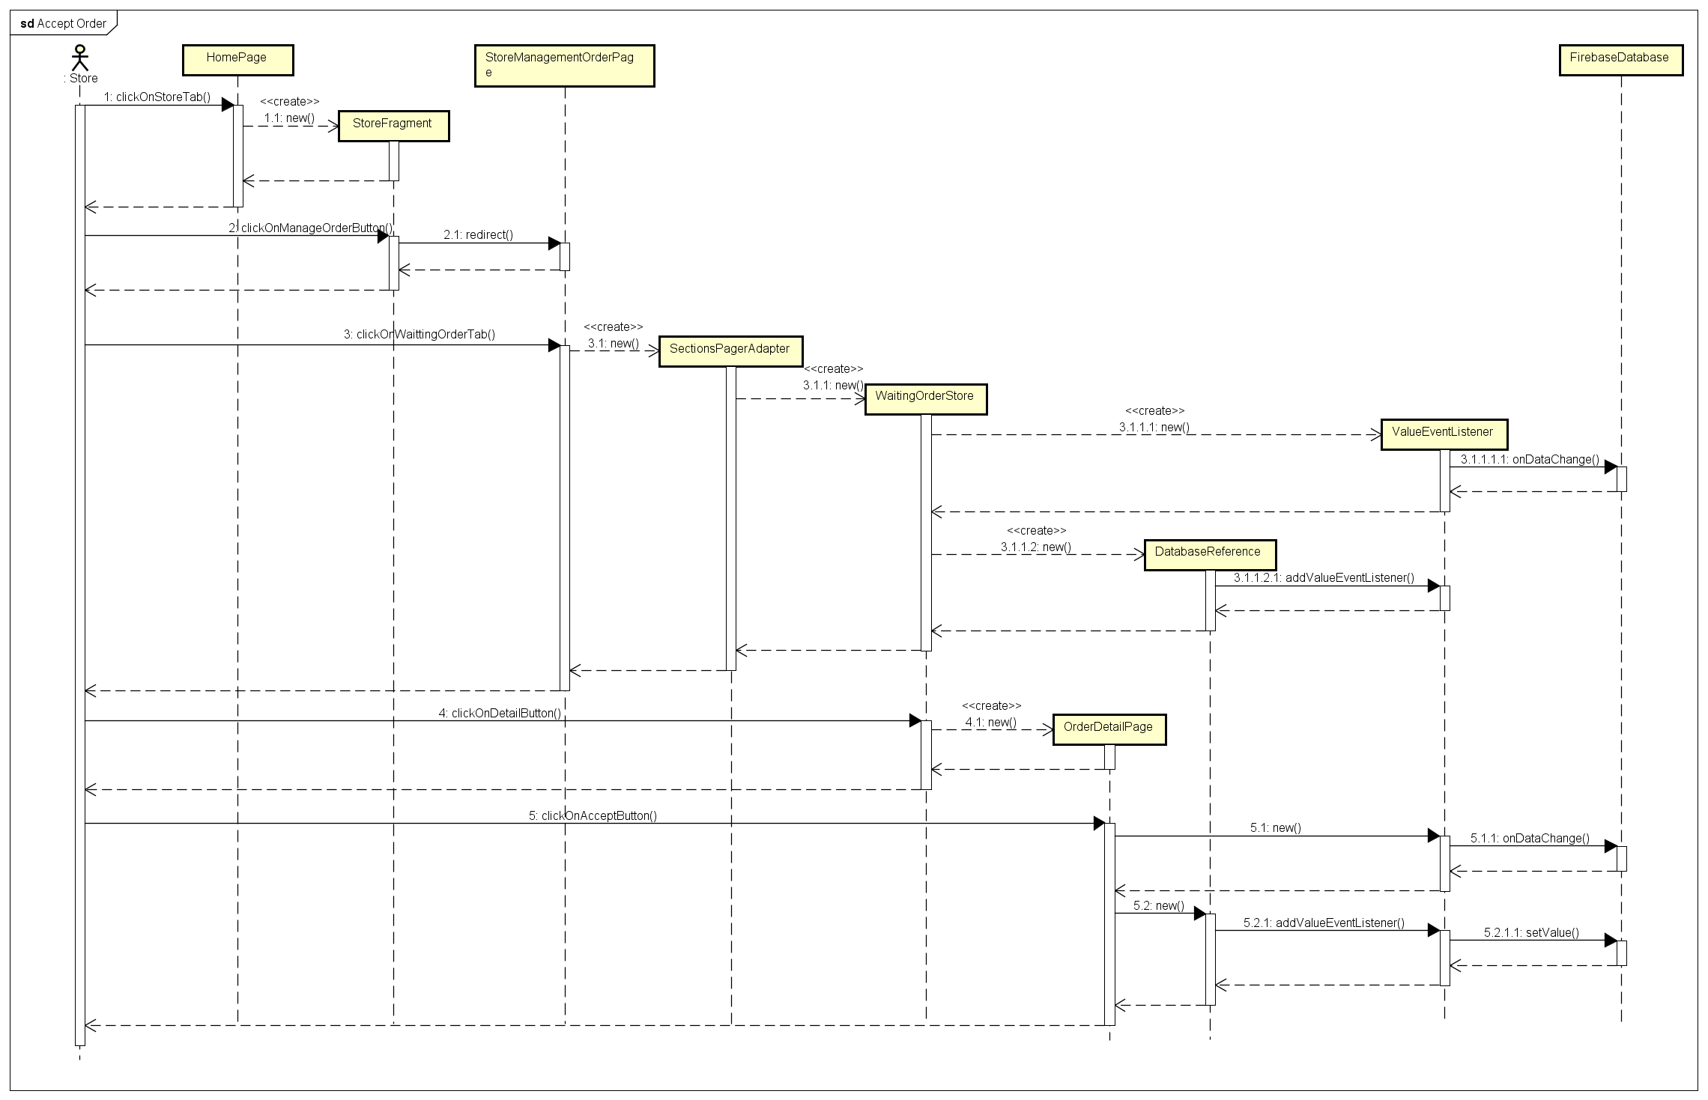

### Reject Order

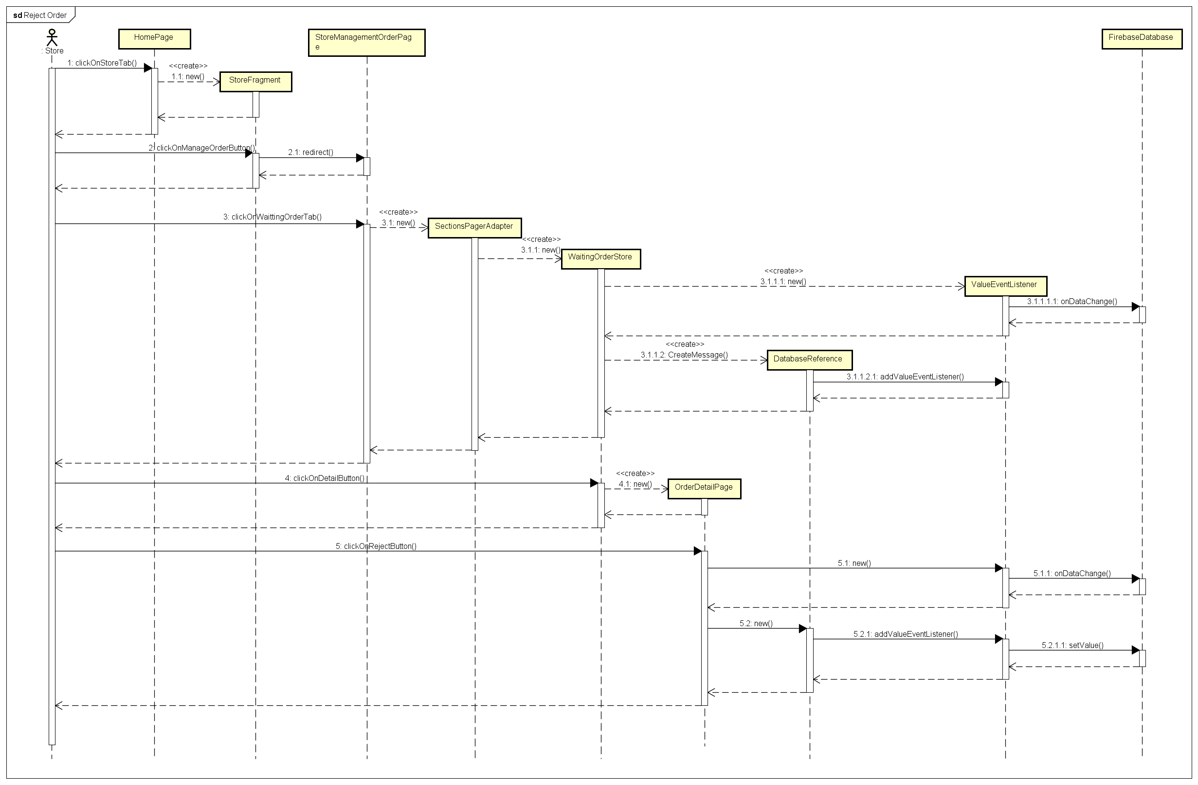

### Close Order

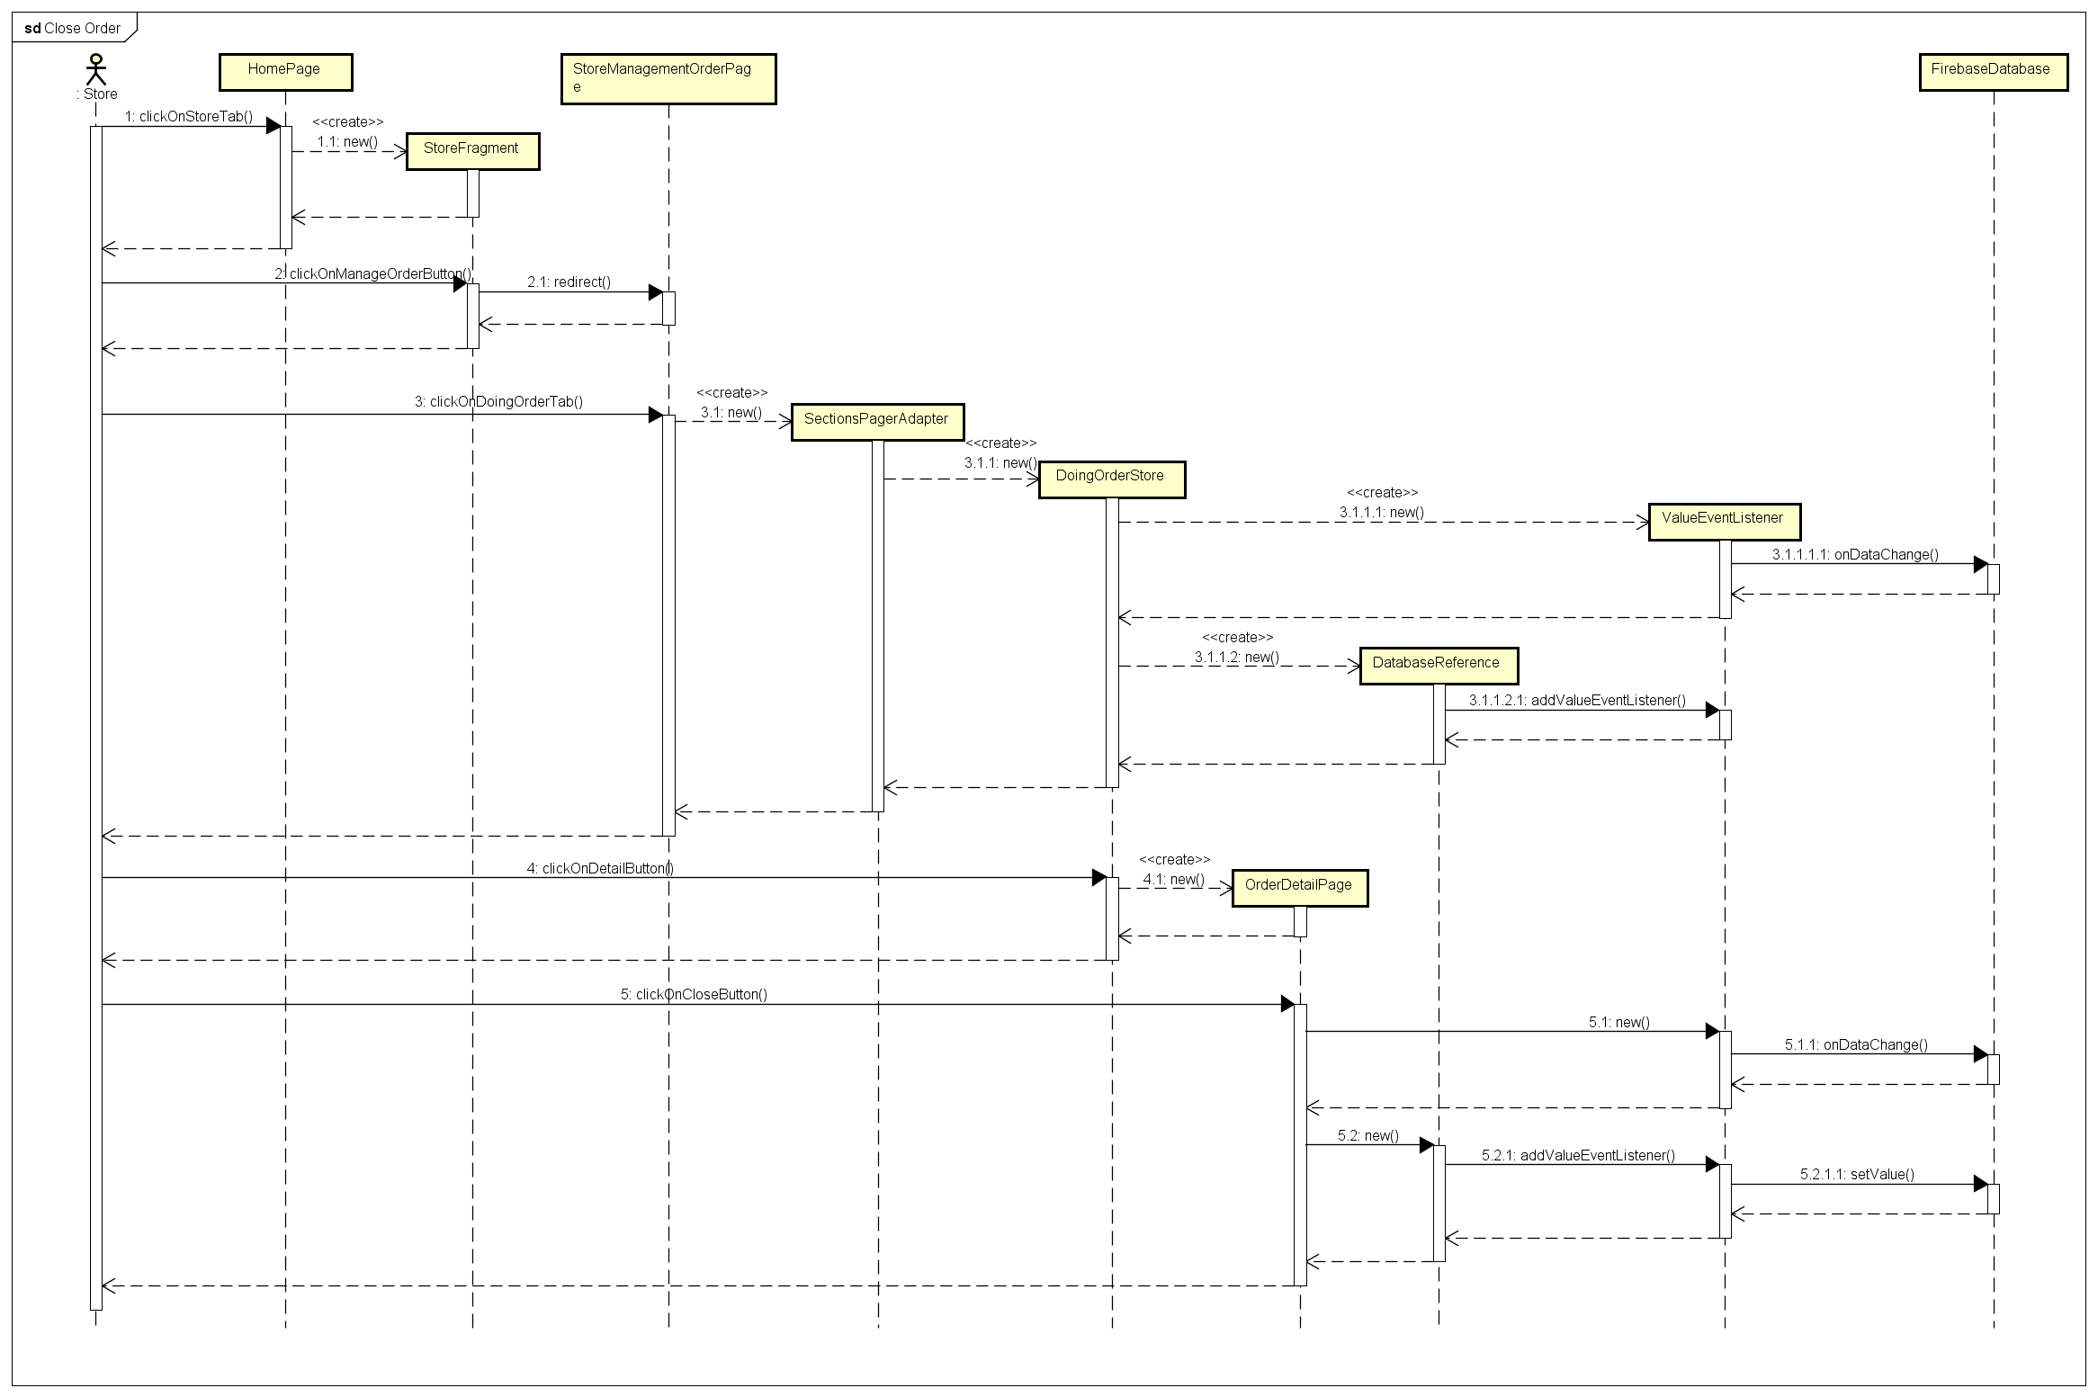

### Register a New Store

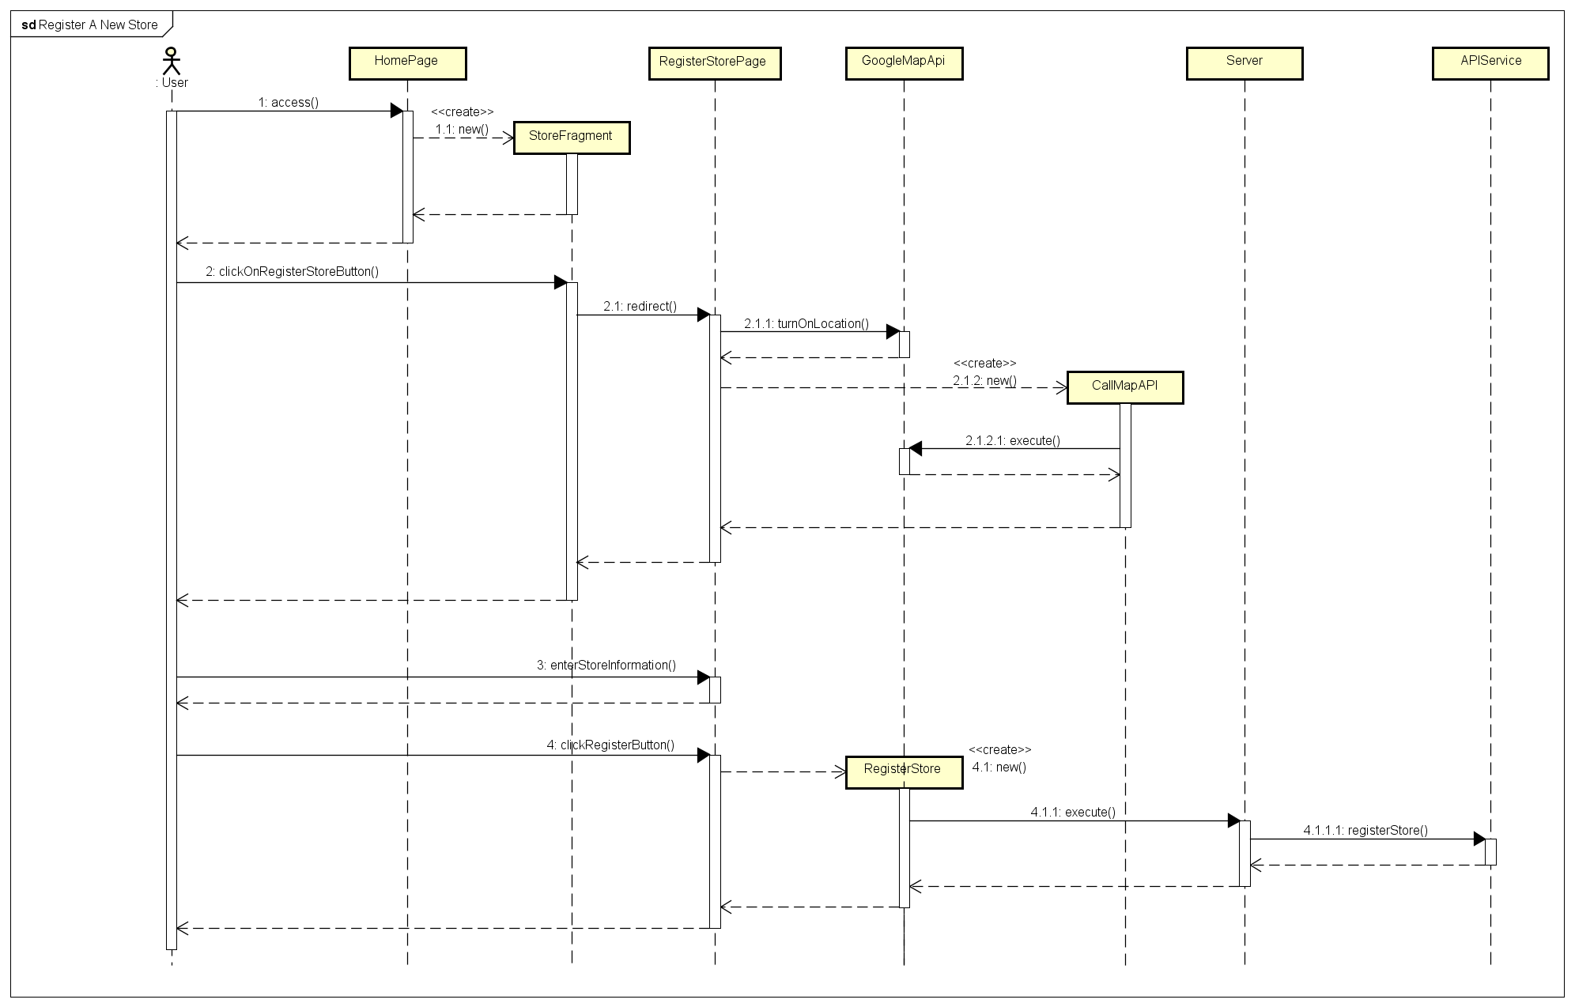

### View Store Information by User

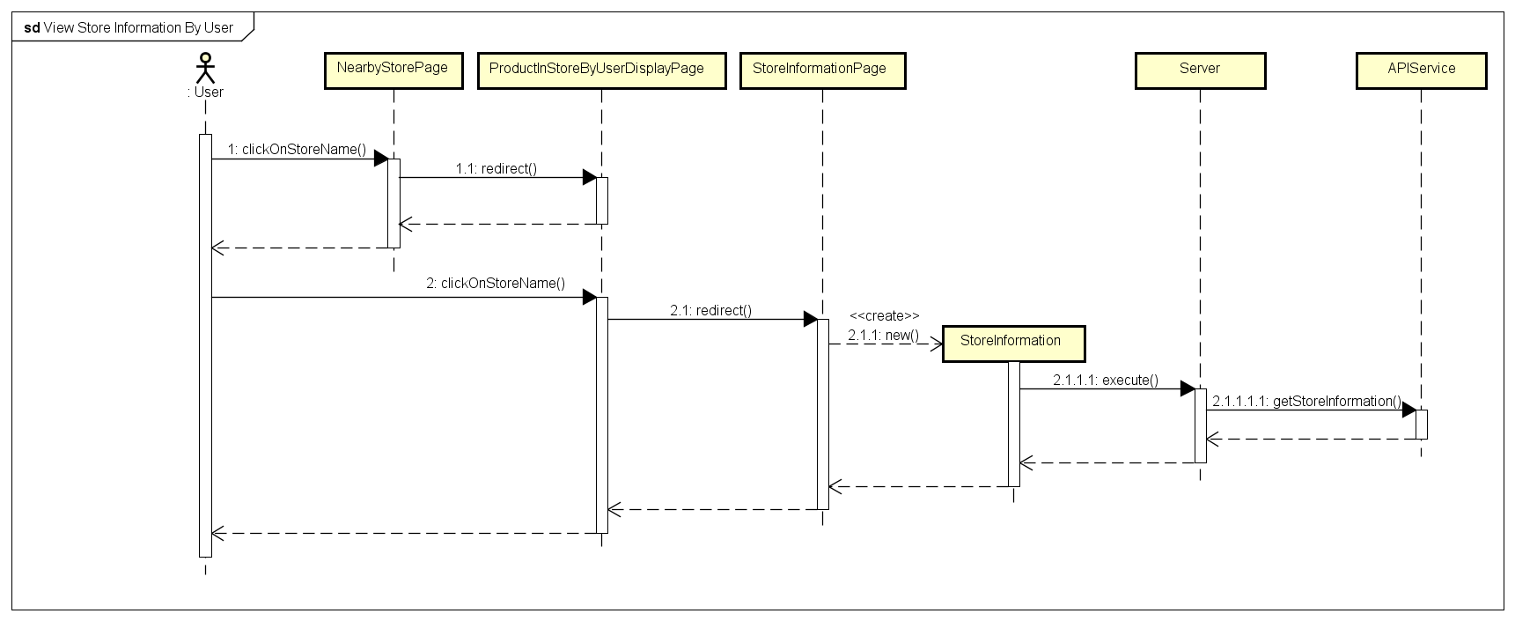

### View Store Information by Store

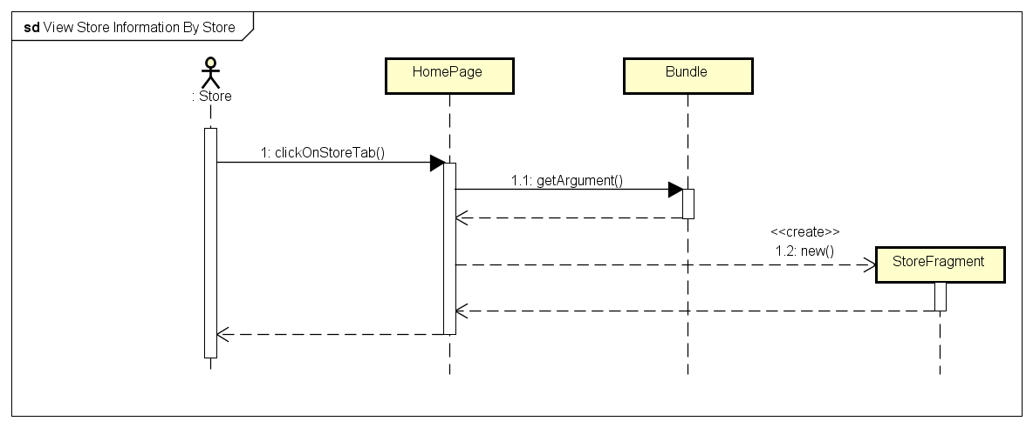

### Change Store Information

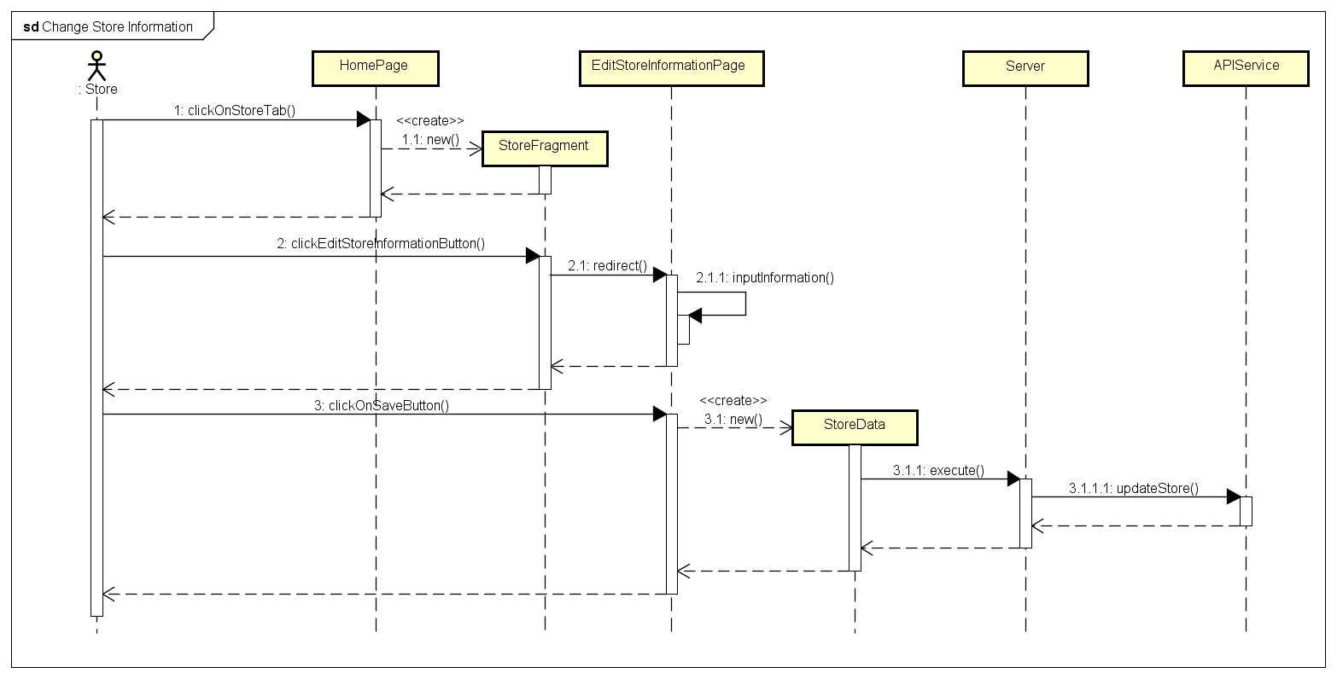

### View User Information

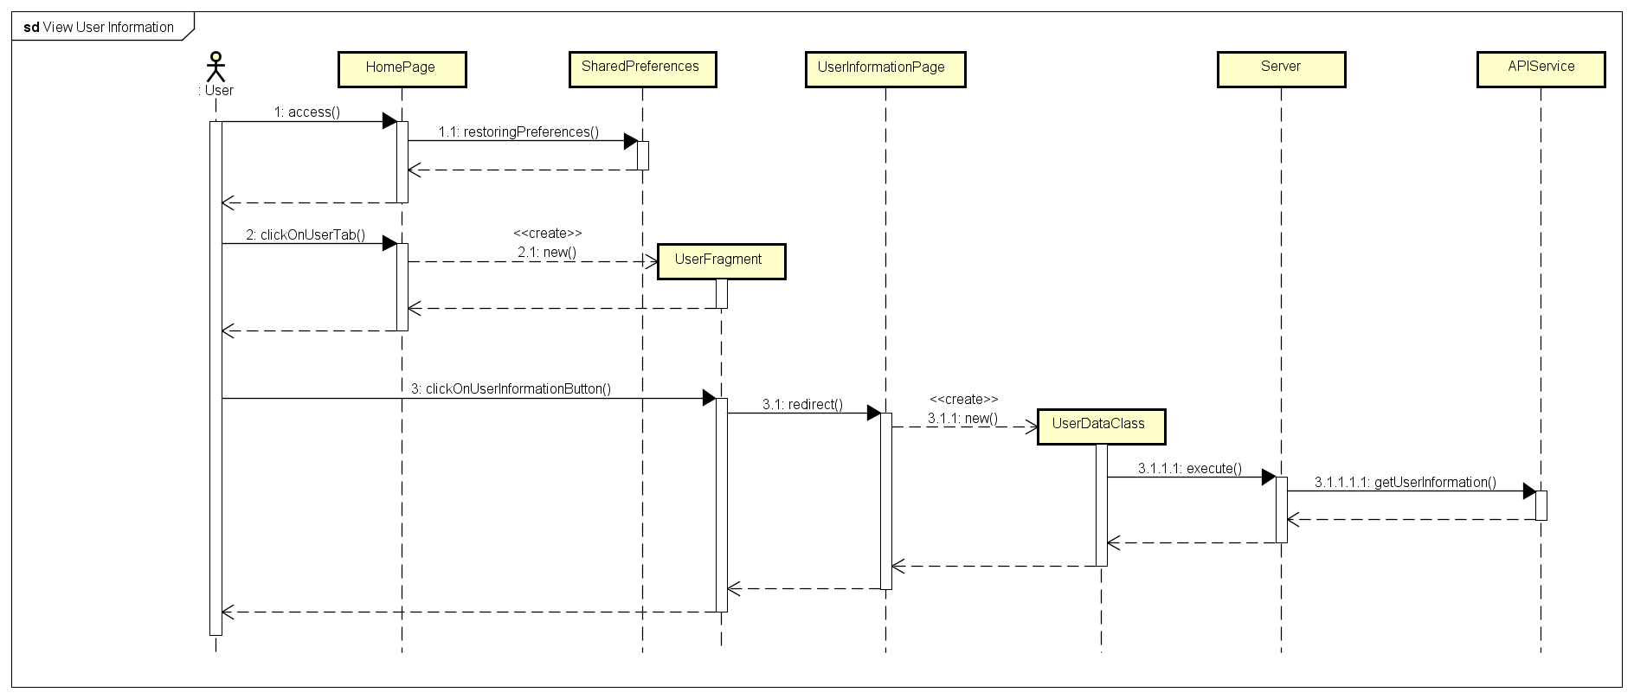

### Change Account Information

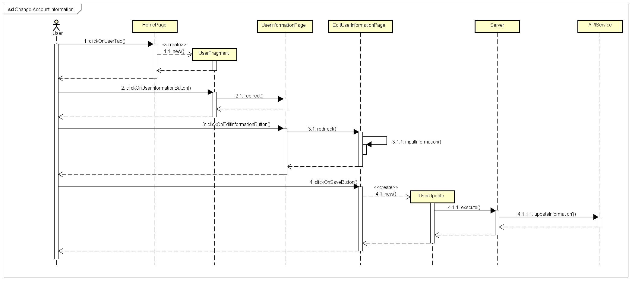

### Register A New Account

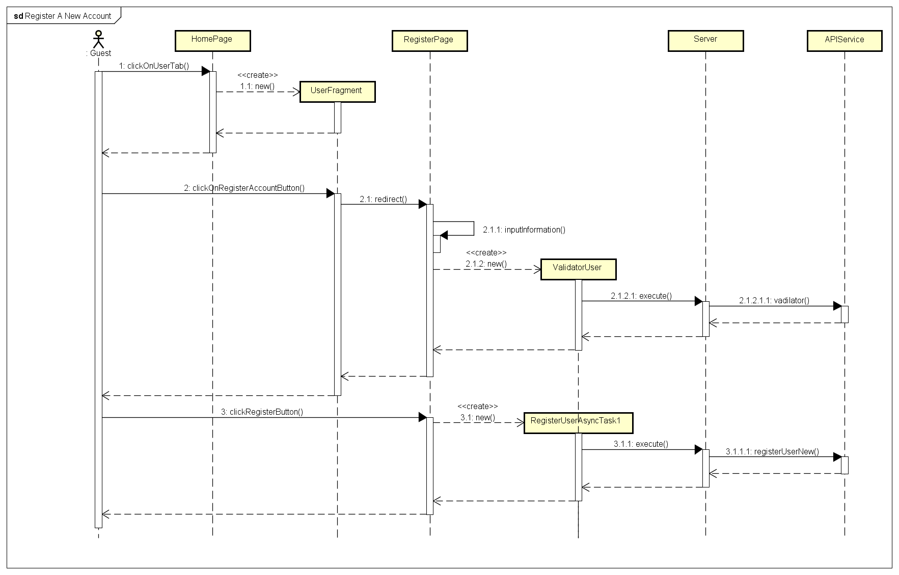

### Reset Account Password

### Change Account Password

### Find Nearby Store By Product With Product Barcode

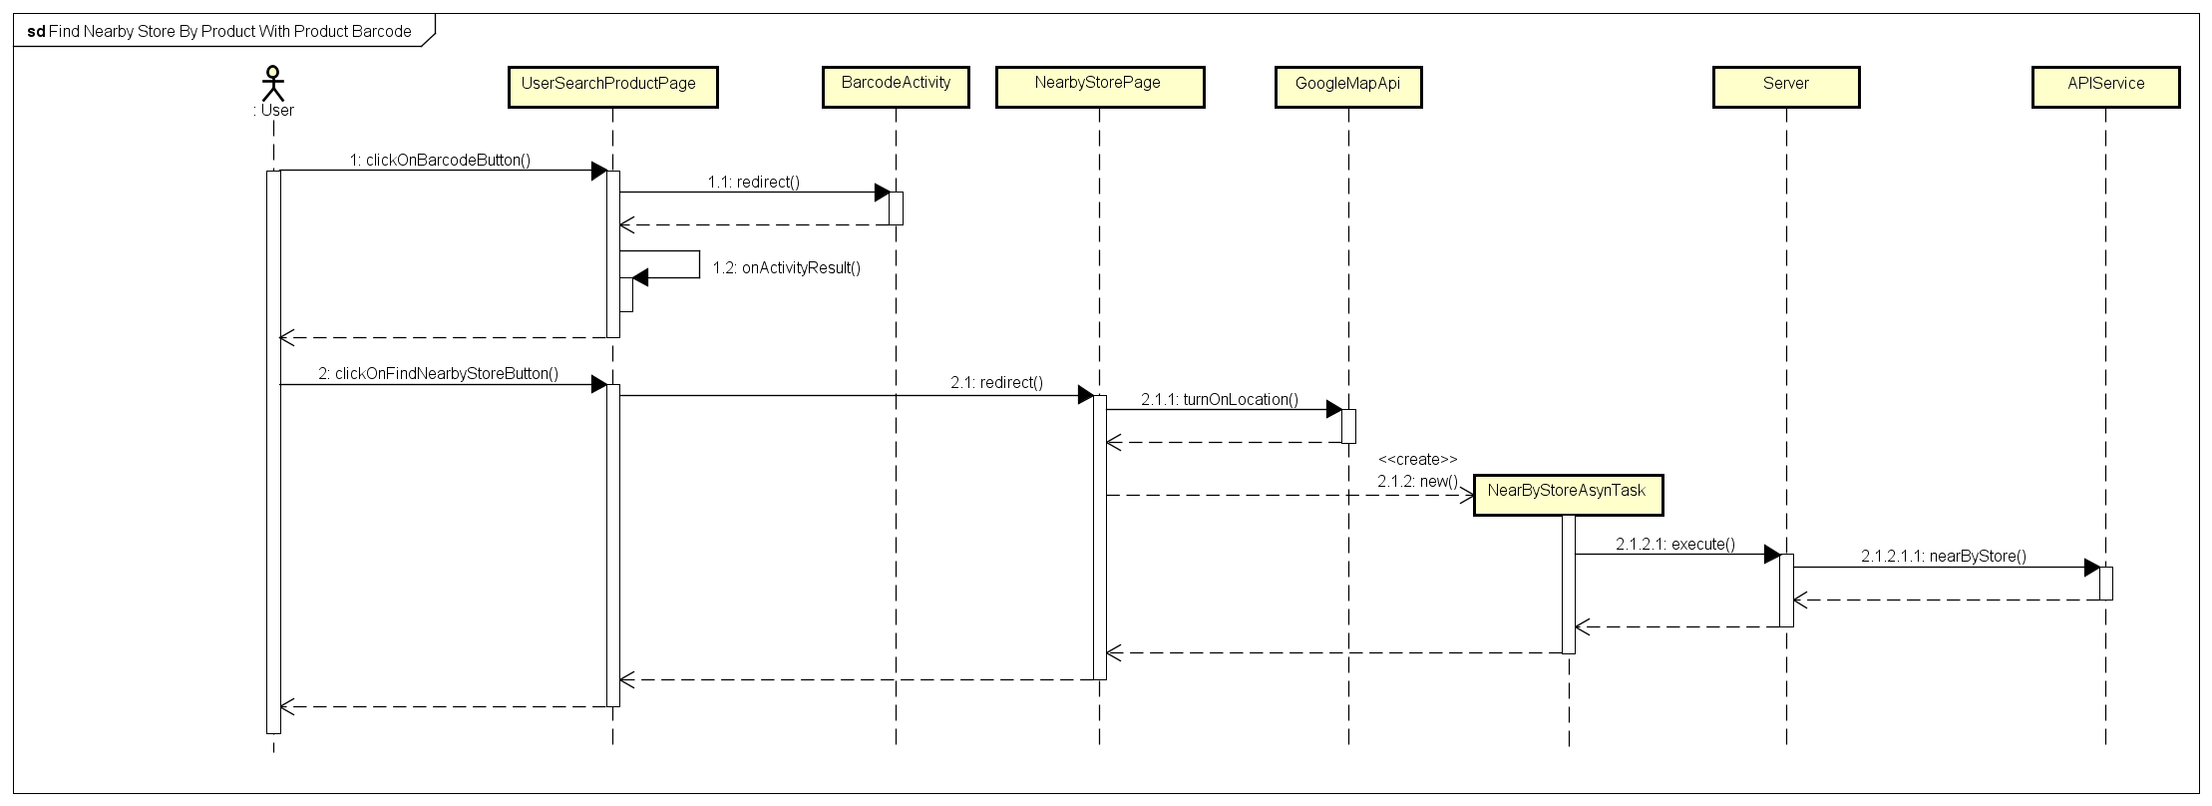

### Find Nearby Store by Product with Product Name

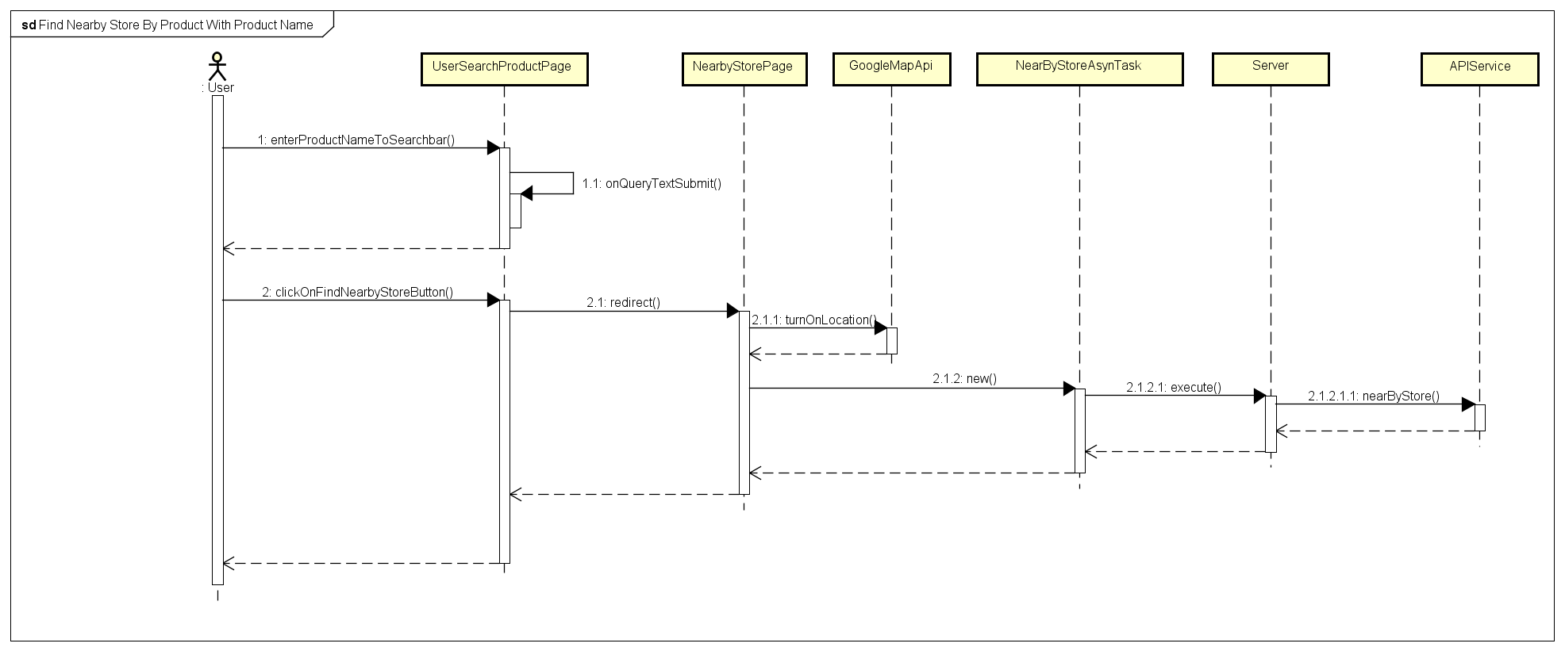

### Search Product by Name

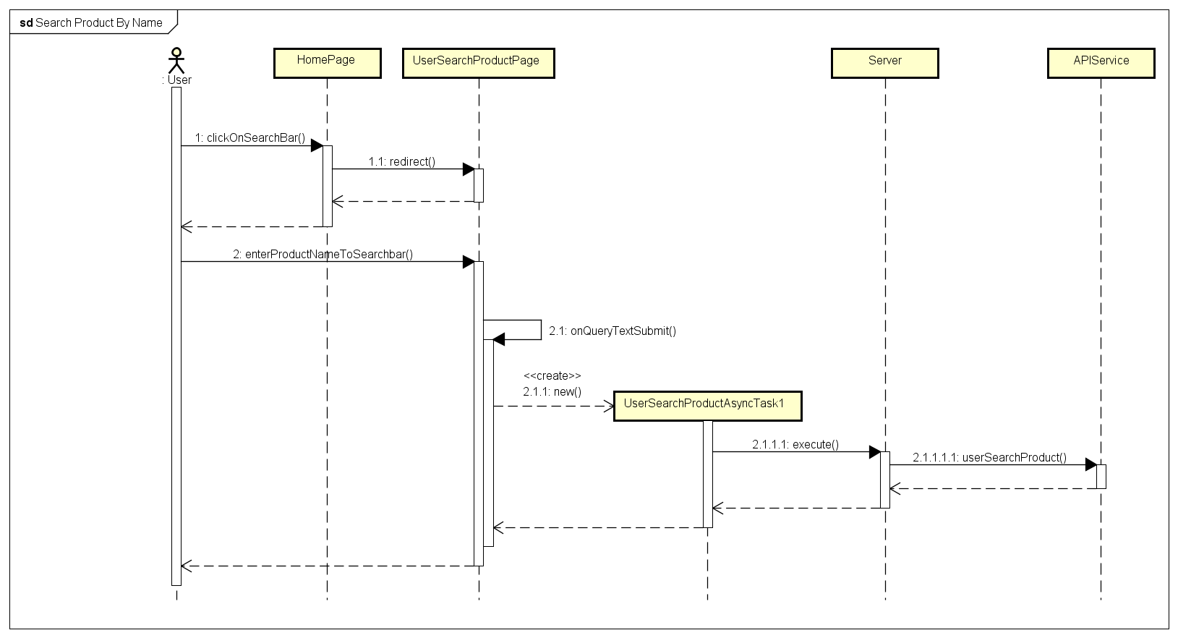

### Search Product by Barcode

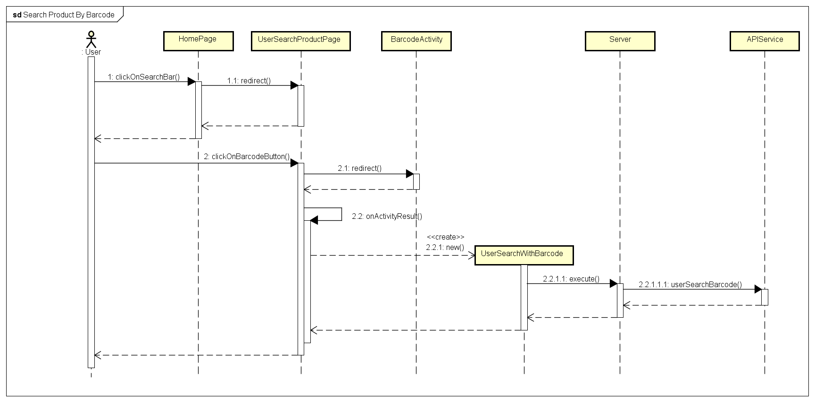

### View Product Detail

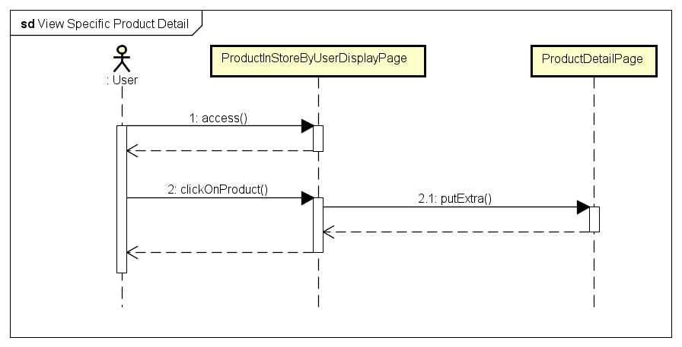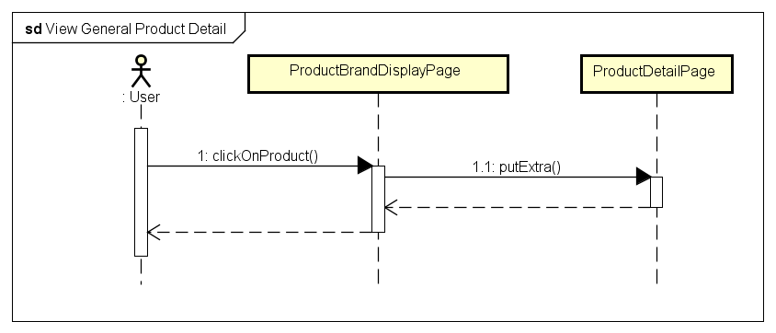

### View Product in Category

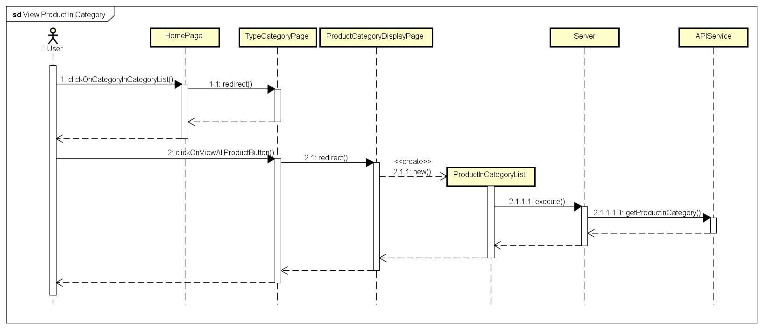

### View Product in Type

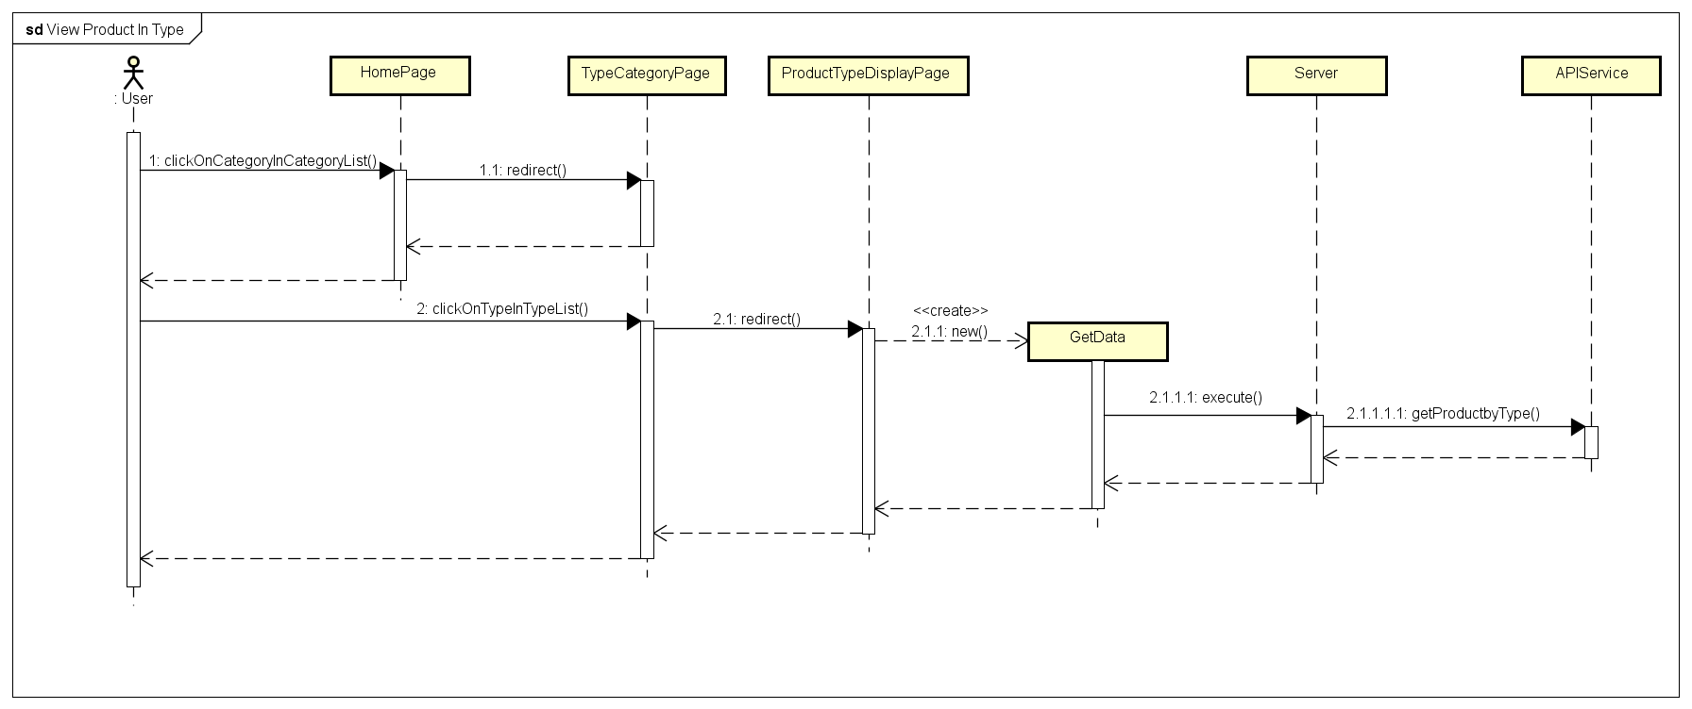

### View Product in Brand

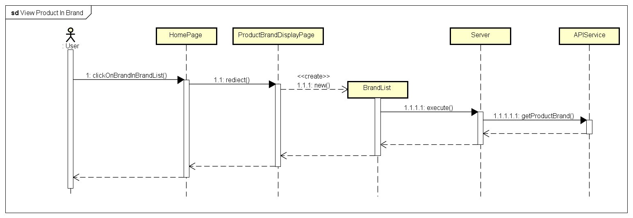

### View Product on Sale

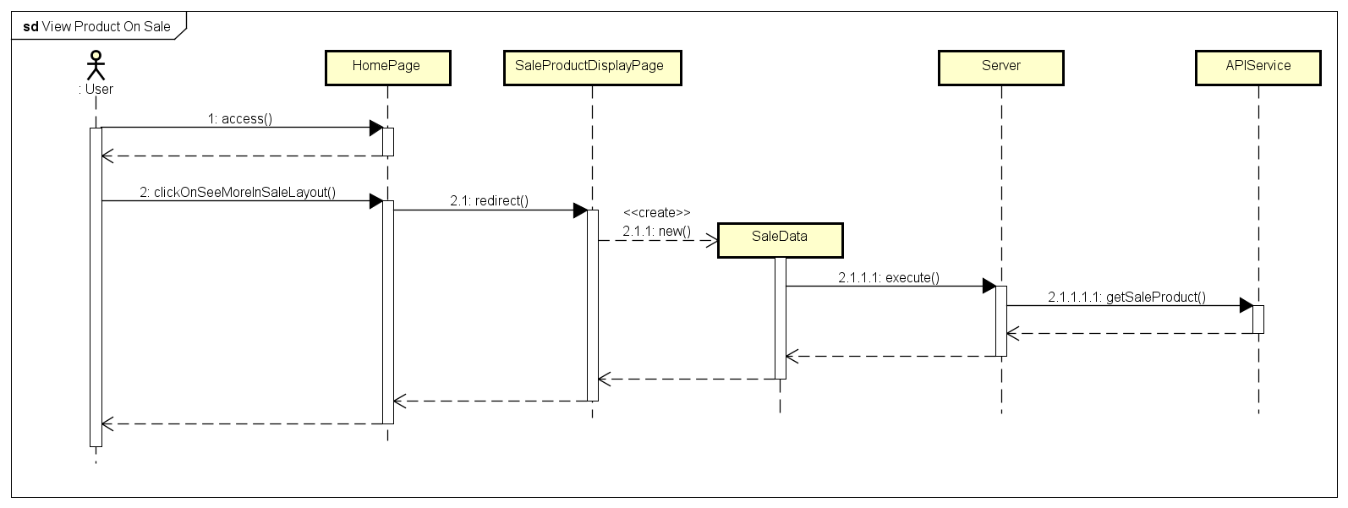

### View Product in Store

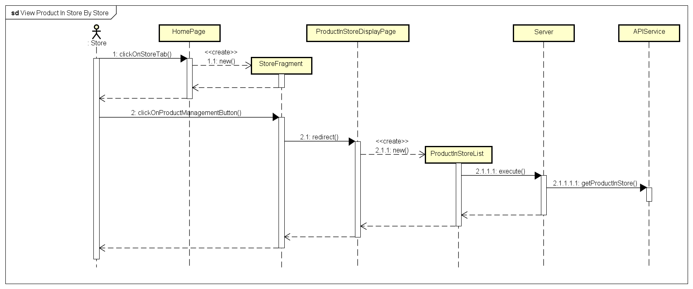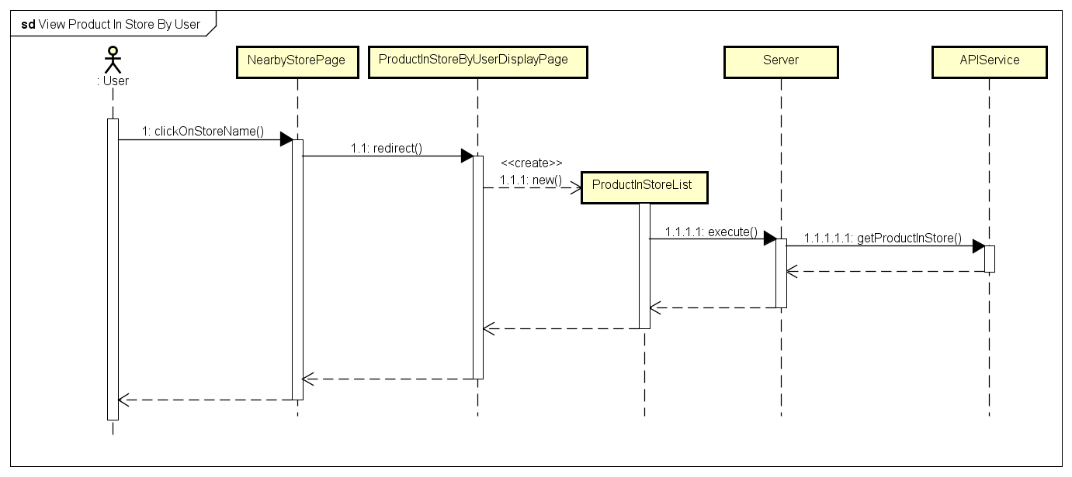

### Add Product by Name

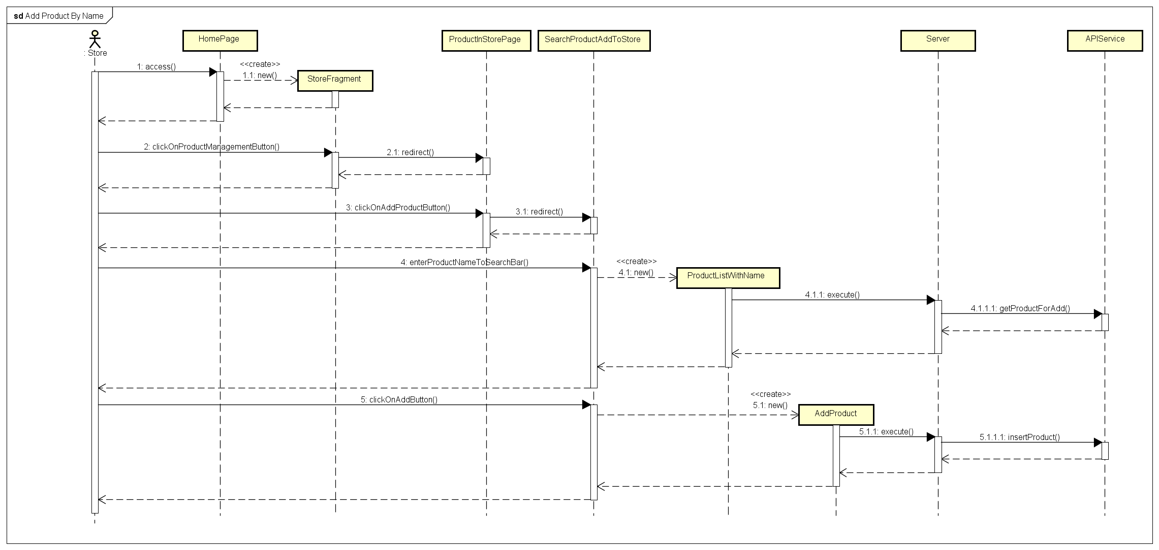

### Add Product by Barcode

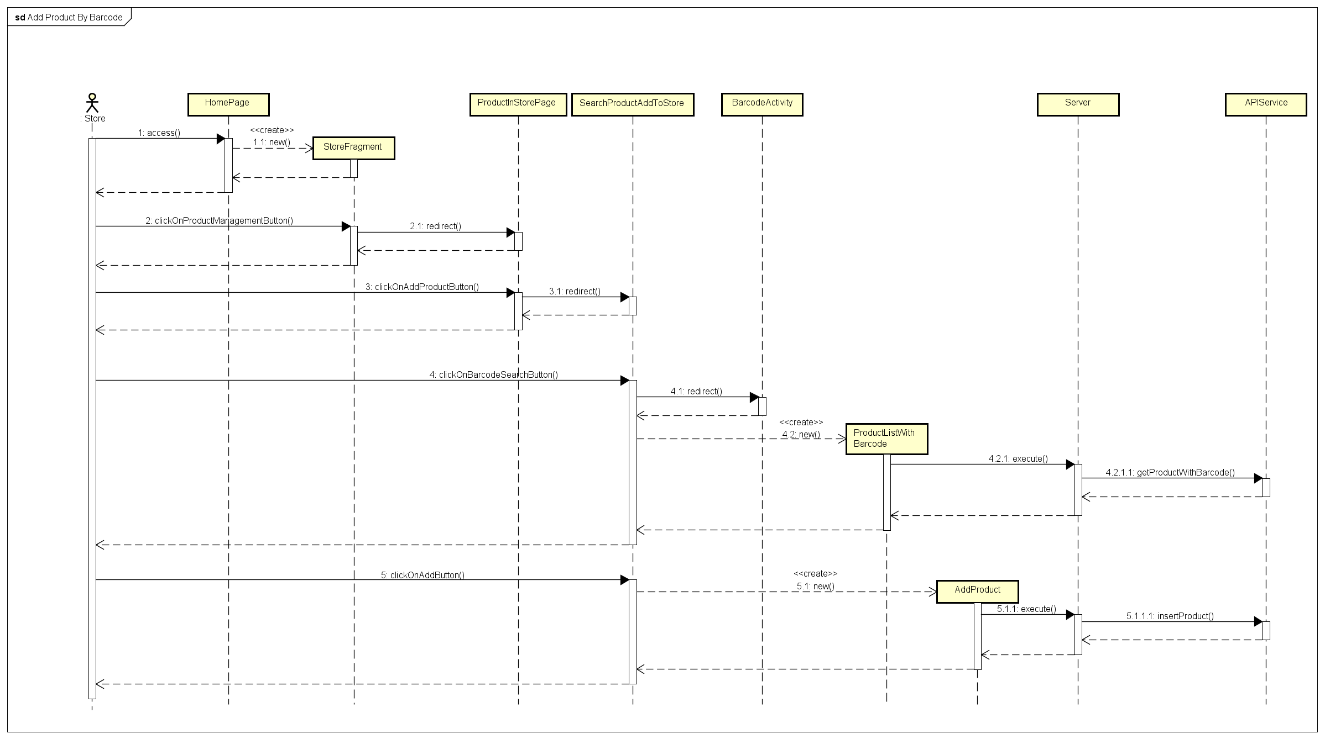

### Delete Product in Store

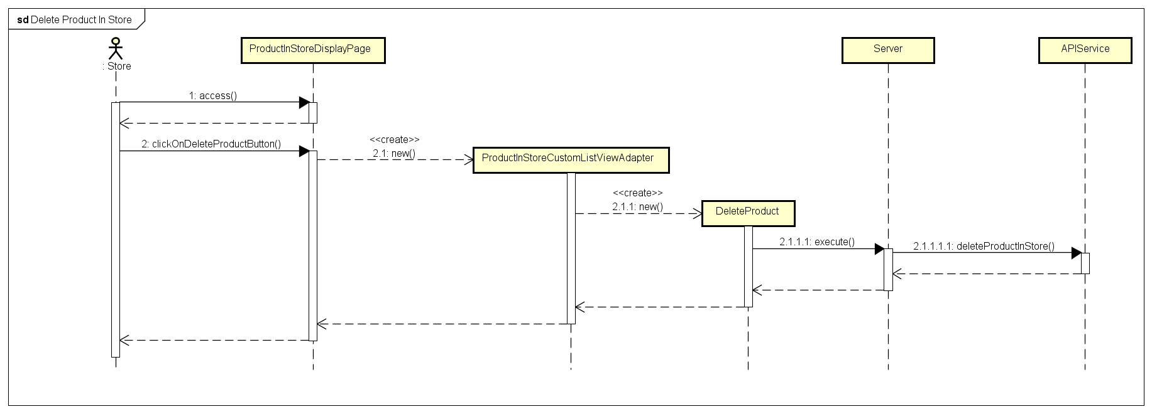

### Change Product Information in Store

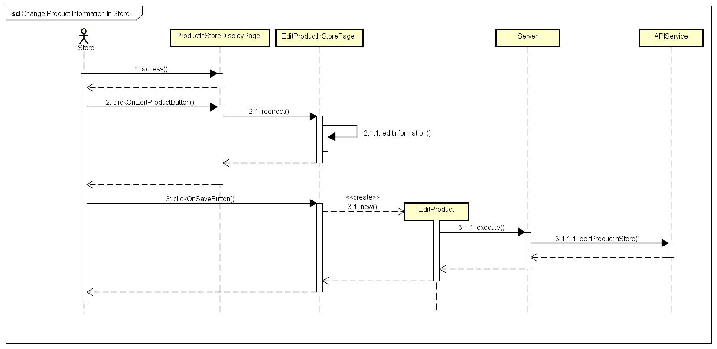

## User Interface Design

### Home Screen

#### Screen Images

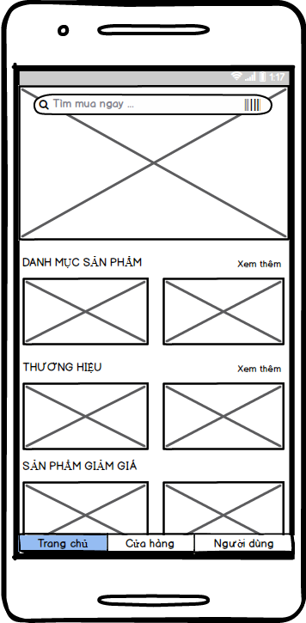

#### Objects and Actions

* + 1. Screen displays some categories, some brands, some sale products and some advertisement images.
    2. Screen is initial screen of application.

### View Categories Screen

#### Screen Images

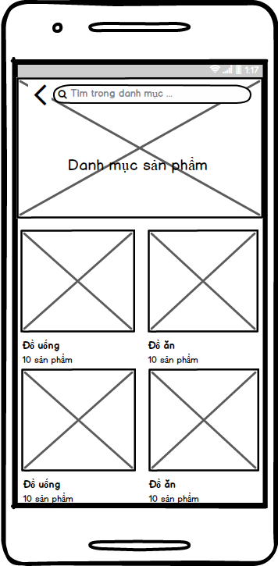

#### Objects and Actions

* + 1. Screen displays all categories in application.

### View Types Screen

#### Screen Images

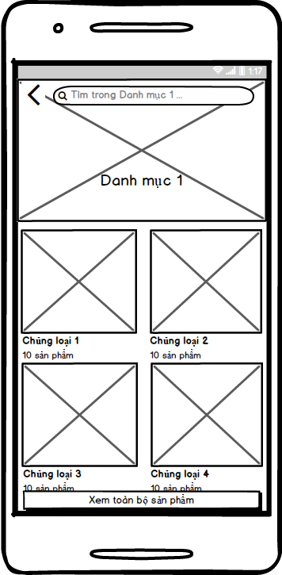

#### Objects and Actions

* + 1. Screen displays all types of any one category in application.

### View Brands Screen

#### Screen Images

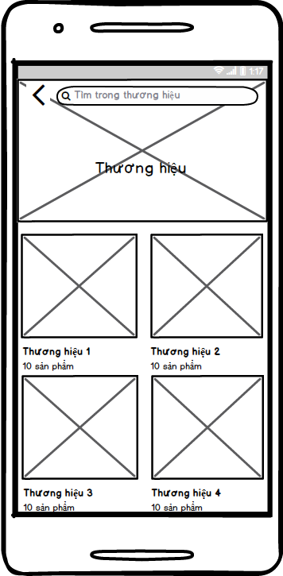

#### Objects and Actions

* + 1. Screen displays all brands in application.

### View Products In Category Screen

#### Screen Images

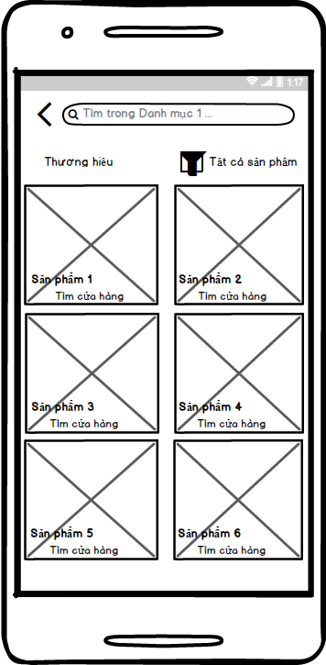

#### Objects and Actions

* + 1. Screen displays all products in any one category in application.

### View Products In Type Screen

#### Screen Images

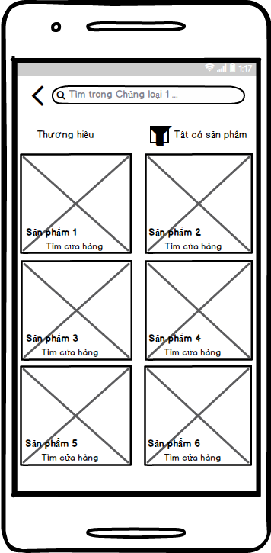

#### Objects and Actions

* + 1. Screen displays all products in any one type in application.

### View Products In Brand Screen

#### Screen Images

#### Objects and Actions

* + 1. Screen displays all brands in application.

### View Sale Products Screen

#### Screen Images

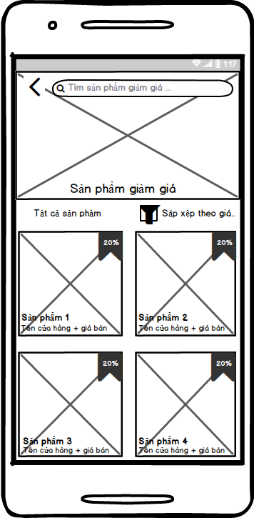

#### Objects and Actions

* + 1. Screen displays all sale products in application.

### View Store Information By Store Screen

#### Screen Images

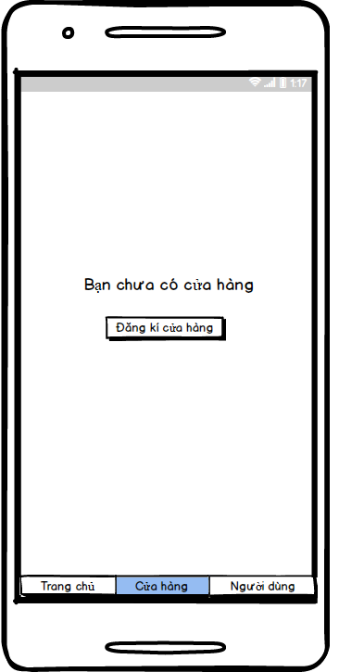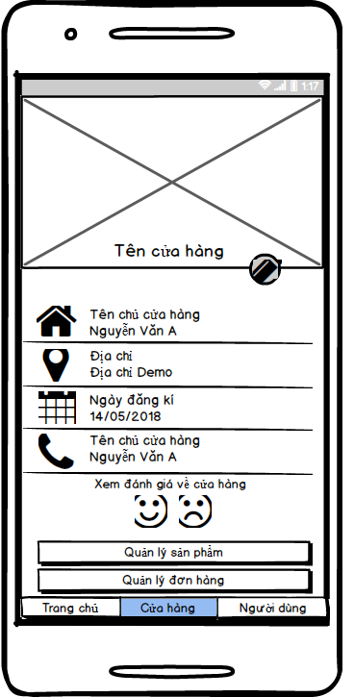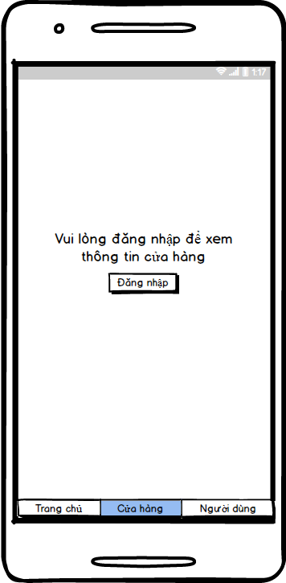

#### Objects and Actions

* + 1. Screen allows Store to view own store information.
    2. Screen is initial screen in management store process.

### View User Functional Management Screen

#### Screen Images

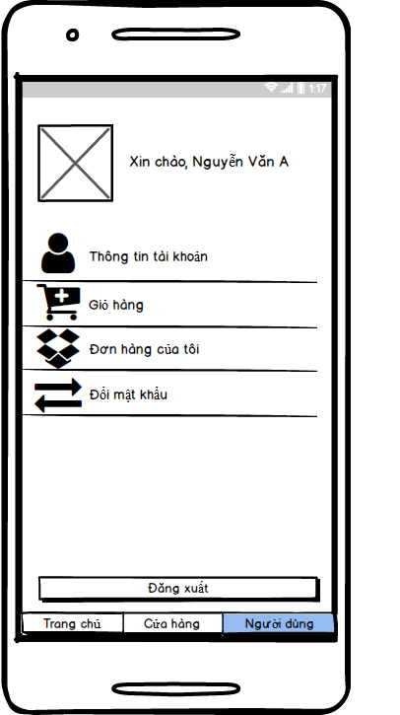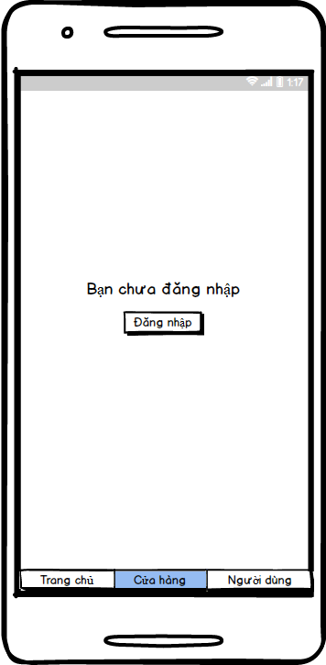

#### Objects and Actions

* + 1. Screen displays account functional management which is viewed by User.
    2. Screen is initial screen in management account process.

### Login Screen

#### Screen Images

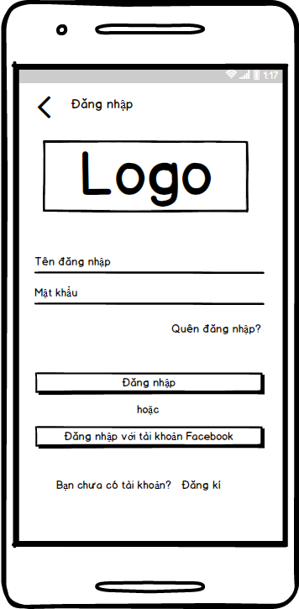

#### Objects and Actions

* + 1. Screen allows User to login to application with 3S account, Facebook account and Google+ account.

### Register Account Screen

#### Screen Images

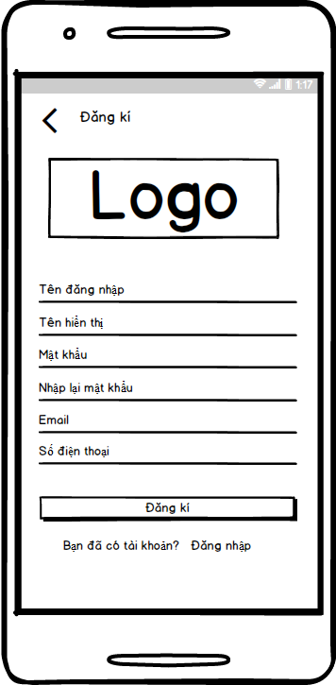

#### Objects and Actions

* + 1. Screen allows User to register a new account.

### View User Information Screen

#### Screen Images

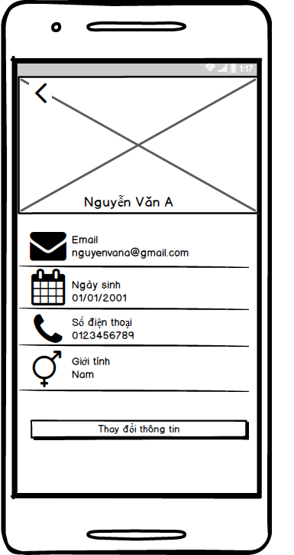

#### Objects and Actions

* + 1. Screen displays user account information.

### Edit User Account Information Screen

#### Screen Images

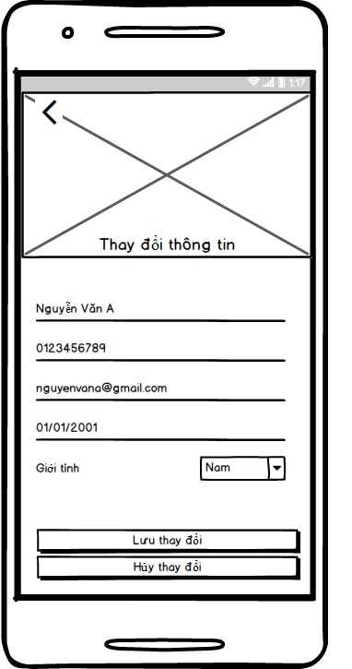

#### Objects and Actions

* + 1. Screen allows User to edit account information.

### Change Password Screen

#### Screen Images

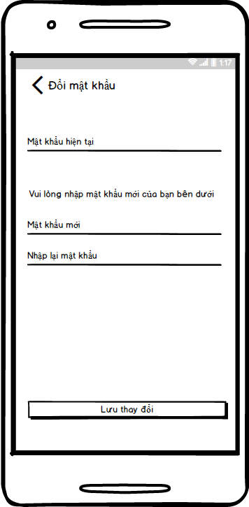

#### Objects and Actions

* + 1. Screen allows User change user 3S account password.

### Edit Store Information Screen

#### Screen Images

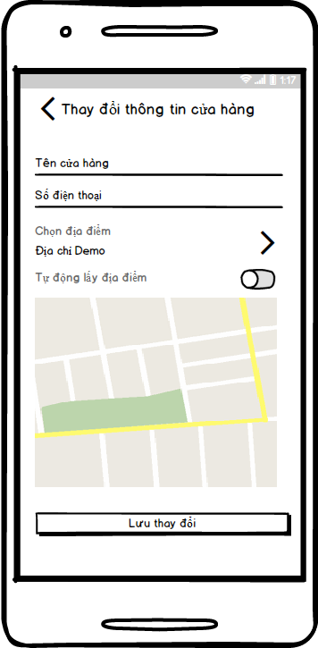

#### Objects and Actions

* + 1. Screen allows Store to edit store information.

### View User Order History Screen

#### Screen Images

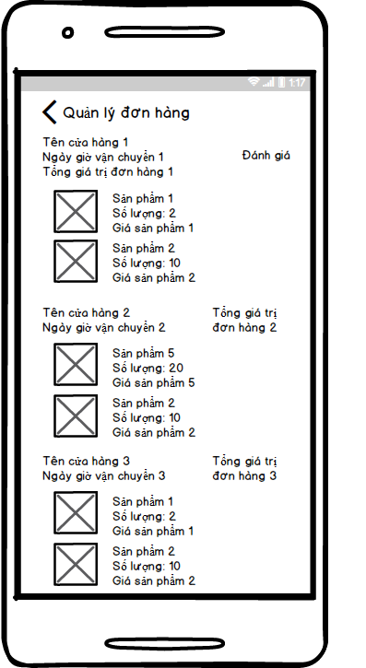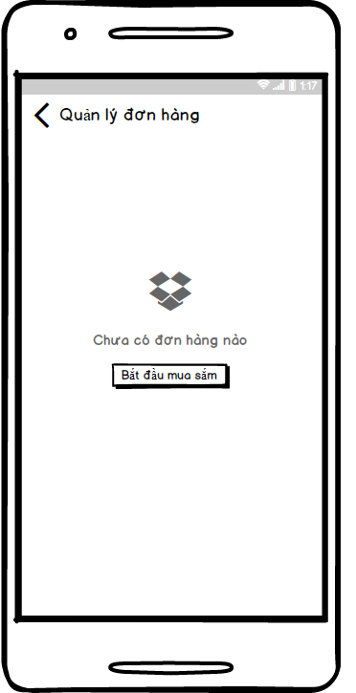

#### Objects and Actions

* + 1. Screen displays user own order history.

### View Product Detail Screen

#### Screen Images

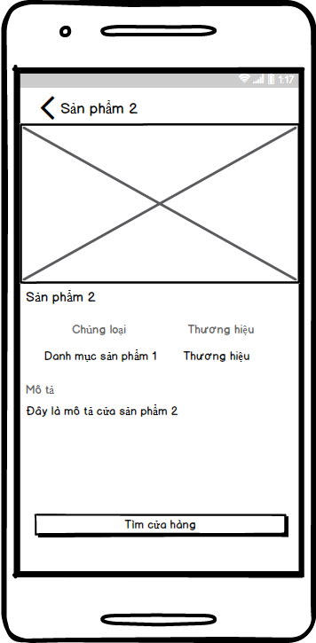

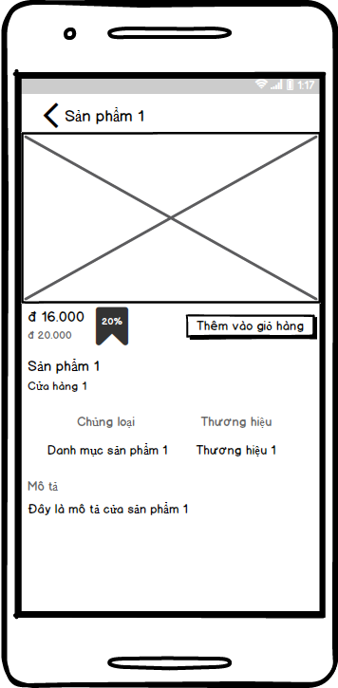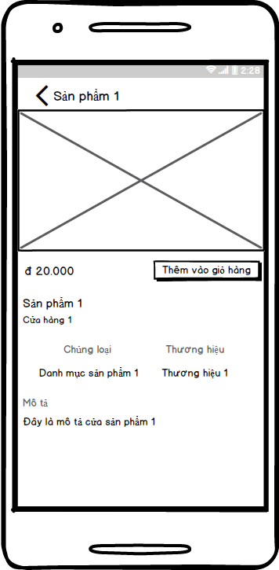

#### Objects and Actions

* + 1. Screen displays detail information of any one product in application.

### Order Screen

#### Screen Images

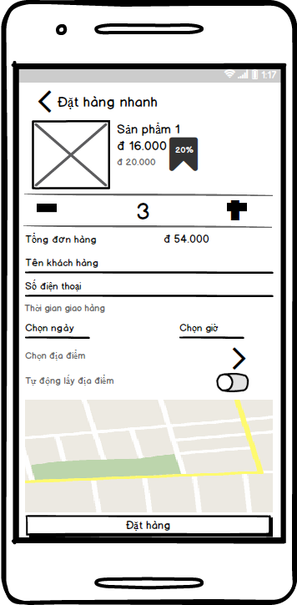

#### Objects and Actions

* + 1. Screen allows User to provide order information.

### View Product In Store By User Screen

#### Screen Images

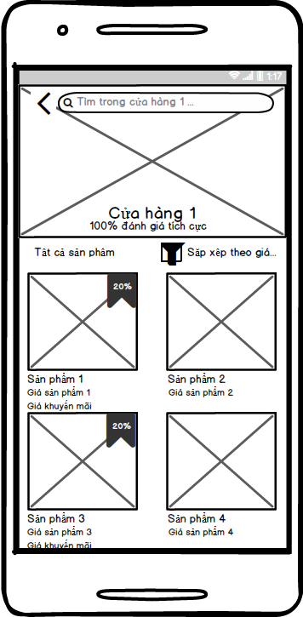

#### Objects and Actions

* + 1. Screen allows User to view products in store .

### View Nearby Store Screen

#### Screen Images

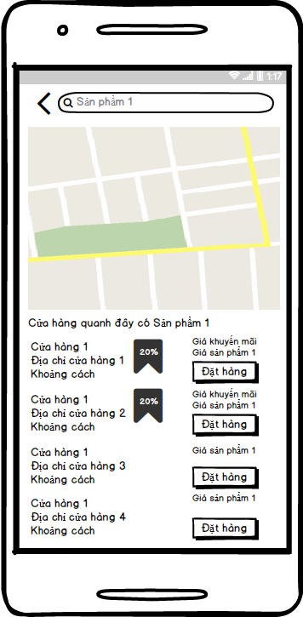

#### Objects and Actions

* + 1. Screen allows User to view nearby store list which have user-needed product.

### User Search Product Screen

#### Screen Images

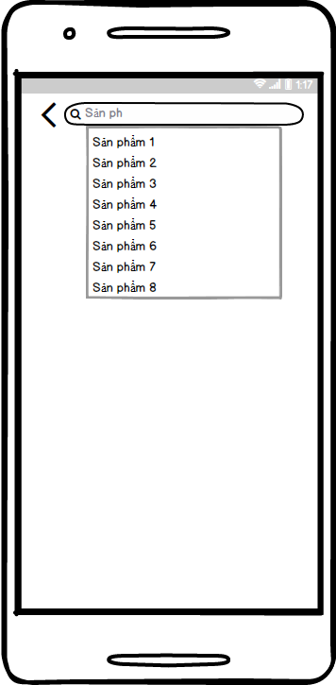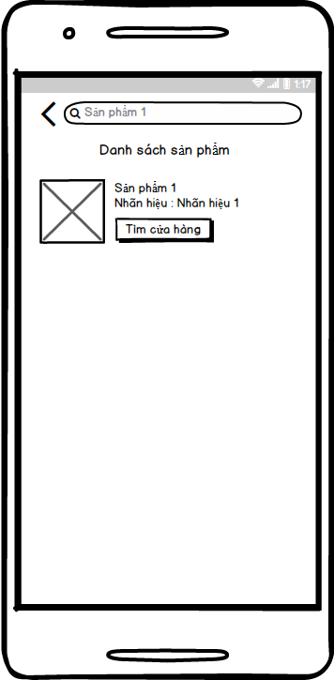

#### Objects and Actions

* + 1. Screen allows User search products and displays searched product list.

### Add Product To Store Screen

#### Screen Images

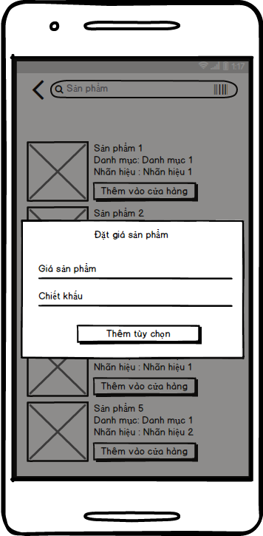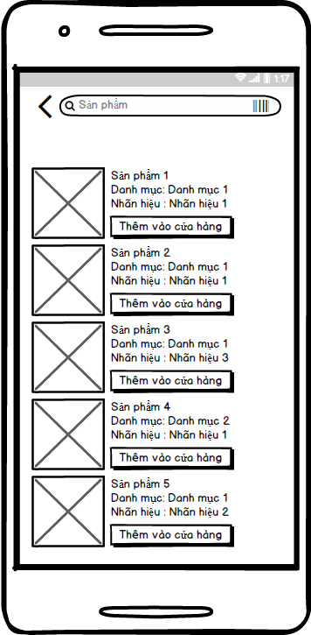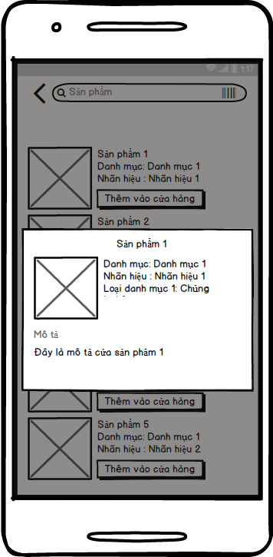

#### Objects and Actions

* + 1. Screen allows Store to view product detail and add new products to store.

### View User Cart Screen

#### Screen Images

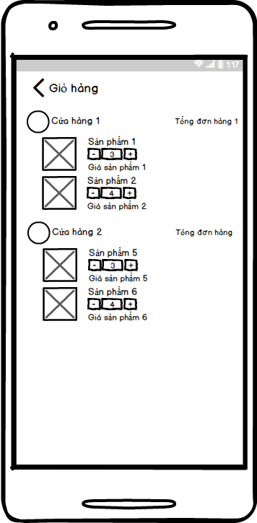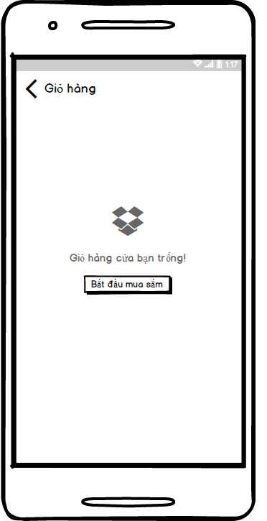

#### Objects and Actions

* + 1. Screen allows User to view current cart which is do-not-checked-out-yet order.

### Forget Password Screen

#### Screen Images

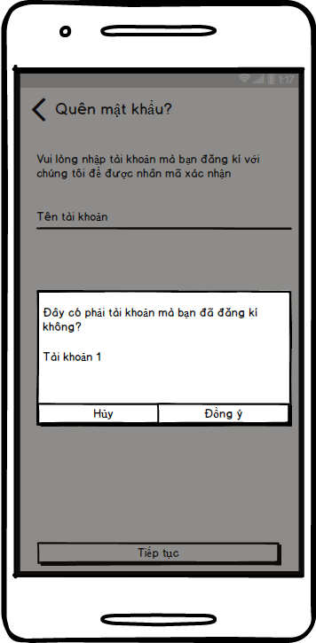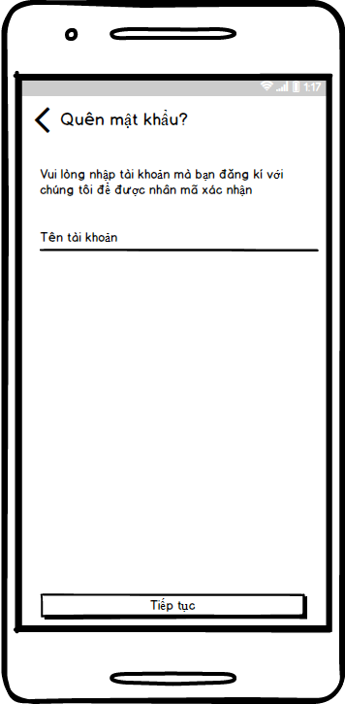

#### Objects and Actions

* + 1. Screen allows User to request getting OTP Code to support reset account password process.
    2. Screen is initial screen in reset account password process.

### OTP Code Screen

#### Screen Images

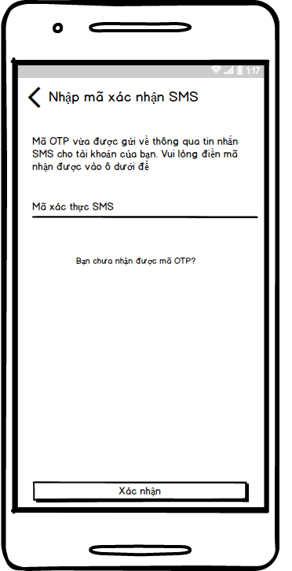

#### Objects and Actions

* + 1. Screen allows User to confirm received OTP Code to support reset account password process.

### View Product In Store By Store

#### Screen Images

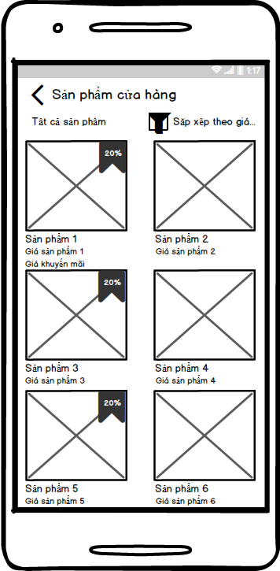

#### Objects and Actions

* + 1. Screen allows Store to view products in own store .

### View Store Order History Screen

#### Screen Images

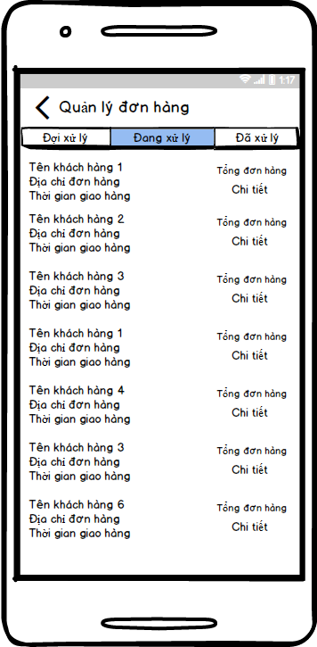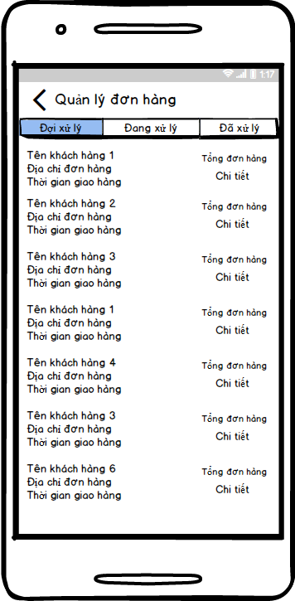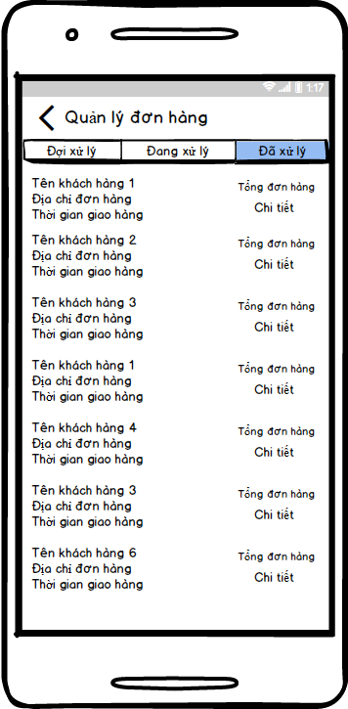

#### Objects and Actions

* + 1. Screen allows Store to view store order history.

### View Order Detail Screen

#### Screen Images

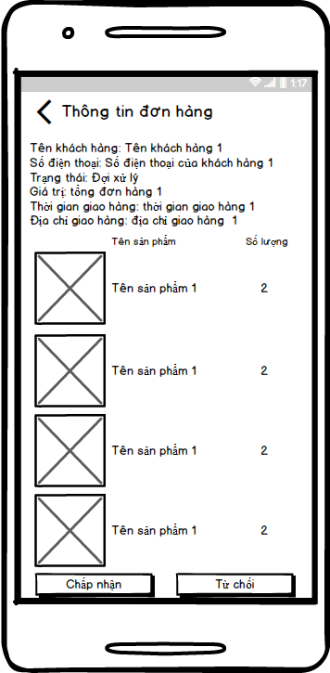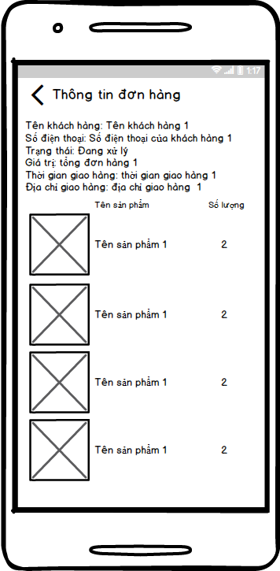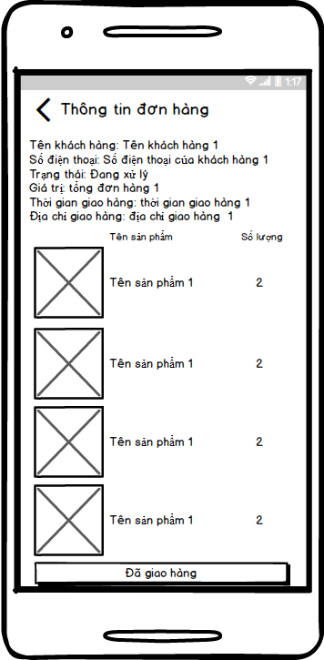

#### Objects and Actions

* + 1. Screen allows Store to view detail information of store’s orders.

### View Direction Of Order Screen

#### Screen Images

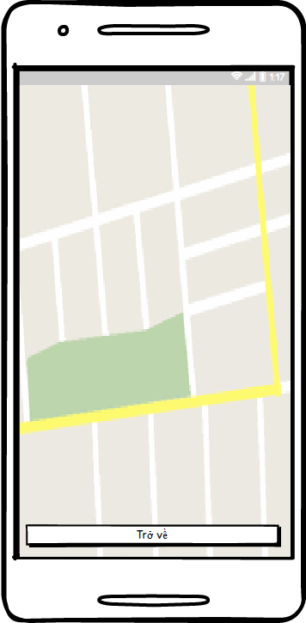

#### Objects and Actions

* + 1. Screen allows Store to view direction from store address to order delivery address.

## Database Design or Data Structures

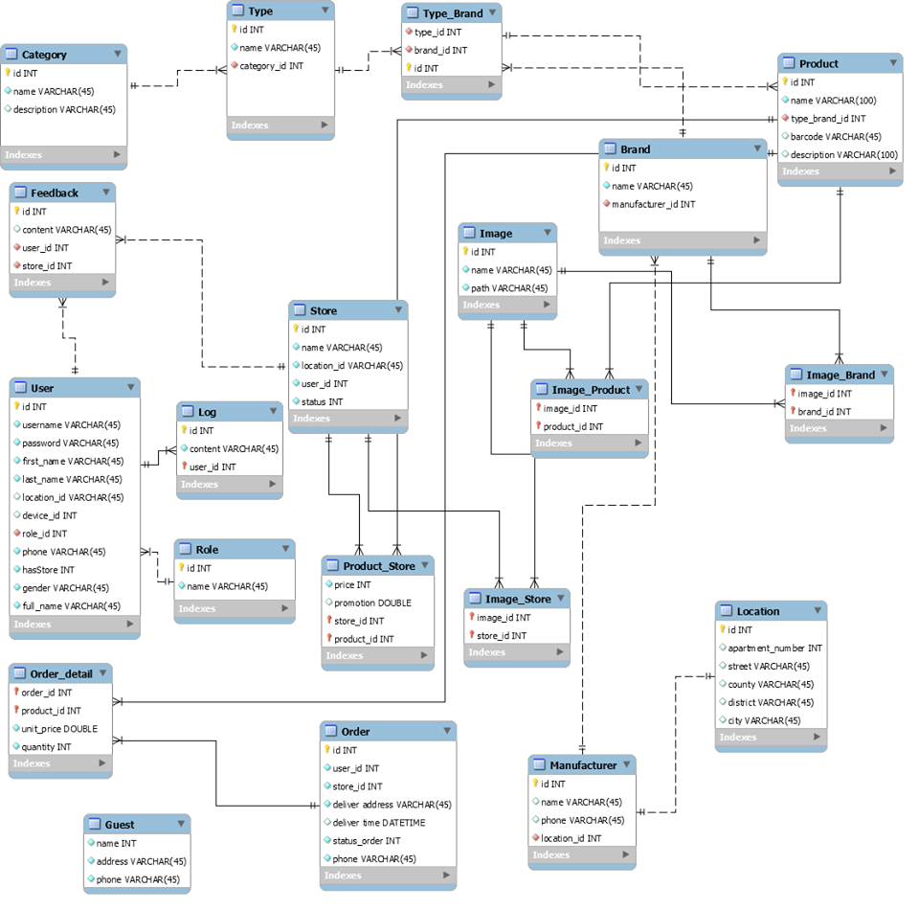

# Software Test Description (STD)

## Purpose

* + This chapter purpose is to detect software failures so that defects may be discovered and correct to ensure that our project is thoroughly tested and resulting in a successful implementation of a new social application we are developing. It contains the following sections:
    - Scope of testing.
    - Testing tools and environment.
    - Resources and responsibilities.
    - Test strategy: Test approach, test plan.
    - Features to be tested.
    - Features not to be tested.
    - Defects log
    - Test report

## Introduction

### Scope of testing

|  |  |  |  |
| --- | --- | --- | --- |
| **No.** | **Test stages** | **Description** | **Implementer** |
| **1** | **Unit testing** | Unit testing will be done by developers and approved by team leader. | Developers |
| **2** | **Integration testing** | Integration testing allows individuals the opportunity to combine all of the units within a program and test them as a group. This testing level is designed to find interface defects between modules/functions. It is particularly beneficial because it determines how efficiently the units are running together. | Testers |
| **3** | **System testing** | System testing is the first level in which the complete application is tested as a whole. The goal at this level is to evaluate whether the system has complied with all of the outlined requirements and to see that it meets Quality Standards or not.  Testers | Testers, Technical leader |
| **4** | **Acceptance test** | Acceptance testing will be executed by all team members in view of end-user. It determines whether system satisfies requirements specified in the requirement analysis phase. Finding defect is not the main task in this stage. Acceptance test will access the system’s readiness for deployment and using | End-users |

### Types of testing

|  |  |  |
| --- | --- | --- |
| **No.** | **Test types** | **Description** |
| **1** | **Function test** | * + Functional testing is a type of software testing whereby the system is tested against the functional requirements or specifications.   + Functions (or features) are tested by feeding them input and examining the output. Functional testing ensures that the requirements are properly satisfied by the application. This type of testing is not concerned with how processing occurs, but rather, with the results of processing.   + During functional testing, Black box testing technique is used in which the internal logic of the system being tested is not known to the tester. |
| **2** | **GUI test** | * + GUI testing is the process of ensuring proper functionality of the graphical user interface (GUI) for a given application and making sure it conforms to its written specifications.   + GUI testing evaluates design elements such as layout, colors, fonts, font sizes, labels, text boxes, text formatting, captions, buttons, lists, icons, links and contents. |
| **3** | **Performance test** | * + Performance testing is the process of determining the speed or effectiveness of a computer, network, software program or device. This process can involve quantitative tests done in a lab, such as measuring the response time or the number of frames per second at which a system functions. |

### Range of testing

* + Team performs all functions defined in the SRS based on the approved version.

## Test plan

### Testing tools and environment

#### Testing tools

* + Microsoft Excel 2017: Excel is used to manage test cases and manage bugs.
  + Netbean: Unit test.

#### Testing environment

* + Android 8.0.0:

|  |  |  |
| --- | --- | --- |
| Thông số | **Samsung Galaxy Note 8** | **Samsung A5 2017** |
| Màn hình | * 6.3 inch | 5.2 inch |
| Độ phân giải màn hình | Full HD+ (2220 x 1080) | Full HD (1920 x 1080) |
| RAM | 6 Gb | 3 Gb |
| CPU | Exynos 8895 8 core 64-bit | Exynos 7880 8 core 64-bit |

* + Android ...

#### Resources and responsibilities

|  |  |  |
| --- | --- | --- |
| **No.** | **Resources** | **Responsibilities** |
| **1** | **Project manager** | * + Reviewing test case and report |
| **2** | **Tester** | * + Performing the actual system testing.   + Managing test resource and assign test tasks.   + Creating test plan.   + Creating test cases.   + Creating test report.   + Executing test and testing log report. |
| **3** | **Developer** | * + Creating unit test.   + Fixing bugs |

#### Test strategy

##### Test model

* + - OAL follows V-Model process to implement testing. V-Model is abbreviation of Verification and Validation model. In software development, the V-Model represents a development process that may be considered as an extension of the waterfall model, and is an example of the more general V-Model. Instead of moving down in a linear way, the process steps are bent upwards after the coding phase, to form the V shape.
    - The V-Model demonstrates the relationships between each phase of the development life cycle and its associated phase of testing. The horizontal and vertical axes represent time or project completeness (left-to-right) and level of abstraction. Advances in the production of executable requirements, architectures, and designs enable testing to begin much earlier on the left side of the V so that requirements, architecture, and design defects can be found and fixed early before they can propagate into downstream work products.

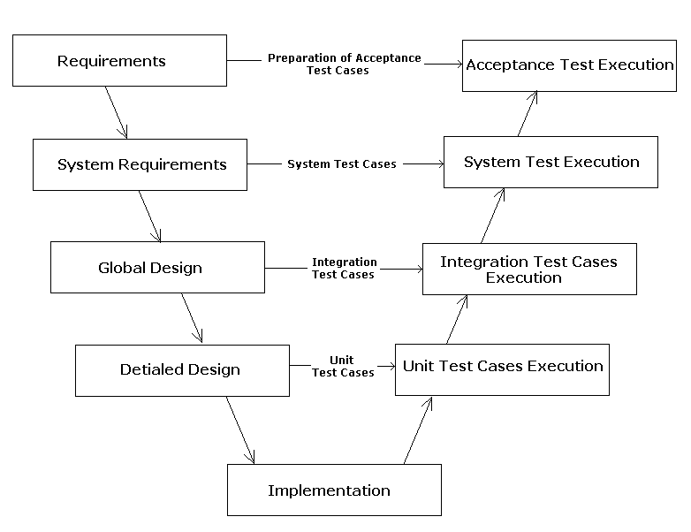

* + - OAL uses V-Model because:
      * It works well for small projects where requirements are easy-to-understand.
      * It is simple and easy-to-use.
      * It saves time because testing activities like planning, test designing happens well before coding.
      * It has proactive defect tracking that defects are found at early stages.
      * It help to avoid the downward flow of the defects.

##### Test stage

|  |  |  |  |  |
| --- | --- | --- | --- | --- |
| **Types of test** | **Stages of test** | | | |
| **Unit test** | **Intergration test** | **System test** | **Acceptance test** |
| **Function test** |  |  |  |  |
| **GUI test** |  |  |  |  |
| **Performance test** |  |  |  |  |
|  |  |  |  |  |

### Features to be tested

* + - All functions that are listed in Use case.
    - Performance specifications: Load time, Memory, Time of censoring.
    - GUI of the Android application.

### Features not to be tested

* + - Functions that are not listed in Use case.
    - Functions that are out of scope.

## Test case